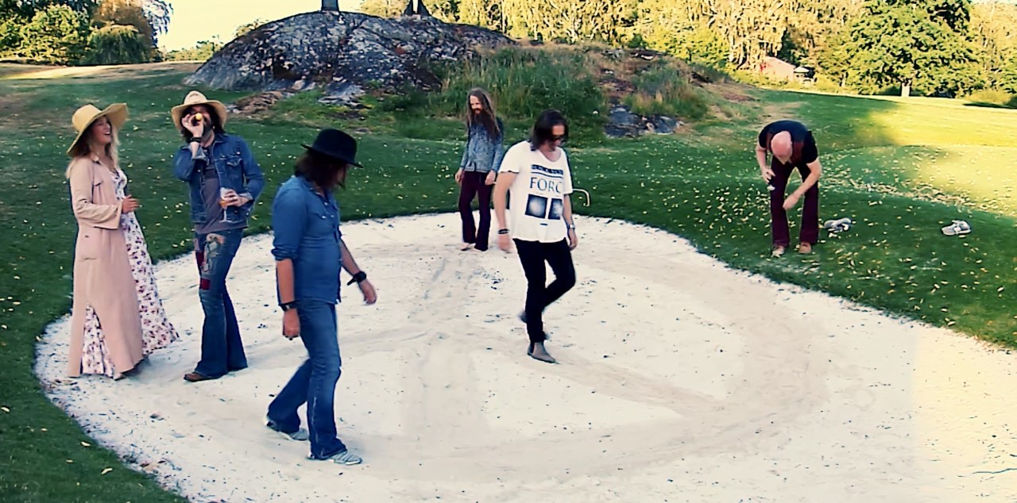
New video release with Peace Conspiracy
by supporting the Non-Violence Project Foundations work against violence
Swedish rock band Peace Conspiracy is releasing their new video to spread hope in troubled times.
“We are in this together and supporting the powerful work of
The Non-Violence Project, we can make this world a more Peaceful Place”
Peace Conspiracy is a Swedish rock band formed with the purpose to spread peace on the planet.
On lead vocals is the Non Violence Projects Ambassador Meja, the award-winning pop star who climbed Billboard Charts, sold millions of albums worldwide and is known for her international hits ”All ’bout the Money” and the duet ”Private Emotion” with Ricky Martin. “As an ambassador it is my humble duty to promote peace in the best way we can, through music, Meja says.
This all-star constellation formed by guitarist/singer Conny Bloom, (Electric Boys, Hanoi Rocks), are Thomas Broman, drums (w/Glenn Hughes of Deep Purple/legendary Joe Lynn Turner), Henrik Widen, organ/keys (Diamond Dogs), bass Mats Rydström (Avatarium/Abramis Brama,) and guitarist/singer Ronnie Åström (The Cloudberries).
The video was shot, pre-corona, in the beautiful Swedish archipelago. It is a modern reminder of the message that was spread in the days of Woodstock. The Words of Peace and Love.
Video Link: https://youtu.be/JqPzEiZ2fA8
Peace Love and Understanding (written by Meja/Tom DeLuca) is produced by Conny Bloom and Erik Holmberg at K51 Stockholm and mixed by Pontus Norgren (Hammerfall).
Spotify: https://open.spotify.com/album/3xauooWLGW4X6MrxDn5HT0
PR: Liza Berthelsen Liza@lizab.se Project manager: kattis@peaceconspiracy.se
For more information visit The Non-Violence Project Foundation: www.nonviolence.com
