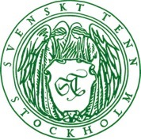
Press release
Stockholm, March 22, 2018

Lars Nilsson designs textile collection for Svenskt Tenn

Fashion designer Lars Nilsson has experience from several leading fashion houses including Nina Ricci, Christian Dior, Bill Blass, Ralph Lauren, Christian Lacroix and Balmain. He has also created his own men’s fashion line, Mr Nils. Active in Paris, London and New York since 1985, Nilsson is now venturing into interior design, introducing his first textile collection, exclusively created for Svenskt Tenn in Sweden.

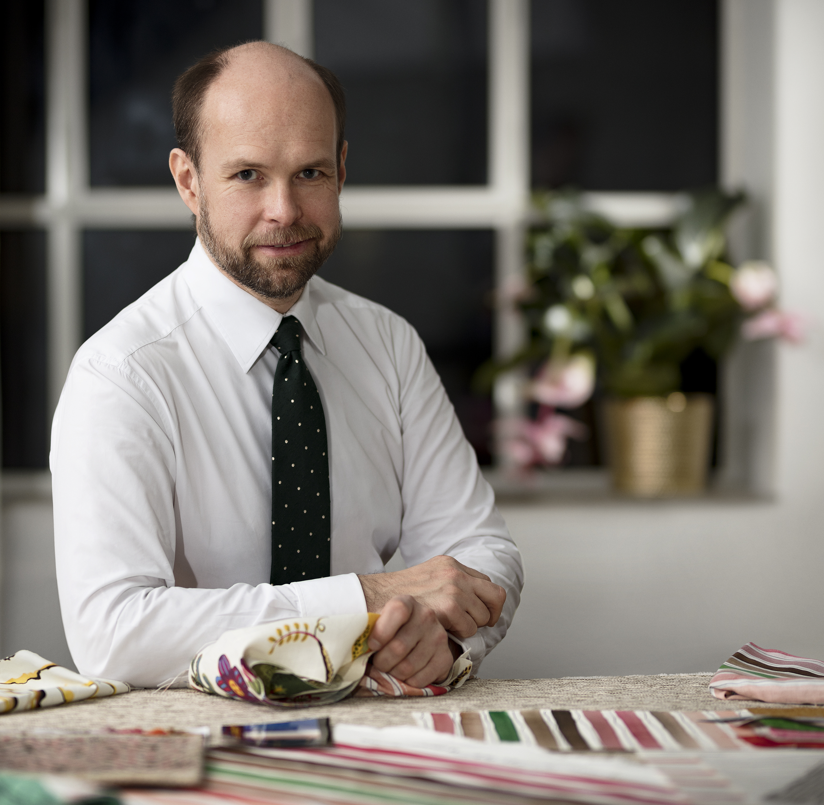
During his career, Lars Nilsson has received numerous awards and accolades for his fashion design work. These include making the Vanity Fair Best-Dressed-list in 2001, New York Magazine 2001 Designer of the Year, and the Swedish fashion magazine Damernas Värld’s award ‘Guldknappen’ in 2006. He is now engaged in his first interior textile collection, to be introduced at Svenskt Tenn the upcoming spring.

The collection comprises seven textiles, four prints and three weave patterns, formed by combinations of stripes in multiple colours, and one which mostly resembles the dash of pencil. The patterns were drawn using watercolour, chalk and felt tip, during Lars Nilsson's stay as an artist-in-residence at Villa San Michele on the Italian island of Capri.

”I have always had a liking for stripes – and most of all for striped men’s shirts,” says Lars Nilsson. ”But this time inspiration also came from the virtually graphic patterns formed by the Gulf of Naples and the dramatic Capri cliffs. Colours were adapted from Capri's nature and flowers.”

The textile collection is presented in the Svenskt Tenn store at Strandvägen 5 in Stockholm, in an exhibition open March 23 through May 27 along with three Lars Nilsson-designed striped wool and linen carpets, two of which feature sheepskin details.

“Lars Nilsson’s textiles have an airy and watercolourly quality to them, which combines well with the tones and feel of Josef Frank’s patterns and furniture, such as the nice rattan sunbed which is reintroduced in conjunction with the exhibition,” says Thommy Bindefeld, Creative Director at Svenskt Tenn.
For further information, please contact:

Thommy Bindefeld, Creative Director: +46 8 670 16 02 or thommy.bindefeld@svenskttenn.se

Svenskt Tenn is an interior design company with retail stores at Strandvägen in Stockholm and online. Since 1975, Svenskt Tenn is owned by the Kjell and Märta Beijer Foundation, which provides research grants within ecology, medicine and the preservation of Swedish interior design tradition.

