Press Update
December 2020
December 2020 - Prime Gaming Monthly Update
Right now, Prime Gaming is offering, exclusive content for more than 30 popular games, plus a library of 38 PC games—a $500+/£380 value representing hundreds of hours of fun—with even more coming soon.
December’s offers include:

- Exclusive content for Ubisoft’s most popular games, including Watch Dogs: Legion and the upcoming Immortals Fenyx Rising
- A download of Electronic Arts’ hit FPS Battlefield 3 on Origin
- 38 games at a $500+/£380 value, including new titles like Sigma Theory: Global Cold War and The Game Awards-nominated title HyperDot

All of these offers can be claimed by visiting gaming.amazon.com. You can download assets here.

Read on for a look at all of the great content and games coming in December!

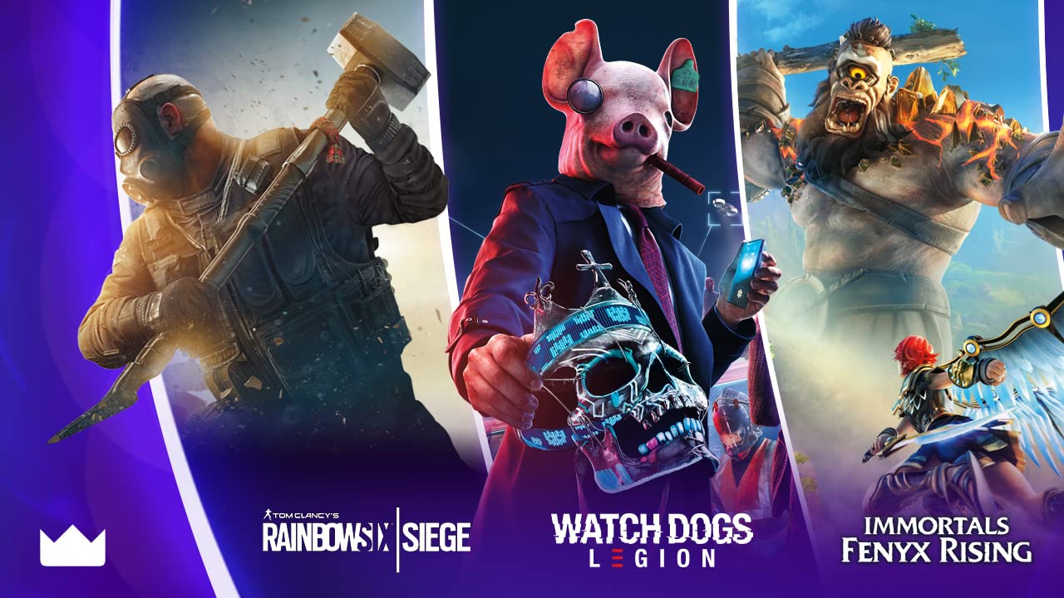
Exclusive Prime Gaming content for Ubisoft’s biggest games!
Coming in December Prime Gaming is thrilled to team up with world-renowned publisher Ubisoft to bring Prime members exclusive in-game content for some of their biggest games, including Watch Dogs: Legion, Immortals Fenyx Rising, Tom Clancy's Rainbow Six Siege, and more!
- Immortals Fenyx Rising – Bring grand mythological adventure to life in the open-world action RPG with this month’s content offering: the Frozen Pack contains a helmet, outfit, wings and campaign horse.
- Watch Dogs: Legion – In-game content for the latest entry in the hack-obsessed franchise is coming soon: the Nerdcore and Futurist outfits.
- Tom Clancy’s Rainbow Six Siege – Prime Gaming also has exciting content on the way for blockbuster online tactical shooter: the Thatcher Gladiator Full Operator Set
Stay tuned over the coming months for more exciting Ubisoft content only available from Prime Gaming!
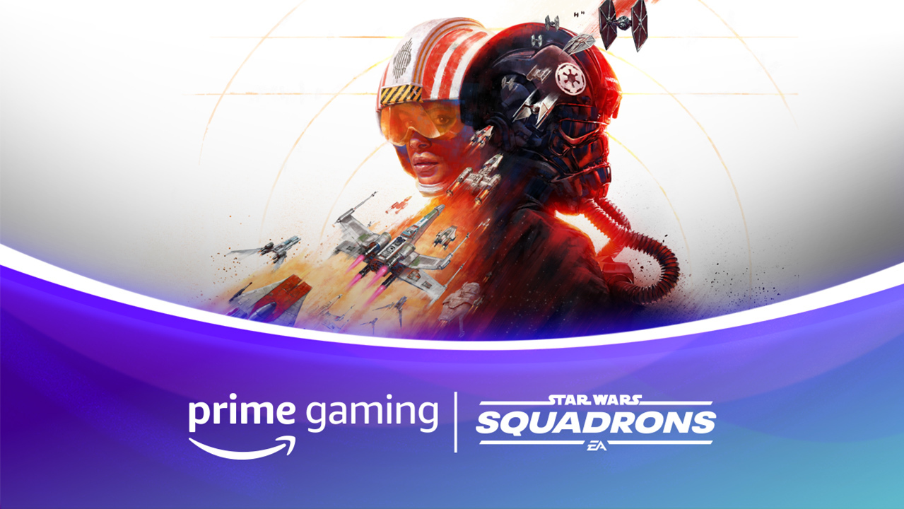
Join the galaxy’s finest in style
Coming December 9 Master the art of starfighter combat in the authentic piloting experience Star Wars: Squadrons, and for a limited time only, get access to two new pilot helmets: the Bold Approach and Vibrant Focus.
Drop 1 of 4
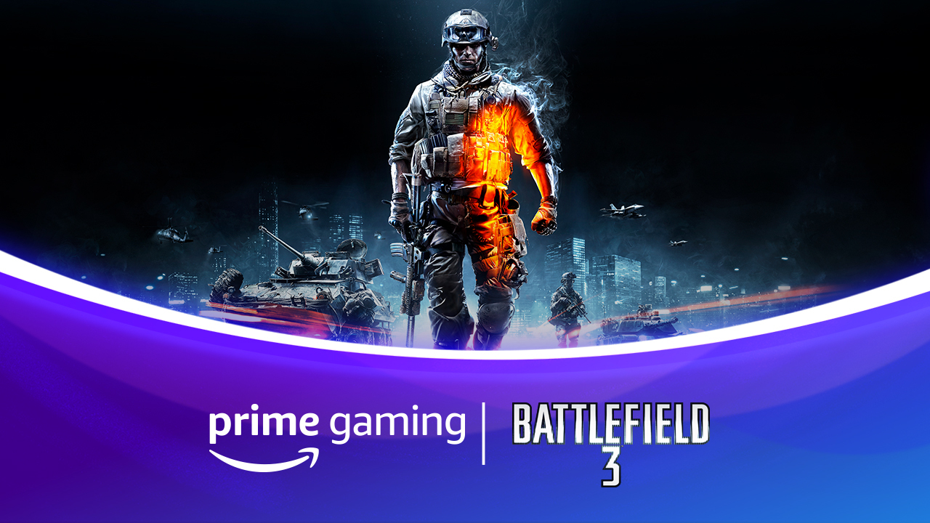
Bonus Game: Battlefield 3
Available Now EA and DICE’s critically acclaimed FPS Battlefield 3 is now available on Origin for Prime members! In the game, players travel around the world to take on over-the-top and dangerous missions as an esteemed member of the U.S. Marines.
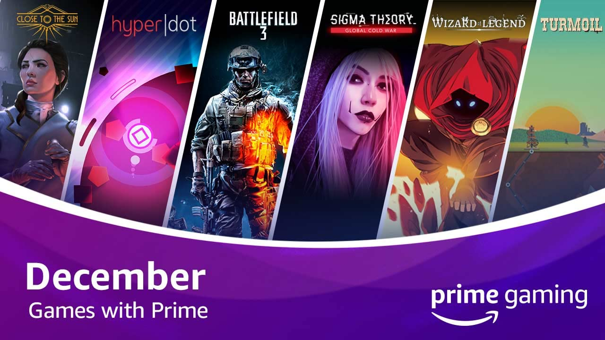
Spread the holiday cheer with dozens of games!
Add 35+ games to your library in December, including Sigma Theory: Global Cold War and HyperDot
Available Now We’re kicking off December with 38 games—a $500+ value—yours for the taking, with more on the way.
In addition to Battlefield 3 on Origin, be sure to pick up favorites like A Knight’s Quest and Aurion: Legacy of the Kori-Odan before they disappear on December 11, and if you haven’t yet, now’s the time to claim more than 20 SNK arcade classics, including Fatal Fury Special, Samurai Shodown II, and Metal Slug 2.
Here’s a look at some of the new games coming to Prime Gaming in December:
- Turmoil – Drill for oil like it's 1899 in this visually charming, tongue-in-cheek take on the simulation genre inspired by the 19th century oil rush in North America.
- Sigma Theory: Global Cold War - Recruit a squad of special agents and run your intel agency to secure the control of the singularity in the turn-based strategy game.
- HyperDot - Nominated for Innovation in Accessibility for The Game Awards this year, this minimal action arcade masterpiece has one rule: dodge everything.
- Close to the Sun - Experience a second era of scientific enlightenment, where the mind and inventions of the great Nikola Tesla have shaped the 19th century
- Wizard of Legend - A fast-paced dungeon crawler with rogue-like elements that emphasizes dynamic magical combat.
Prime members have unlimited access to a growing collection of PC games, with new titles added each week. We rotate our collection to keep titles fresh, so check back each week to claim new games and grab others before they’re gone. Prime Gaming offers hundreds of dollars’ worth of games and in-game content available at all times—and all games are yours to keep forever.
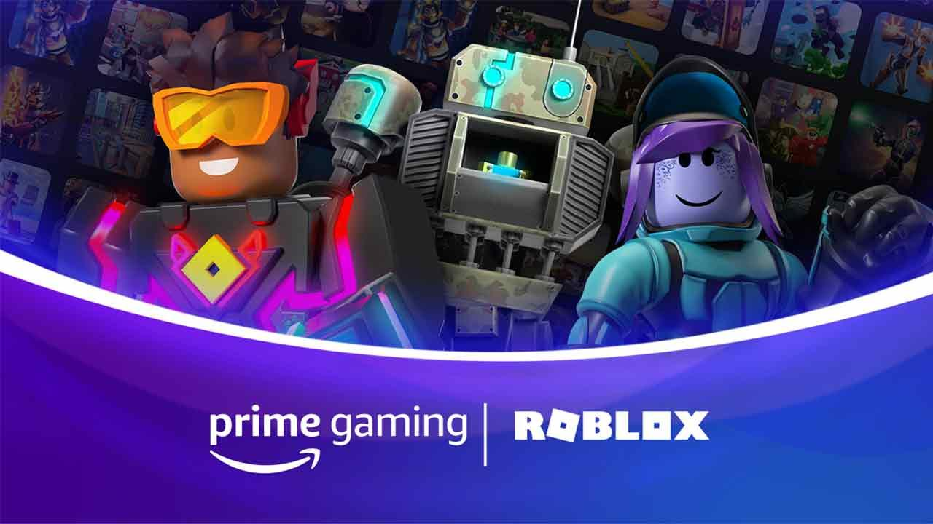 | 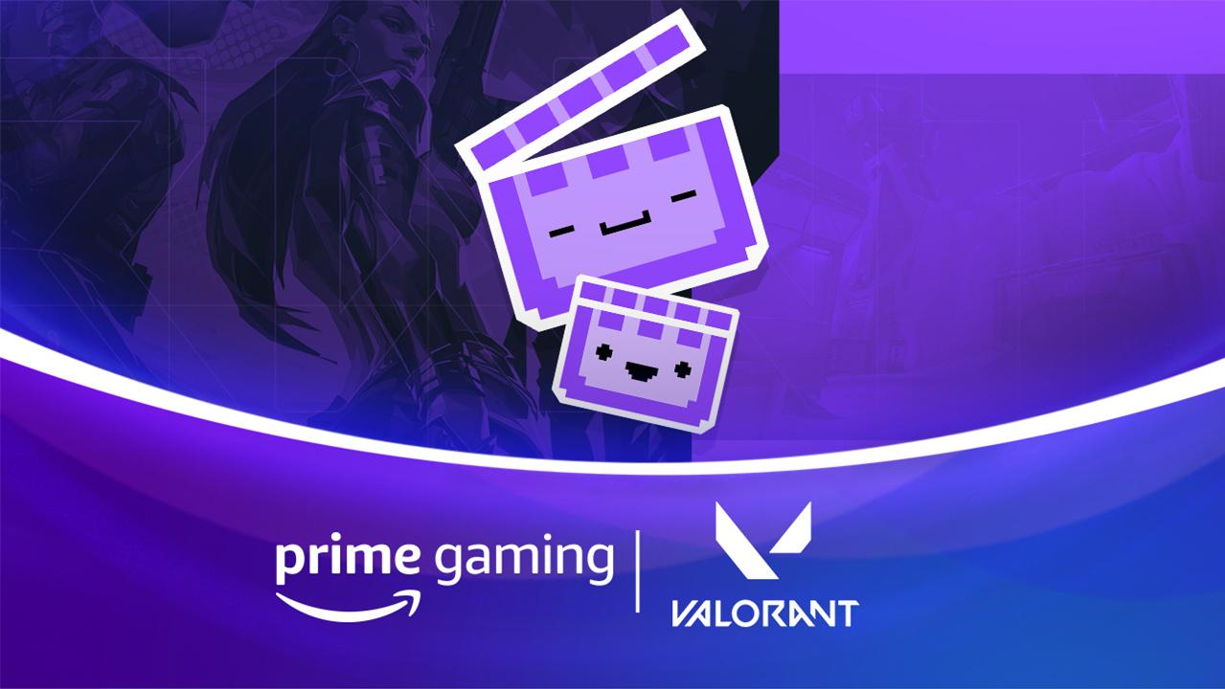 | 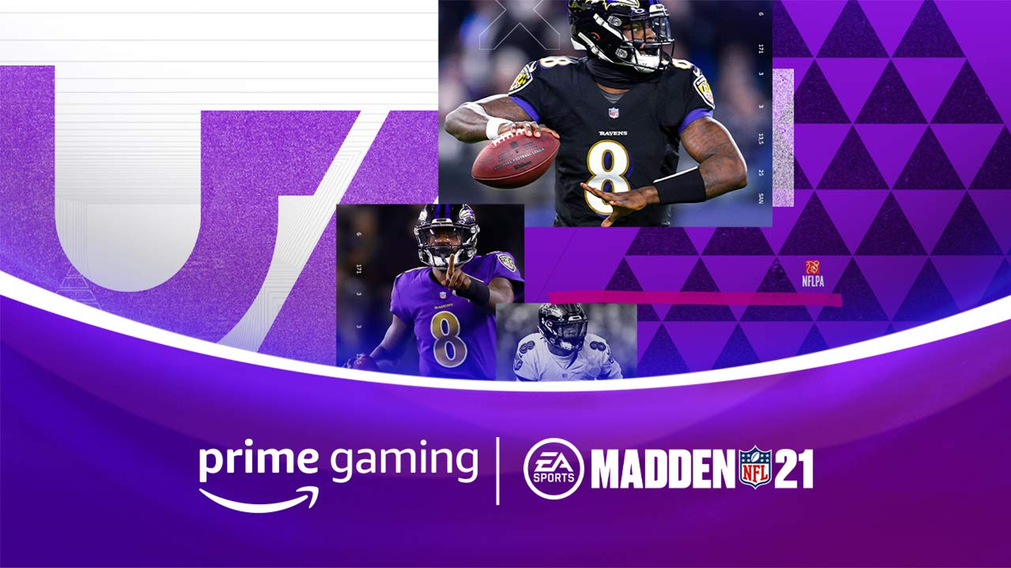
Roblox  Available December 11  December is bringing more Roblox fun to the whole family! Claim a Roblox avatar item, PLUS an exclusive in-game item for Bubble Gum Simulator through January 12  Drop 5 of 8 | VALORANT  Available Now  Unlock a Clip It Spray in the popular 5v5 tac-shooter this month.  Drop 3 of 3 | Madden NFL 21  Available December 14  Go all out and push your limits with the Prime Gaming Pack! This pack includes 1 elite player, 2 gold players and 3 silver players.  Drop 3 of 11
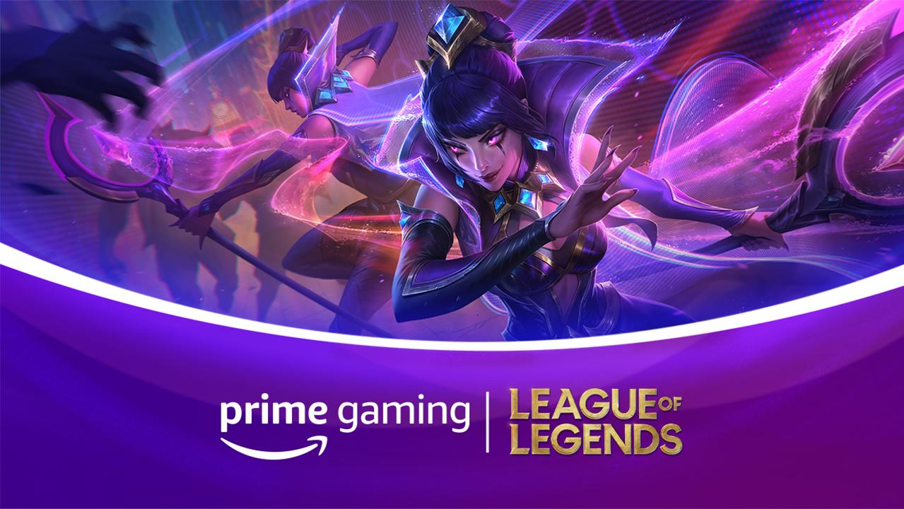 | 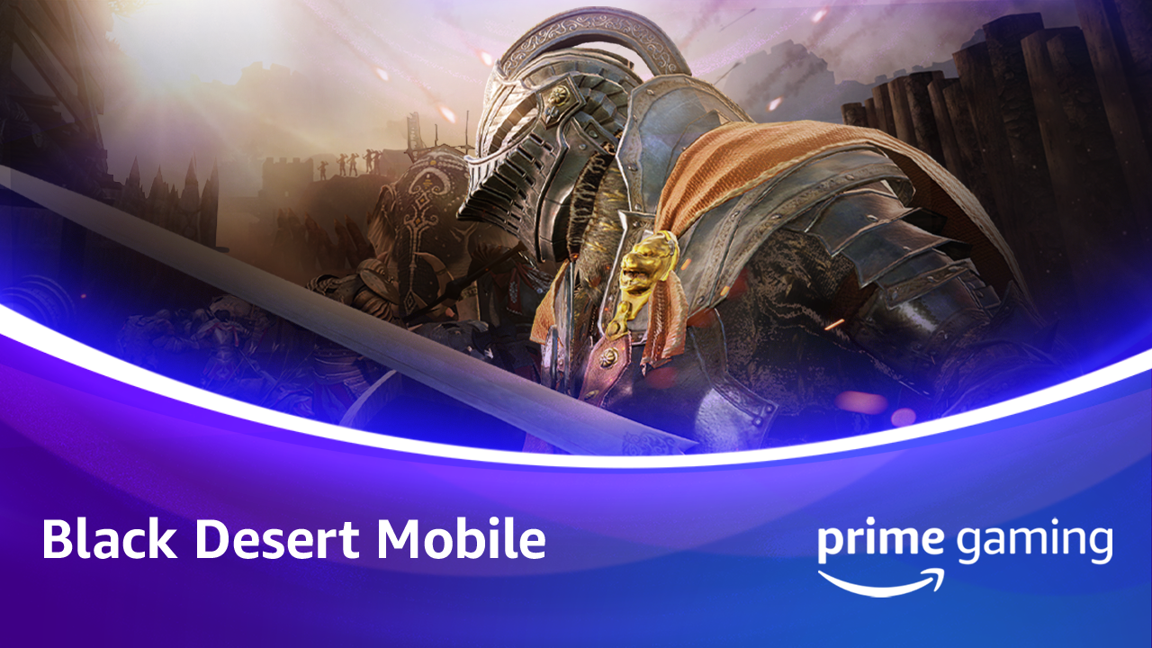 | 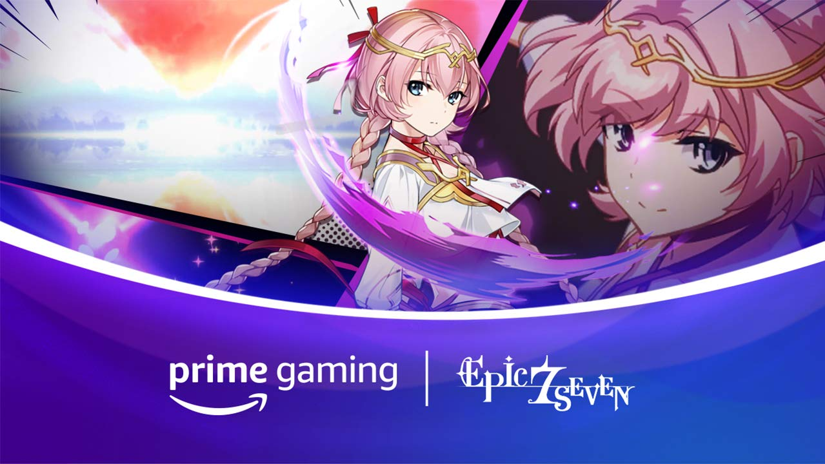
League of Legends  Drop 3 (Available Now)  Drop 4 (Available December 3)  This month, grab two mystery Skin Shards! | Black Desert Mobile  Drop 4 (Available December 8)  Drop 5 (Available December 22)  Prime members can now grab two new content drops for Black Desert Mobile. Claim a Hadum's Chest: Holy Vial of Light and Boss Stamps & Tablets x15,000 Bundle. | Epic Seven  Drop 10 (December 2)  Drop 11 (December 16)  Drop 12 (December 30)  December is full of Epic Seven content! New in-game items and resources include a Lv 95 Epic Equipment Set, Greater Equipment Charms x5 500,000 Gold and x20 Leifs.
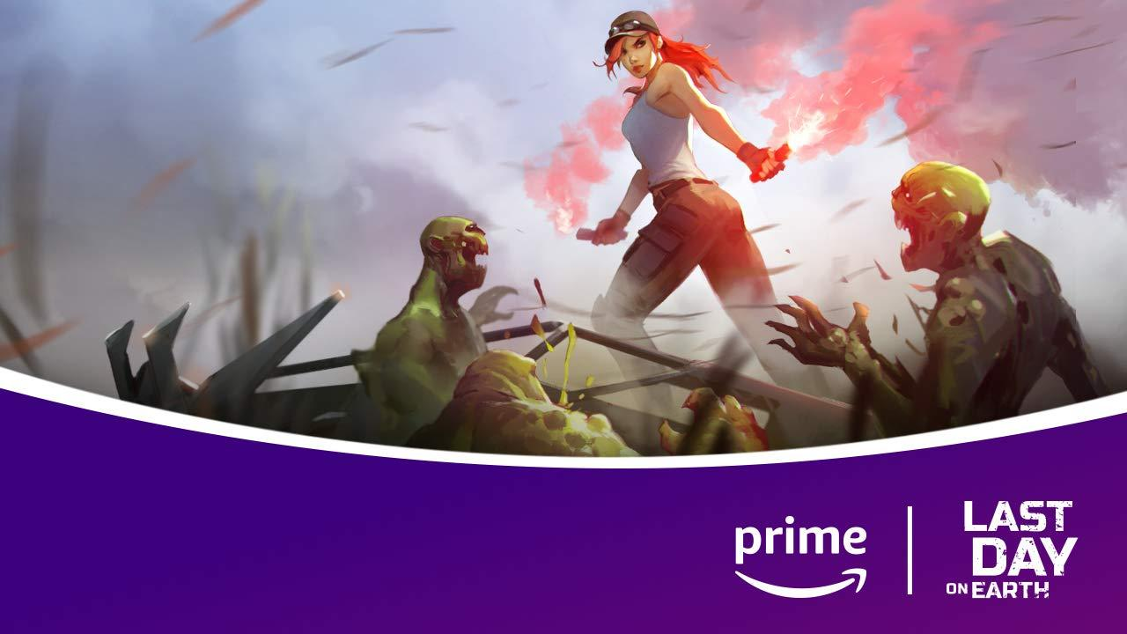 | 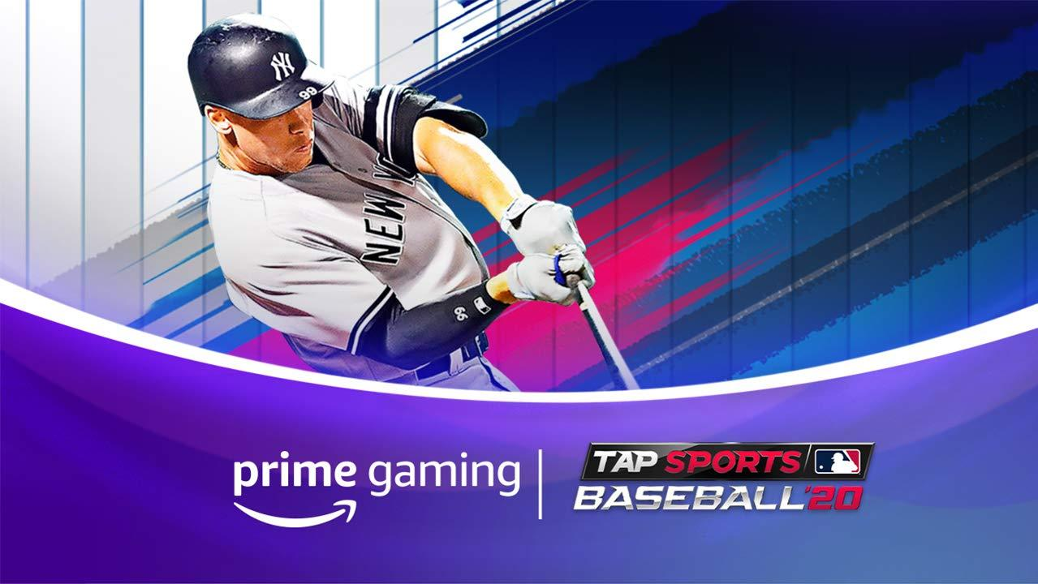 | 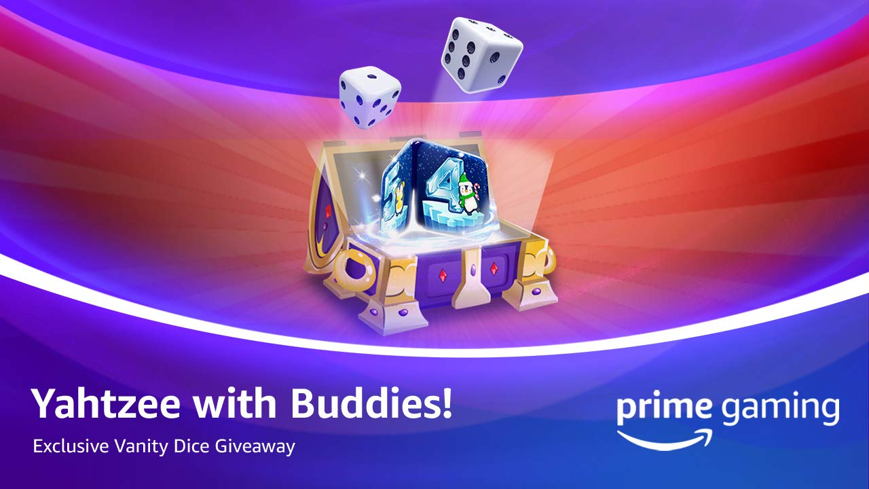
Last Day on Earth  Drop 15 (December 3)  Drop 16 (December 10)  Be sure to grab the three new content drops from Last Day on Earth!  Prime Members can claim various cosmetics and in-game items, including a Rank III Husky Puppy, 500 Caps, a Kevlar Armor Set and MOdified AK. | MLB Tap Sports Baseball  Drop 11 (December 2)  Drop 12 (December 9)  Batter up, this month brings three new content drops in MLB Tap Sports Baseball! Claim numerous cosmetics and in-game items, such as a Next Level Evolution, Clutch Cash and The Gilded Gift beginning November 25. | Yahtzee with Buddies  Drop 12 (December 9)  Drop 13 (December 23)  Yahtzee! Prime Gaming brings two new content drops to the multiplayer game. Starting December 9, players can participate in the Frozen Frame Giveaway to win a seasonal vanity frame worth $20. Beginning December 23, players can also enter the Vanity Dice Giveaway to win a season vanity dice worth $50.
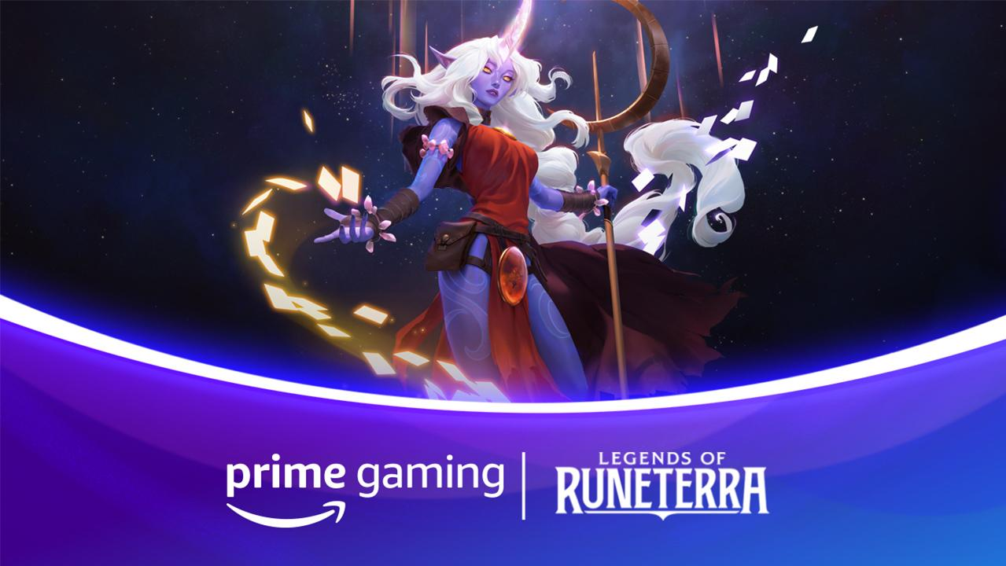 | 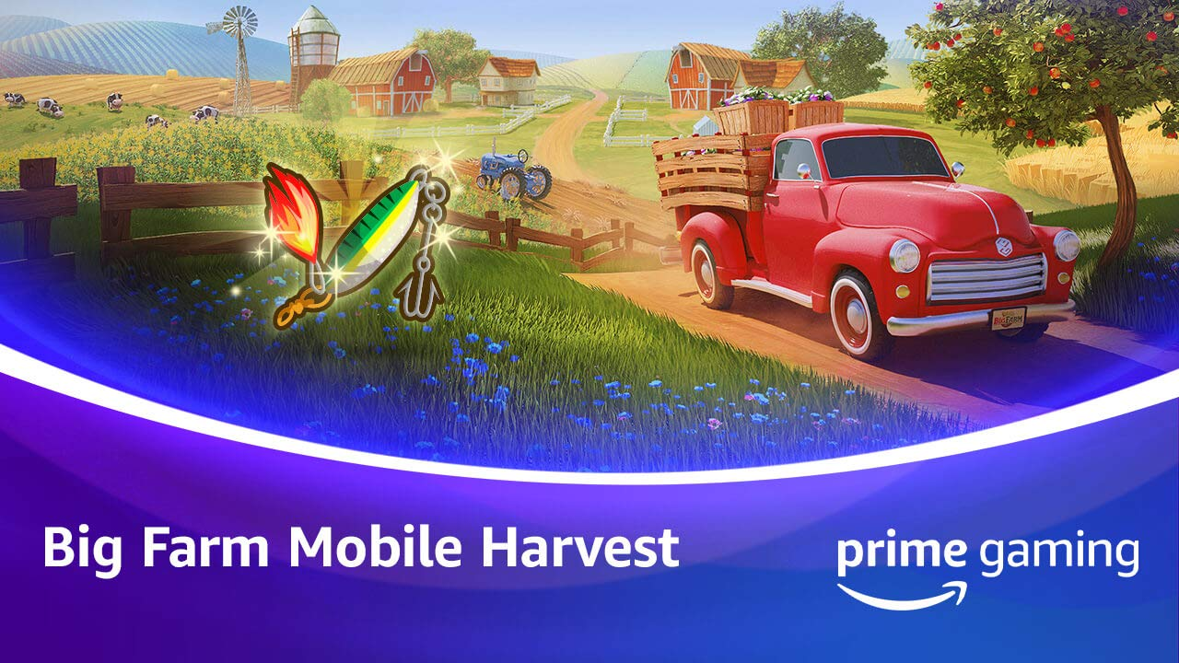 | 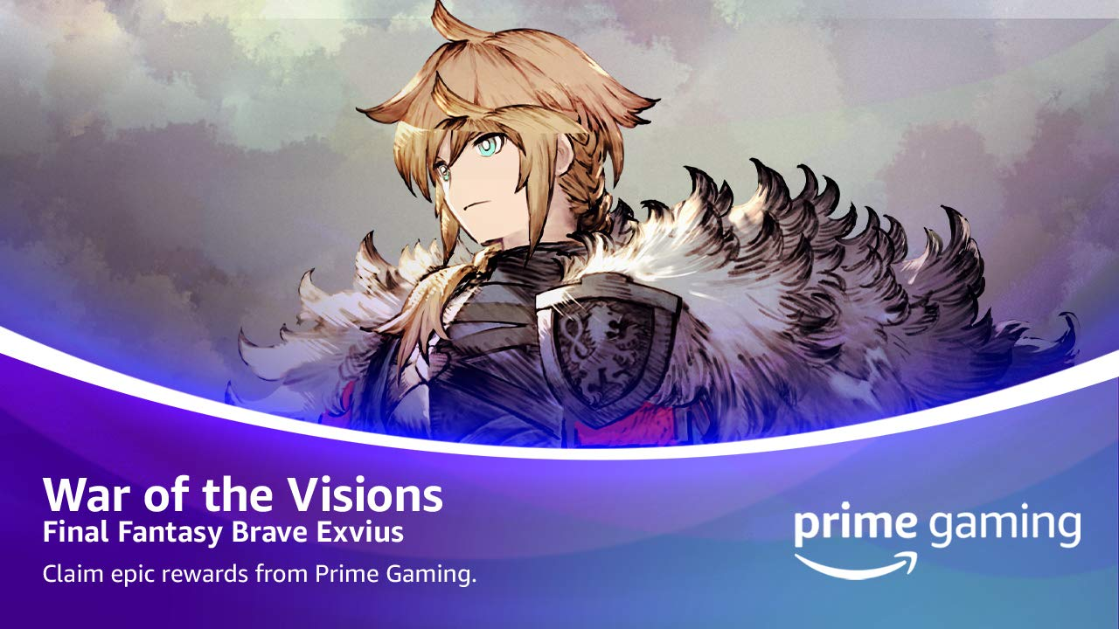
Legends of Runeterra  Available Now  December is bringing Prime members a Epic Wildcard for the digital collectible card game!  Drop 2 of 2 | Big Farm: Mobile Harvest  Drop 14 (December 14)  Claim the Paw Prints x750 from November 30 through December 14 and Super Lures x20 from December 14 through December 28. | WAR OF THE VISIONS FINAL FANTASY BRAVE EXVIUS  Available Now  Be sure to grab SIX new content drops for WAR OF THE VISIONS FINAL FANTASY BRAVE EXVIUS this December.  Prime Members can look forward to in-game items and resources, such as MR + Guaranteed Unit Summon Ticket, Gil x5 MM, NRG Resource (L) x10 and much more!  Drop 1 of 12
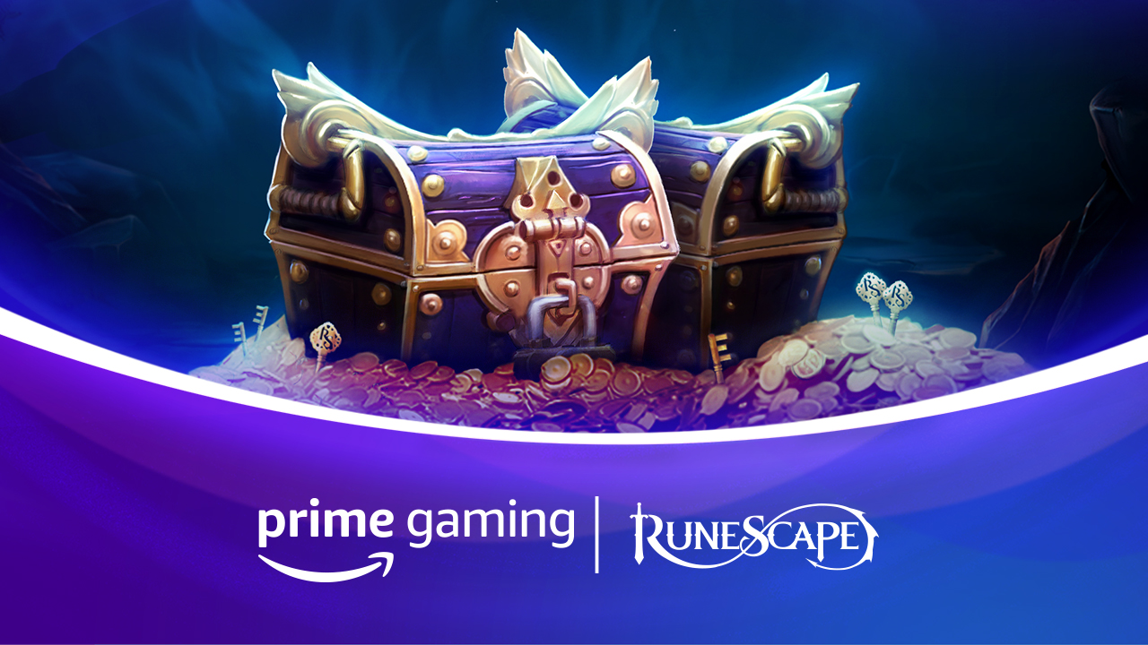 | 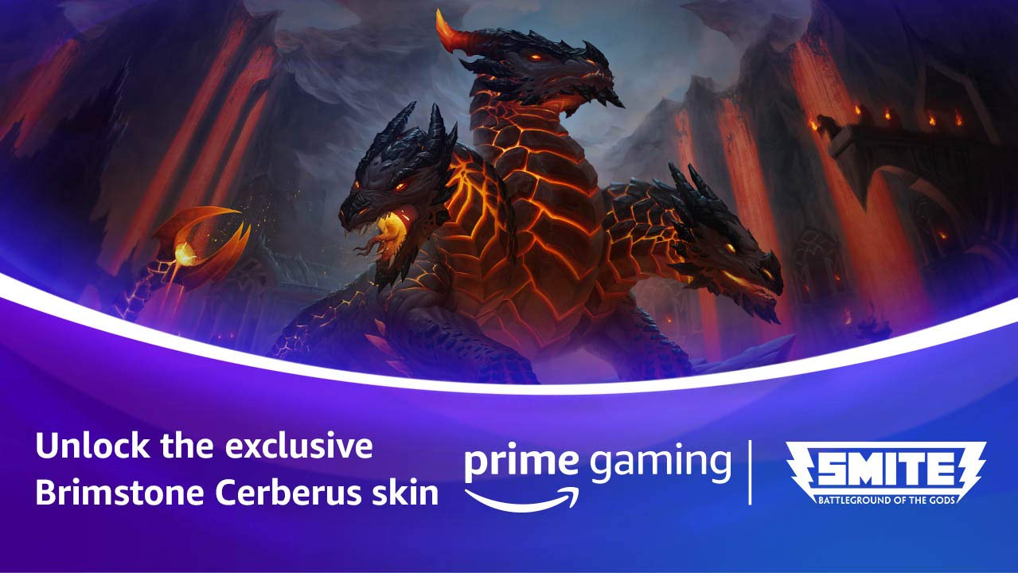 | 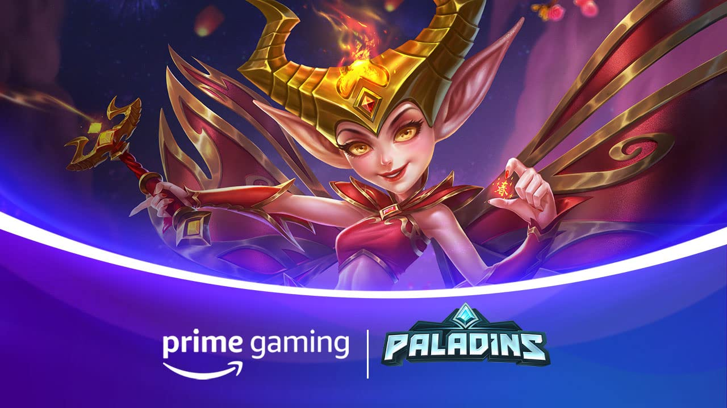
RuneScape and Old School Runescape  Available Now  This month, RuneScape and Old School Runescape is offering a 7 day RuneScape and Old School RuneScape membership!  Drop 3 of 6 | Smite  Available Now  Prime members can look forward to a Brimstone Cerberus skin in the free-to-play, third-person multiplayer online battle arena video game available November 24.  Drop 3 of 9 | Paladins  Available Now  Claim a Firecracker Willo skin in the free-to-play fantasy team-based shooter sensation between November 30 and December 30.  Drop 3 of 9
Calendar December 2020
Now Available Battlefield 3 game download on Origin
Now Available Games with Prime - Turmoil, Sigma Theory: Global Cold War, HyperDot, Close to the Sun, Wizard of Legend
Now Available League of Legends Drop 3
Available Now Legends of Runeterra Drop 2
Now Available RuneScape and Old School Runescape content
Now Available VALORANT Drop 3
Now Available Smite Drop 3
Now Available WAR OF THE VISIONS FINAL FANTASY BRAVE EXVIUS Drop 1
Now Available Last Day on Earth Drop 14
Now Available MLB Tap Sports Baseball Drop 10
Now Available Big Farm Mobile Harvest Drop 13
Now Available Paladins Drop 3
Coming Soon Immortals Fenyx Rising content
Coming Soon Star Wars: Squadrons Drop 1
Coming Soon Watch Dogs: Legion content
Coming Soon Tom Clancy’s Rainbow Six Siege content
December 2 Epic Seven Drop 10
December 2 Legends of Runeterra Drop 2
December 2 MLB Tap Sports Baseball Drop 11
December 3 Last Day on Earth Drop 15
December 3 League of Legends Drop 4
December 8 Black Desert Mobile Drop 4
December 9 MLB Tap Sports Baseball Drop 12
December 9 Yahtzee with Buddies Drop 12
December 10 Last Day on Earth Drop 16
December 11 Roblox Drop 5
December 11 Last chance to claim: Victor Vran, A Knight’s Quest, Smoke and Sacrifice, Lethis – Path of Progress, Aurion: Legacy of the Kori-Odan
December 14 Big Farm Mobile Harvest Drop 14
December 14 Madden NFL 21 Drop 3
December 16 Epic Seven Drop 11
December 22 Black Desert Mobile Drop 5
December 23 Yahtzee with Buddies Drop 13
December 30 Epic Seven Drop 12

For the latest on content, offers and sweepstakes, follow Prime Gaming on Twitter, Facebook and Instagram.

About Prime Gaming
With Prime Gaming, Amazon Prime members enjoy tons of, exclusive content for their favorite PC, console, and mobile games. Plus, they can claim a collection of PC games for every month that are theirs to keep forever, and a monthly Twitch channel subscription. Prime Gaming’s selection of in-game content and PC games is always growing and rotating to stay fresh, with new items and games added every month.

This is in addition to the many other benefits available with Prime, including the best of shopping and entertainment from Amazon, including fast, delivery, along with exclusive savings, early access to deals, Prime Day, and so much more. Members enjoy unlimited streaming access to a vast collection of TV shows, movies, sports and more with Prime Video, ad-free listening of 2 million songs plus thousands of stations and playlists with Amazon Music, unlimited access to a rotating selection of more than 1,000 books and magazines with Prime Reading, and unlimited photo storage with Amazon Photos.

