Kongsberg Digital welcomes Yxney to the
Kognifai Partner Program

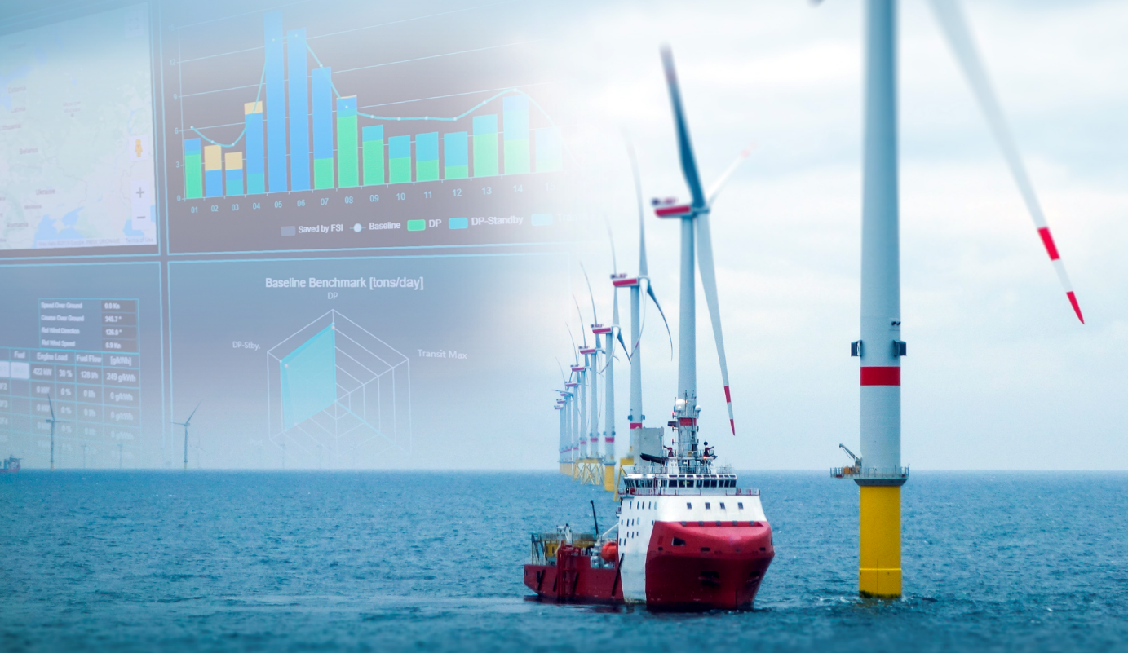
Yxney’s Maress digital management solution for decarbonizing maritime operations is now available to Kongsberg Digital’s Vessel Insight customers via the Kognifai Marketplace
Asker, Norway, March 8th, 2021 – Kongsberg Digital and Yxney, an energy efficiency specialist who helped customers achieve combined savings of more than 60,000 tonnes of CO₂ in 2020, have teamed up to offer shipowners and operators a unique tool for fleet energy management. Their Maress application will be available for all Vessel Insight users on the Kognifai Marketplace from March 8th, 2021.
Yxney’s Maress application is a digital management solution for decarbonizing maritime operations, providing vessel owners and operators with the insight they need to reduce fuel consumption and emissions. Maress facilitates transparency and a new way of collaborating towards industry emission targets by establishing a unique baseline for each vessel in a fleet, based on historic performance for every activity on board. This baseline, teamed with real-time data from the operations of each vessel and the entire fleet, enables Maress to make analyzing the effect of energy saving initiatives and programs much easier.
As of January 2021, approximately 300 vessels are already using Maress within the offshore and shipping segments. Yxney has experienced rapid growth over the past few years, demonstrated by an approximately 100 percent increase in its customer base from 2019 to 2020. This rapid growth suggests an increasing demand for data-driven solutions that reduce fuel consumption, costs, and environmental impact for shipowners and energy companies.
“We are very excited to partner up with Yxney,” says Eirik Næsje, Senior Vice President of Vessel Insight, Kongsberg Digital. “The concept of Yxney brilliantly challenges the dichotomy between reducing environmental footprint and cutting costs, and offers a service that’s been highly called for in the industry. We can now offer our subscribers a powerful tool to improve their understanding of vessel energy consumption and to capitalize on operational data. With the driving forces towards meeting IMO2030, IMO2050 and continuously stricter regulations, it is a much-needed application that will increase the business value of Vessel Insight for its users.”
The partnership will add great value to all users of Vessel Insight, KONGSBERG’s SaaS-based vessel-to-cloud data infrastructure solution. Vessel Insight captures and aggregates quality data in a cost effective and secure way, providing instant and easy access to fleet overview, vessel specific dashboards and data analysis tools. In addition, through the Kognifai Marketplace, customers have access to a large range of applications and services – now including Yxney’s Maress – that can offer further synergies and unlock immediate benefits. By being part of the Kognifai Marketplace, Yxney can reach more customers in need of their solution.
“We see KONGSBERG as a leader in maritime technology and navigational systems. Vessel Insight and Kognifai enable KONGSBERG systems installed on thousands of vessels worldwide to send data to the cloud. The partnership between Kongsberg Digital and Yxney enables Maress to utilize the data from KONGSBERG systems onboard the vessels to deliver visualizations and transparency on data related to sustainability. With this partnership KONGSBERG, Yxney and their customers can set sail to drive change in the maritime industry for a sustainable future,” says Yxney CEO, Gjord Simen Sanna.
The partnership was signed by Yxney Maritime and Kongsberg Digital on January 27th, 2021 and the Yxney Maress application will be available on the Kognifai Marketplace on March 8th, 2021.
Ends

For further information, please contact:

Mathilde Vik Magnussen
VP Communications & Marketing
Kongsberg Digital
Tel: +47 456 78 255
mathilde.magnussen@kdi.kongsberg.com

David Pugh
Saltwater Stone
Tel: +44 (0)1202 669244
d.pugh@saltwater-stone.com
Sindre Stemshaug Bornstein
Chief Commercial Officer
Yxney Maritime AS
Tel: +47 977 50 023
sindre@yxney.com

About Kongsberg Digital
Kongsberg Digital is a provider of next-generation software and digital solutions to customers within maritime, oil and gas, and renewables and utilities. The company consists of more than 500 software experts with leading competence within the internet of things, smart data, artificial intelligence, maritime simulation, automation and autonomous operations.
Kongsberg Digital is subsidiary of KONGSBERG (OSE-ticker: KOG), an international, knowledge-based group delivering high-technology systems and solutions to clients within the oil and gas industry, subsea, merchant marine, defence and aerospace. KONGSBERG has 11,000 employees located in more than 40 countries.
Web: Kongsberg Gruppen | Kongsberg Digital
Social media: LinkedIn | Twitter | Facebook
About Yxney Maritime
Yxney Maritime is a Norway-based software provider for data-driven decarbonization in maritime operations. Data analytics is at the core of Yxney’s activities, and the Maress cloud-service has been adopted by some of the most advanced vessel owners and energy companies in the world. Maress contributes directly to significant customer emission reductions.
Web: Yxney Maritime

