Epson announces launch of its most versatile 3LCD laser projectors with interchangeable lenses

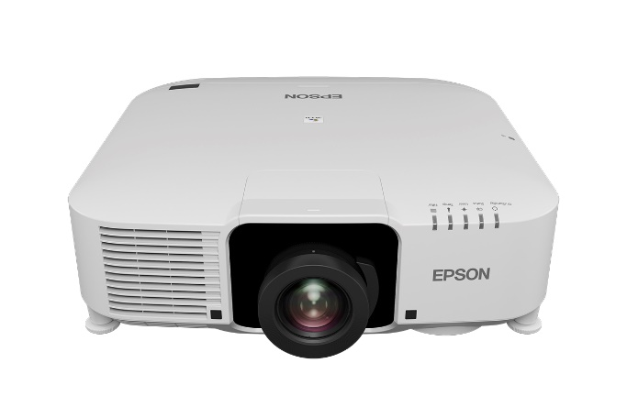

Epson EB-L1070UNL and EB-L1060UNL projectors

Malaysia, 21 November 2019 – Epson, the world’s leading projector manufacturer, announced its new range of 3LCD laser installation projectors, the EB-L1060UNL and EB-L1070UNL, which are Epson’s most versatile installation projectors complete with 4K enhancement and supporting interchangeable lenses, for public displays, conference and lecture halls.

The projectors come with an inconspicuous, clean-lined design, a smaller footprint and quieter fan noise, ensuring they fit seamlessly into a wide variety of environments, from visitor attractions to lecture theatres, museums to meeting rooms.

Each projector is available as ‘body only’ which provides the user with a wide choice of optional lenses, making this Epson’s most versatile projector. This flexible approach enables the user to fit the most appropriate lens for any given scenario. There are 12 interchangeable Epson lenses available, covering short to long throw projection, including the ELPLX01W white ultrashort throw lens with zero lens offset, suited for narrow spaces and rear-projection applications.

The EB-L1070UNL and EB-L1060UNL produce impressive laser image quality and create rich colours, high contrast, clear whites, defined shadow detail and deep blacks for outstanding images. These are achieved through WUXGA resolution, 4K enhancement technology, laser light source technology, up to 7,000 lumens, high colour light output, 3LCD technology and contrast of over 2,500,000:1.

Installation is easy and their fit-and-forget reliability means they can be positioned even in hard-to-access areas with confidence. They also benefit from 360-degree installation flexibility and are quieter and lighter than the previous series. Once fitted, these laser
projectors are maintenance free for 20,000 hours.

With the Epson projector management tool, users can monitor and control all Epson projectors in the network, enabling monitoring of up to 2,000 projectors. This includes monitoring of projector temperature and updating of firmware via network and scheduling.

“These new range of installation laser projectors is a welcome addition to our already impressive line-up. Their powerful, detailed output is complemented by a design subtlety that allows users greater installation flexibility and reliability. With an improved product design in terms of aesthetics and size, the new projectors bring greater versatility and ensure a seamless fit into a variety of premises,” said Daisuke Hori, Managing Director of Epson Malaysia.

***

About Epson
Epson is a global technology leader dedicated to becoming indispensable to society by connecting people, things and information with its original efficient, compact and precision technologies. The company is focused on driving innovations and exceeding customer expectations in inkjet, visual communications, wearables and robotics. Epson is proud of its contributions to realizing a sustainable society and its ongoing efforts to realizing the United Nations’ Sustainable Development Goals.

Led by the Japan-based Seiko Epson Corporation, the worldwide Epson Group generates annual sales of more than US$10 billion.
http://global.epson.com

About Epson Malaysia
Epson began operations in Malaysia in 1991 as Epson Trading (M) Sdn Bhd before being incorporated as Epson Malaysia Sdn Bhd. The company has the exclusive rights to market, distribute and support a complete range of leading-edge Epson consumer and business digital imaging products in Malaysia and Brunei. Today, Epson Malaysia has 84 employees and an extensive network of 61 authorised service outlets throughout the country. For more details, please visit www.epson.com.my or connect with us at www.facebook.com/EpsonMalaysia/.

For media enquiries, please contact:
Chua Li Tinn,
Marketing Communications Manager
Epson Malaysia Sdn Bhd
Tel: (03) 5628 8288 Ext 274
Email: ltchua@emsb.epson.com.my

LEWIS
Natasha Aida / Leong Ee Sa
Tel: +603 2716 5818
Email: EpsonMY@teamlewis.com

20,000H life for Laser light source: Approximate time until brightness decreases 50% from first usage. Measured by acceleration test assuming use of 0.04 - 0.20 mg/m3 of particulate matter. Time varies depending on usage conditions and environments. Replacement of parts other than the light source may be required in a shorter period.

