Ballstad, 9th of March 2016

Luer-Jack Lock patent granted - unscrewing with one hand!

The UK Intellectual Property Office granted 2nd of March 2016 the UK patent for Luer-Jack Lock. The patent is the frontrunner for similar filed applications (pending) in all important markets world wide and is a fundamental member of the Luer-Jack patent family, ensuring a very simple one-hand operated release of connections for different fluid transfer applications.

Luer-Jack Lock is a syringe with a threaded locking interface, and where the release of the threaded locking is done using a very simple trigger action.

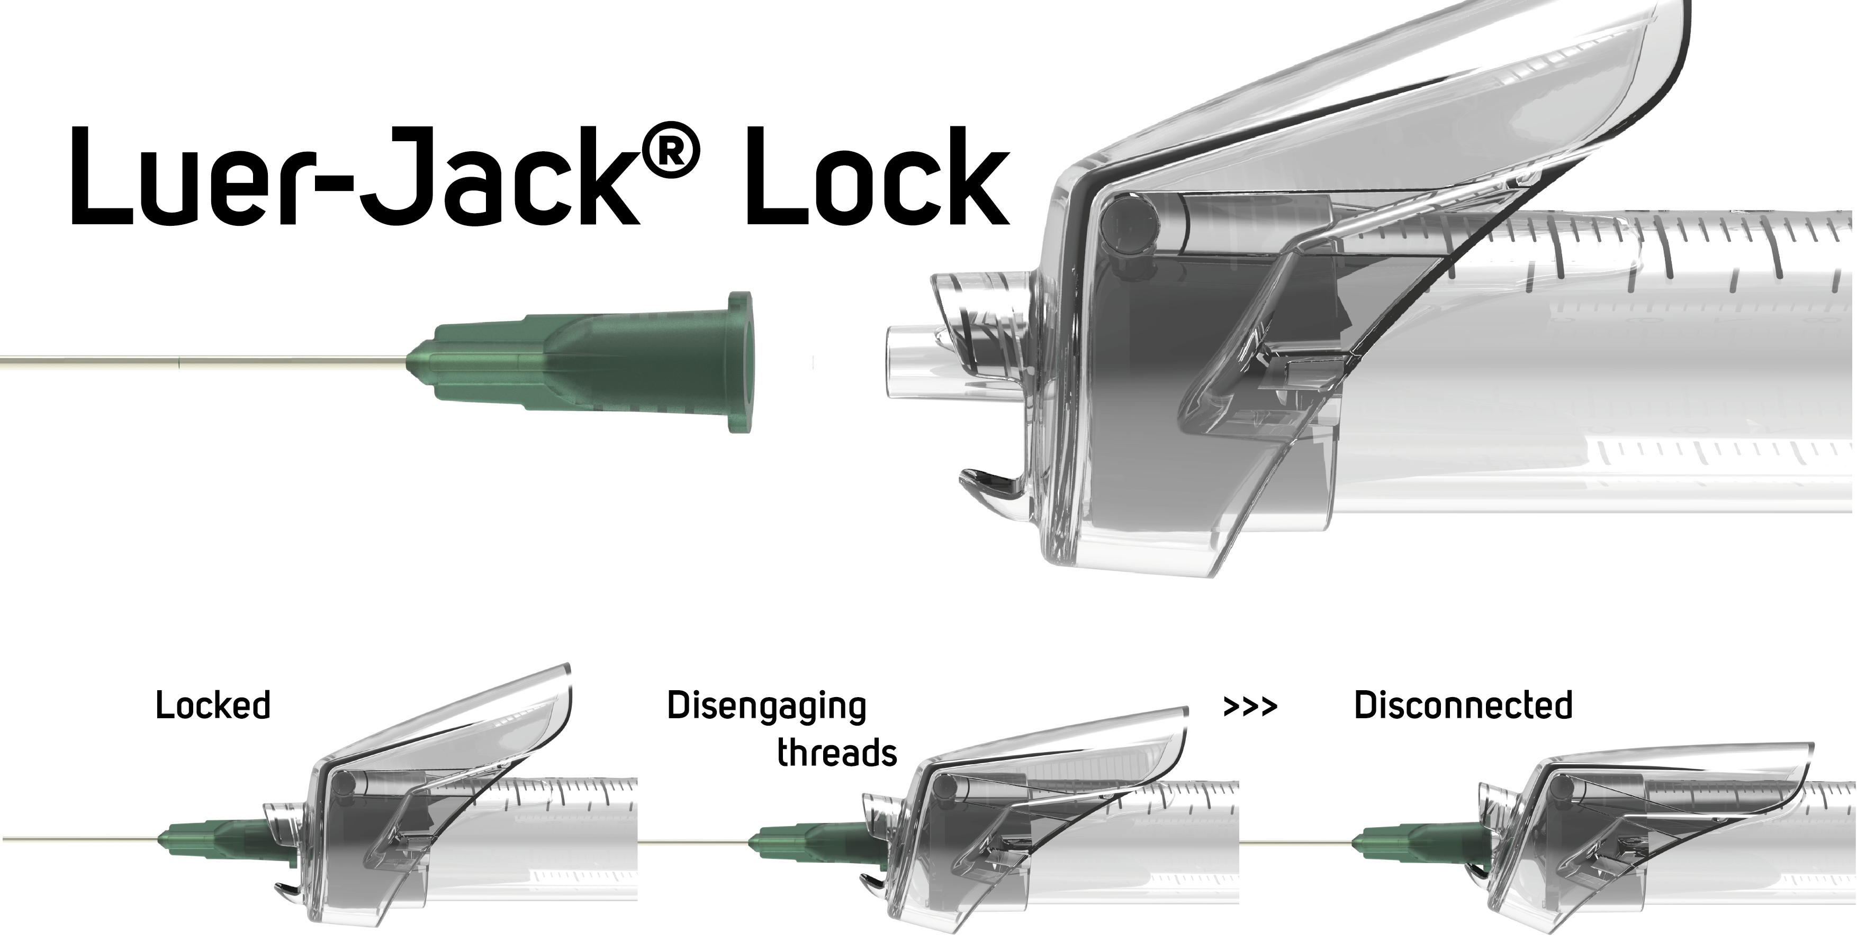
This will protect the concept of safeguarding high pressure fluid applications, as well as ensuring a very simple one-hand operated release of the connection for different fluid transfer applications.

One-hand release of connections safeguards against accidental contamination of micro critical aseptic parts and facilitates disconnection of contaminated sharps using only one hand. And the concept is compatible with the good, old and omnipresent Luer Slip and Luer Lock connections.

Luer-Jack market entry worldwide
ConceptoMed already holds the patent for Luer-Jack Slip and IP protection for both Slip and Lock applications will further fuel the market introduction of Luer-Jack in all markets world wide.

- Obviously, there are some historical implications in this grant. An extremely important luer lock connection concept just got even better. Twisting off tight connections with two-hand operation is quite different from one-hand trigger action - furthermore maintaining full compatibility with the more-than-a-century old luer standard. The Luer-Jack technology may be applied to any friction fit, screw fit connections. Medical is only one such area of application of the technology, where our IP provides coverage. Syringes with Luer-Jack is only the start, says CEO and M.D. Christian Mide.

ConceptoMed is committed to pursuing global distribution, and to offer an innovative addition to the traditional medical disposable syringe worldwide, and are now searching for additional eager-to-grow distribution partners worldwide.

Background
The 6% taper friction fit (luer) connection is the most common connector type used in medical settings. Tapered fittings ensure tight connections by allowing female hubs to bond with male tips by friction fit. The simple design creates a strong hold. It was invented in the 1890's and has been used predominantly in medical settings for over a century.

In 1930, the Luer Lock patent was granted to Mr. Fairleigh Dickinson (founder of Becton, Dickinson & Company) and comprises a combination of the taper friction tip with an internally threaded collar surrounding the tapered tip - to prevent accidental disengagement when used in high pressure applications.

Both traditional luer slip and luer lock applications are disengaged using two hands for the operation - with fingers in close proximity with critical aseptic parts and sharp objects of medical procedures.

