Kongsberg Digital acquires Danish maritime software company COACH Solutions

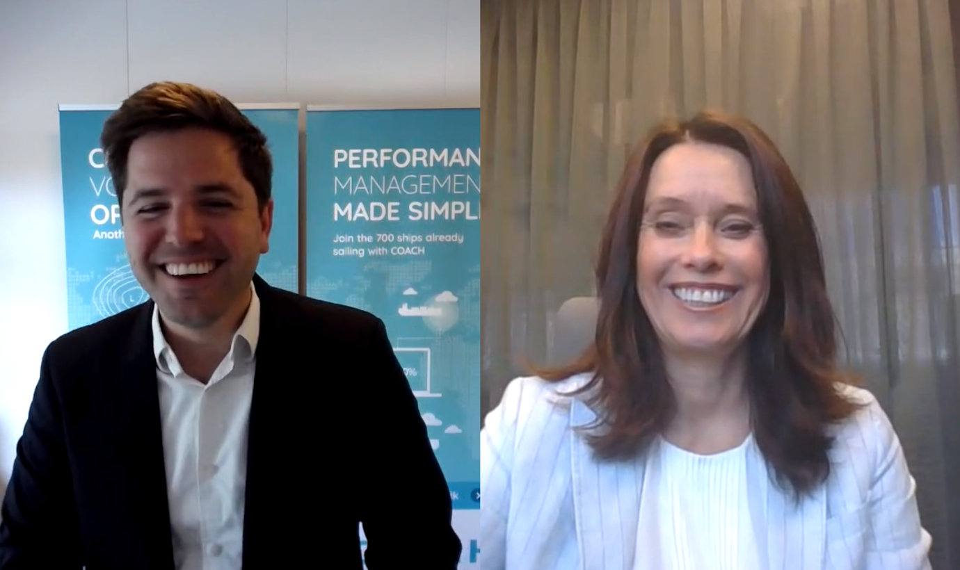
Anders Bruun (CEO, COACH Solutions) and Hege Skryseth (President, Kongsberg Digital) digitally sign the deal
Oslo/Copenhagen, July 1st, 2020 – Kongsberg Digital has acquired COACH Solutions, a leading supplier of software solutions for vessel performance and monitoring. The new name will be KONGSBERG COACH Solutions.
COACH’s vessel performance monitoring system was developed by Danish shipping company Clipper Group. In 2016 COACH was established as an independent company – COACH Solutions ApS – which has grown rapidly. Its software currently has over 900 licenses running.
COACH supplies vessel operators, owners, pool managers and technical managers with a suite of tools for vessel performance, weather routing and noon reporting. COACH’s solutions allow its customers to optimize energy consumption and receive constantly updated weather routing, assisting them in making large economic and environmental savings from their operations. The software tools are a natural fit with Kongsberg Digital’s maritime portfolio, and the addition of Kongsberg Digital’s resources and global network will accelerate COACH’s growth.
“The strength of COACH Solutions’ product offering is evident in their rapid growth. Their ability to deliver solutions that address the most urgent needs of their clients demonstrates the team’s insight into the customers’ pain points and level of digital maturity. COACH’s software is highly complementary to the portfolio of maritime digital solutions we offer and will be of strategic importance in our further development,” says Hege Skryseth, President of Kongsberg Digital.
“Joining Kongsberg Digital is a fantastic step forward for COACH, so we can continue delivering business value to our clients. Kongsberg Digital has an unrivaled ability to unlock the value of digital data with its Kognifai intrastructure. We at COACH very much look forward to joining the KONGSBERG family and being part of the journey of digitalizing the world fleet,” says Anders Bruun, CEO of COACH Solutions.
As part of KONGSBERG, KONGSBERG COACH Solutions will be integrated in Kongsberg Digital’s Maritime Digital Solutions portfolio, offering digitalization solutions to the maritime sector. The solutions will complement KONGSBERG’s Vessel Insight data infrastructure solution and the Kognifai Maritime Ecosystem.
“COACH Solutions completes our range of maritime digital solutions to the merchant marine market. COACH Solutions’ software is simple to install and use, giving customers key tools and a foundation on which to start their digitalization. We are happy to welcome the team onboard and look forward to working with KONGSBERG COACH Solutions as part of the KONGSBERG family,” says Vigleik Takle, SVP, Maritime Digital Solutions at Kongsberg Digital.
”We are pleased to have been the early developer of COACH,” says Peter Norborg, Group CEO, Clipper Bulk A/S. “Based on continuous input from our organization COACH has developed one of the industry’s leading software solutions for optimizing vessel performance and routing. But software development is not a core competence for Clipper, and we are glad that, in KONGSBERG, COACH will have a dedicated, long-term, technology-focused owner who can accelerate COACH’s development and deployment.”
The acquisition was finalized on 30th June 2020.
Ends

For further information, please contact:

Mathilde Vik Magnussen
VP Communications & Marketing
Kongsberg Digital
Tel: +47 4567 8255
mathilde.magnussen@kdi.kongsberg.com

David Pugh
Saltwater Stone
Tel: +44 (0)1202 669244
d.pugh@saltwater-stone.com

About Kongsberg Digital
Kongsberg Digital is a provider of next-generation software and digital solutions to customers within maritime, oil and gas, and renewables and utilities. The company consists of more than 500 software experts with leading competence within the internet of things, smart data, artificial intelligence, maritime simulation, automation and autonomous operations.
Kongsberg Digital is subsidiary of KONGSBERG (OSE-ticker: KOG), an international, knowledge-based group delivering high-technology systems and solutions to clients within the oil and gas industry, subsea, merchant marine, defence and aerospace. KONGSBERG has 11,000 employees located in more than 40 countries.
KONGSBERG COACH Solutions optimizes vessel performance through monitoring and analysis. We keep operators updated throughout the voyage with unified reporting and energy deviation alerts. COACH Solutions is a complete solution for Noon-Reporting, Vessel Performance & Weather Routing.
Web: Kongsberg Gruppen | Kongsberg Digital | COACH Solutions
Social media: LinkedIn | Twitter | Facebook

