MEDIA RELEASE

Inclusion Seminar Presented Positive New Findings
That Impact Corporate Culture & Performance
Eight Business Leaders and Inclusive Hiring Champions Discussed
The Business Case For Hiring Inclusively and the Available Supports

October 2, 2019, Singapore – Pan Pacific Hotels Group, along with co-organisers United Overseas Bank and SG Enable, hosted an Inclusion Seminar this morning, titled “Moving from Corporate Social Responsibility to Corporate Strategy”, graced by Guest-Of-Honour Mr Chan Chun Sing, Minister for Trade and Industry.

The seminar examined and discussed the overall impact of inclusive hiring on corporate culture and performance, moving it beyond the typical lens of corporate social responsibility. Supported by Ministry of Manpower and Ministry of Social and Family Development, the seminar saw close to 300 senior executives from private sector corporations and the non-profit sector in attendance.

Leading the seminar was keynote speaker Professor Elijah Wee, Assistant Professor of Management at Foster School of Business, University of Washington. Professor Wee collaborated with Pan Pacific Hotels Group (PPHG) on a six-month study to investigate the ripple effects of inclusive hiring on employee’s attitudes, behaviours, and ultimately, its impact on organisational culture and company performance over time. The research included over 1,000 employees across all organisational levels from PPHG’s corporate office and properties in Singapore.

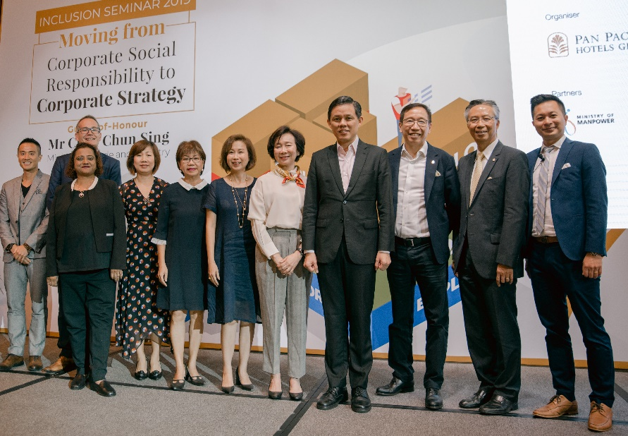
Dr Marvin Tan, Group Executive Director, Adera Global Group of Companies (extreme left), Mr Grant Spooner, Managing Director, APAC Employment Law Lead and Singapore I&D Sponsor for Persons with Disabilities, Accenture, Ms Pratima Amonkar, APAC Area Head, ISV Partners and Microsoft’s Diversity & Inclusion Council Lead on Accessibility, Microsoft, Ms Ku Geok Boon, Chief Executive Officer, SG Enable, Ms Denise Phua, President, Autism Resource Centre and Mayor, Central Singapore District, Ms Susan Hwee, Managing Director and Head Group Technology & Operation, United Overseas Bank, Ms Wee Wei Ling, Executive Director, Asset, Lifestyle and Corporate Social Responsibility at PPHG, Mr Chan Chun Sing, Minister for Trade and Industry, Mr Liam Wee Sin, UOL Group Chief Executive, Mr Cheo Peng Sum, PPHG Chief Executive Officer, Professor Elijah Wee, Assistant Professor of Management at Foster School of Business, University of Washington.

Professor Wee’s research findings revealed that PPHG’s inclusive hiring policy yielded positive outcomes at the employee and organisational levels when it is accompanied by experiential and reflection activities which reframe disability as a strength and help employees sense make the implication and meaning of the policy in their day-to-day work. As a result, significantly higher levels of compassion, organisational pride and proactive customer service were observed, among other indicators. The research also showed that compassion is a strong predictor of the company’s financial performance.

Moderated by Michelle Martin, Radio Show Host on MONEYFM89.3, the panel discussions which ensued expanded on the impact of inclusive hiring on company performance and saw insightful contributions and practical initiatives on how companies embarked on their respective journeys. Giving their valuable perspectives and learnings as panellists were Ms Denise Phua, President, Autism Resource Centre and Mayor, Central Singapore District; Ms Ku Geok Boon, Chief Executive Officer, SG Enable, along with business leaders from United Overseas Bank (UOB), Accenture, Adera Global (Datapost), Microsoft and PPHG. The presence of representatives from both the public and private sectors provided a balanced view and articulated the importance of collaboration between them.

PPHG and Co-Organisers Walk the Talk and Champion Inclusive Hiring Initiatives

Taking the lead in encouraging private sector companies to align inclusive practices with corporate strategy to strengthen their competitive advantage, this is the second inclusion seminar presented by PPHG together with UOB and SG Enable, after a successful inaugural seminar in 2017.

PPHG was the first hotel employer which participated in SG Enable’s Project IN, a School-to-Work transition programme, back in 2017, and has since developed a structured recruitment and training process for associates with disabilities. Today, PPHG has 16 persons with disabilities in employment across its Singapore hotels and serviced suites, with another 12 undergoing training.

Ms Wee Wei Ling, Executive Director, Asset, Lifestyle & Corporate Social Responsibility, PPHG, said, “Our mission is to create a caring culture where colleagues are not just passionate about their work, but compassionate towards one another. We have learned through the years that inclusive hiring has not only nurtured greater compassion and teamwork in the workplace, but also made a transformative impact in the lives of those we hired and their families. This is most rewarding and heartening to us.”

UOB has also been a long-term champion of inclusive hiring, initially through the UOB Scan Hub and more recently through ‘The Unlimited’, the first inclusive hiring collaboration among the private, public and people sectors in Singapore, bringing together SG Enable, Autism Resource Centre, Movement for the Intellectually Disabled of Singapore (MINDS) and SPD to promote sustainable employment for persons with disabilities.

Ms Susan Hwee, Head of Group Technology and Operations, UOB said, “As an organisation that champions inclusive hiring, we recognise that many business leaders face challenges in building an inclusive workforce that is sustainable and scalable. Through ‘The Unlimited’, we help businesses to see the value in providing meaningful employment for persons with special abilities and to develop their capabilities in inclusive hiring through training and support from public sector partners. We encourage more businesses to tap these opportunities to build a more stable workforce with diverse skills and perspectives.”

Under The Unlimited, UOB acts as the private sector catalyst for inclusive hiring, engaging companies to raise their awareness and to generate interest in the hiring of persons with disabilities. The Bank also assists interested organisations with enquiries on inclusive hiring and connects them to SG Enable, which will in turn work with ARC, MINDS, and SPD to provide job placement advice. Companies interested in hiring persons with disabilities can find out more about inclusive hiring through UOB’s dedicated website – uob.com.sg/TheUnlimited.

“We are delighted to co-organise this Inclusion Seminar with Pan Pacific Hotels Group and UOB, two corporates in the private sector that champion inclusive employment. When disability inclusion is part of a company’s corporate strategy, it can gain benefits and persons with disabilities can contribute meaningfully to the company’s performance. SG Enable looks forward to working with businesses to build their capabilities in hiring persons with disabilities and put in place practices that enable them to be contributing members of the workforce,” said Ms Ku Geok Boon, Chief Executive Officer, SG Enable.

-ENDS-
For media queries, please contact:
Kit Pui LEE
Vice-President, Brand Marketing & Communications
Pan Pacific Hotels Group
DID: +65 6808 1256
M: +65 9437 5973
E: lee.kitpui@pphg.com
Zhu Jiahui
Executive, Brand Marketing
Pan Pacific Hotels Group
DID: +65 6808 1257
M: +65 9627 6913
E: zhu.jiahui@pphg.com

About Pan Pacific Hotels Group
Pan Pacific Hotels Group is a wholly-owned hotel subsidiary of Singapore-listed UOL Group Limited, one of Asia’s most established hotel and property companies with an outstanding portfolio of investment and development properties.
Based in Singapore, Pan Pacific Hotels Group owns and/or manages 40 hotels, resorts and serviced suites with more than 12,000 rooms including those under development in Asia, Oceania, North America and Europe.
Voted “Best Regional Hotel Chain” by readers in Asia in 2017 and 2018, Pan Pacific Hotels Group comprises two acclaimed brands: its signature brand, Pan Pacific and its deluxe brand, PARKROYAL.
Sincerity is the hallmark of Pan Pacific Hotels Group. The Group is known to its guests, partners, associates and owners for its sincerity in people and the sense of confidence which alleviates the stresses of today’s complex world.

UOB Scan Hub – the Bank’s nerve centre for checking, digitisation and archiving of customer documents – employs people with autism or deaf persons for their special abilities such as attention to detail and high levels of concentration and accuracy.

