Iconic Malaysian Designer Melinda Looi Showcases Epson Digital Textile Printing For KL Fashion Week 2017

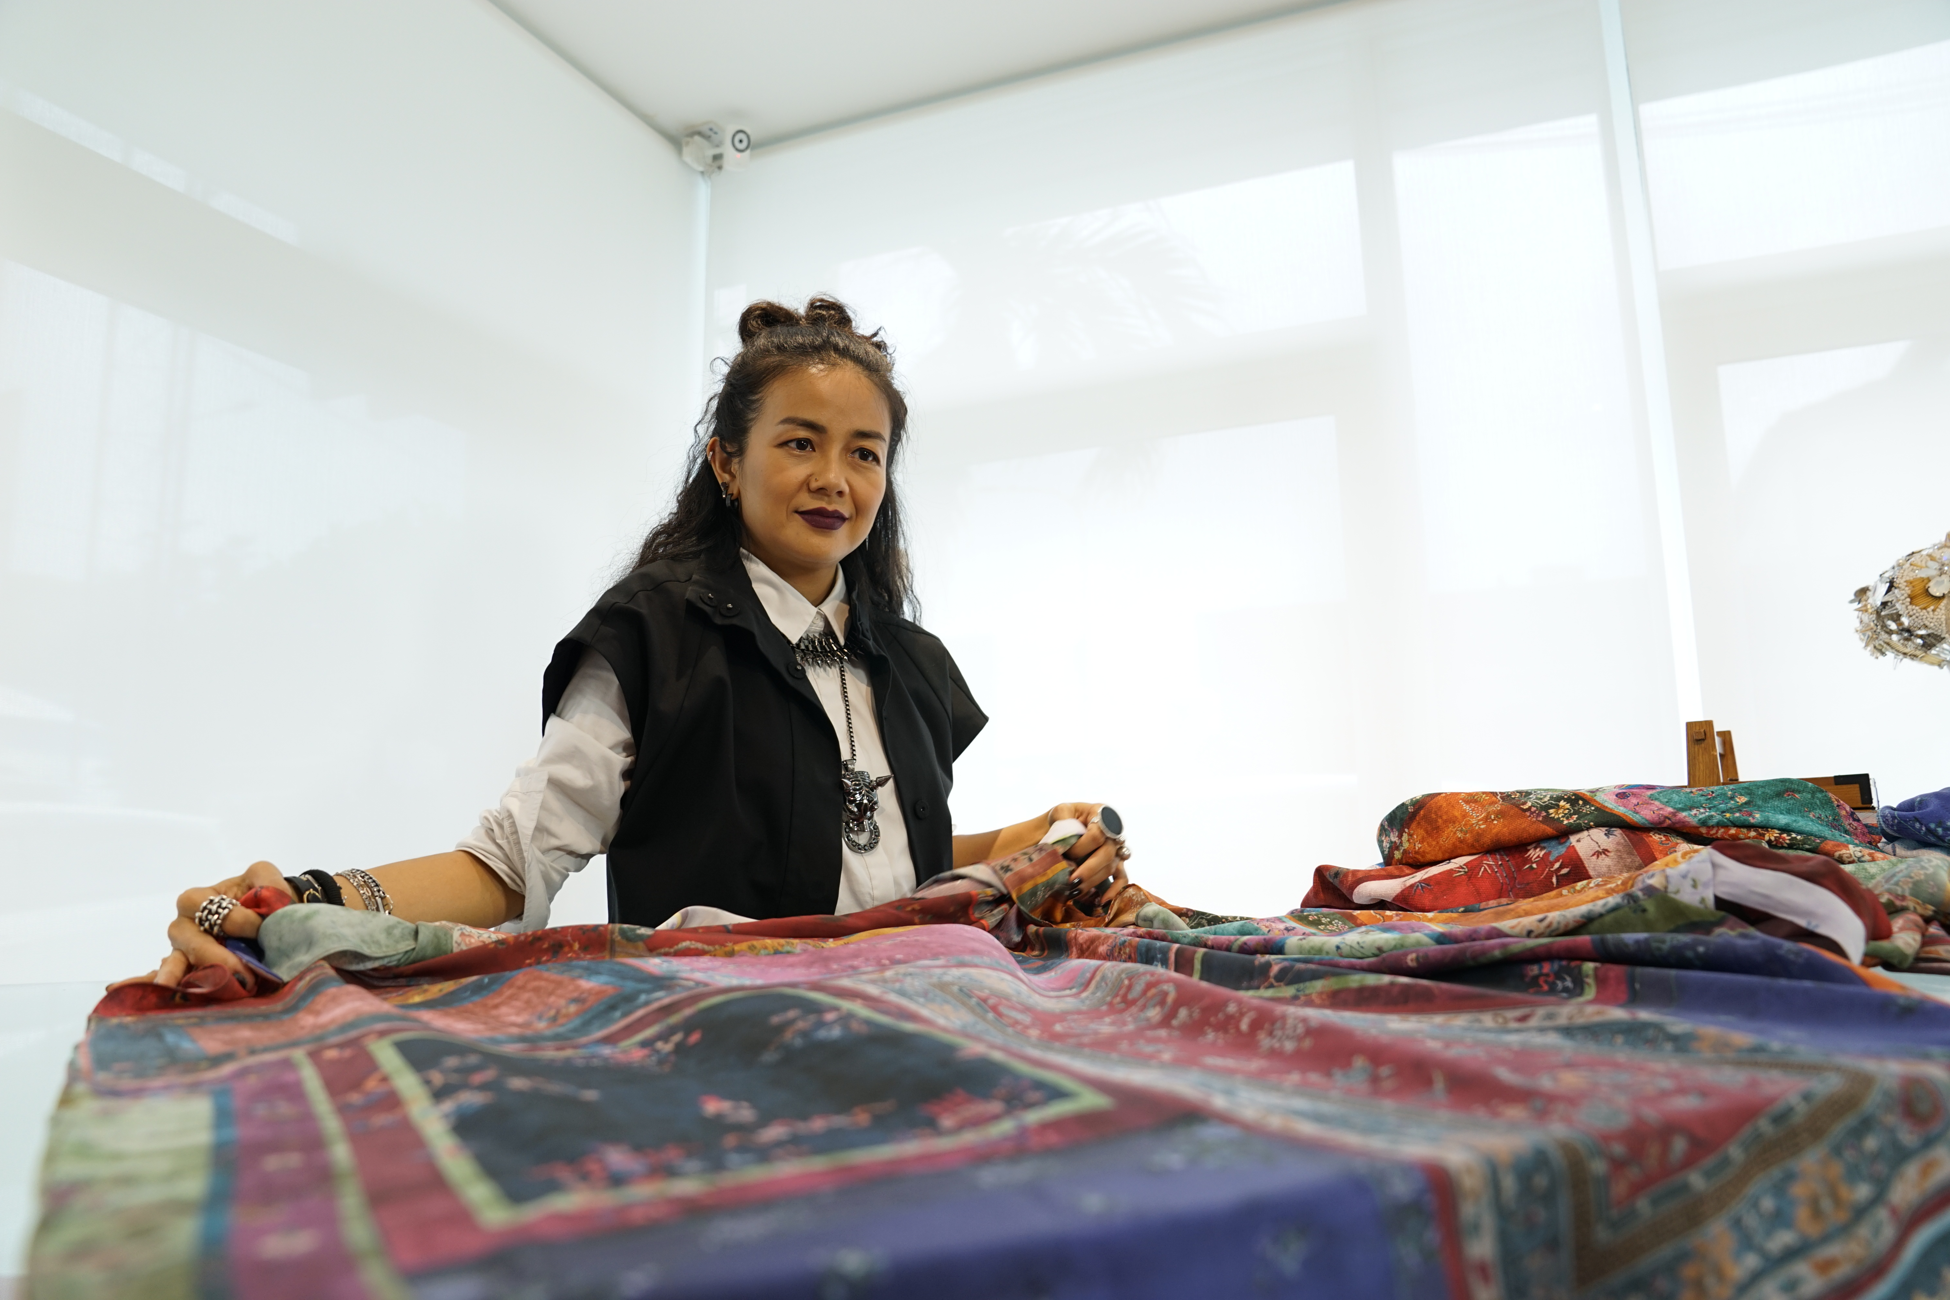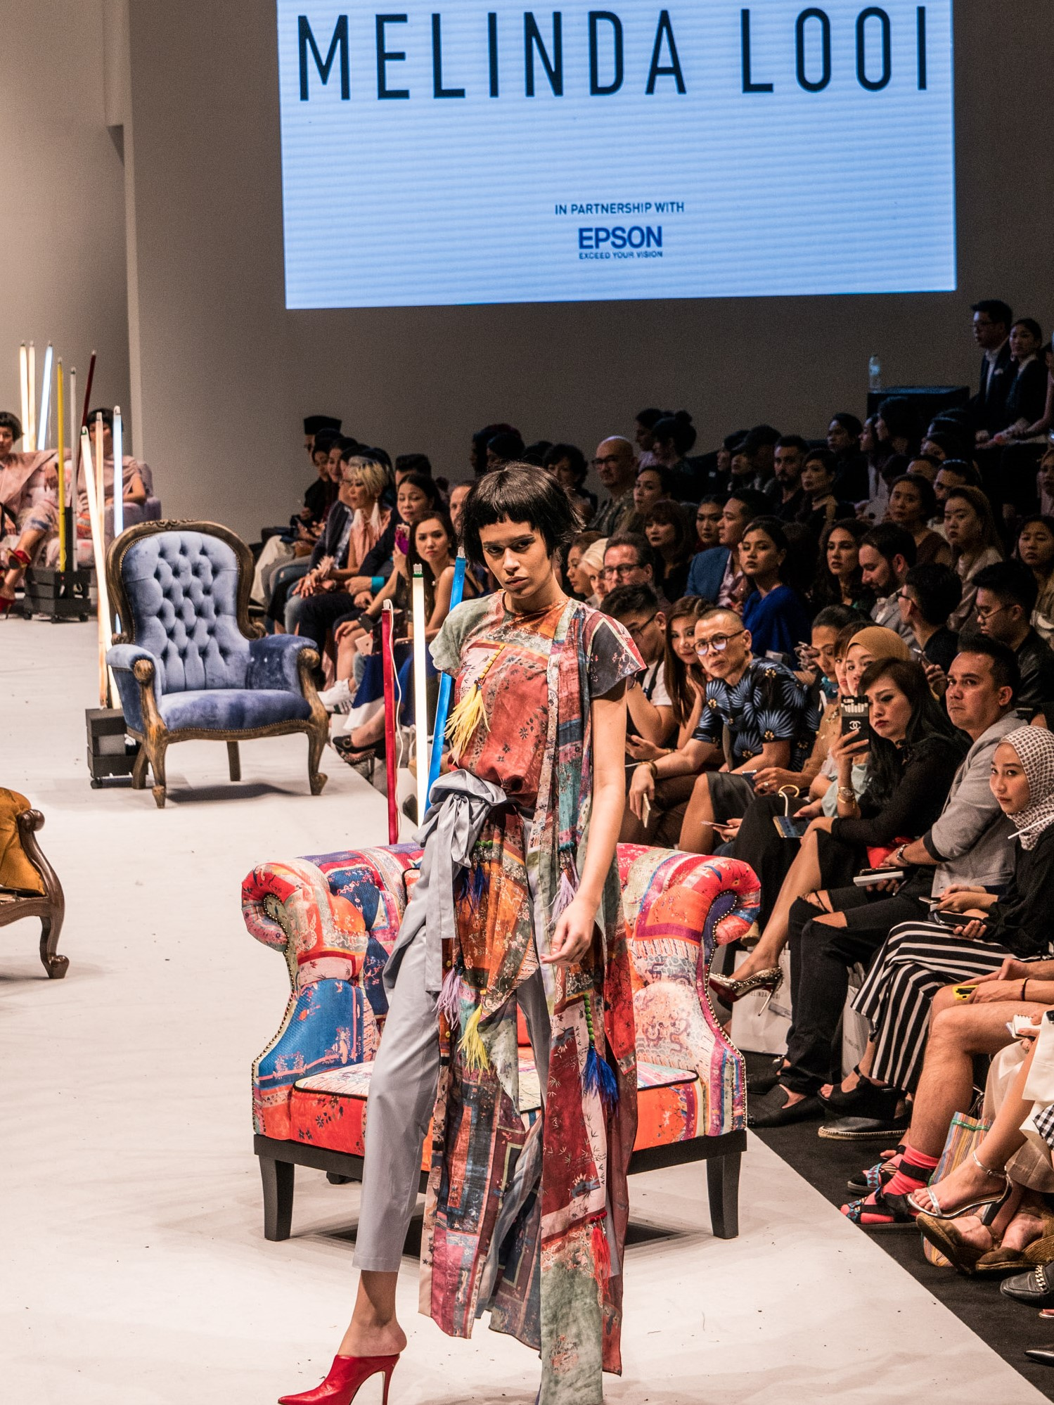

Kuala Lumpur, Malaysia, August 21, 2017 – One of the most influential, iconic and award-winning fashion designers in Malaysia and the region, Melinda Looi and Epson Malaysia (www.epson.com.my) – a global leader in digital imaging and printing solutions, came together on the runway of the Kuala Lumpur Fashion Week (KLFW) 2017 to showcase an innovative collaboration – THE INTERIORS.

Drawing inspiration from the decorative elements and components of interior space, THE INTERIORS collection looks at the curation of space with an eclectic mix of textures, patterns and colours. What makes this collection even more special is the use of Epson’s digital textile printing for the 20 creations in Melinda Looi’s 2018 collection that was first showcased at the KLFW 2017.

Not a stranger to using technology for her creations, Melinda Looi has been called a tech-savvy fashion brand out of Asia. Therefore, it’s only natural that she wants to continue to add personal touches such as her paintings into her collection, which is why Epson came as a viable partner for her 2018 ready to wear collection.

Designed to produce high quality colour artwork that can be transferred onto textiles, Epson SureColor F-series digital textile dye sublimation printer was used by the Melinda and her creative team, to try out new, different designs, colours and effects on textile. It gave her a wide range of flexibility and speed in trying out new print ideas, without the exorbitant cost and time consuming mould or frame-making that is required for conventional textile printing.

Speaking more about how technology makes all these creative impulses possible, Melinda said: “I believe that technology adds an incredible advantage to apply innovation in the fashion industry. A number of different technologies are currently being experimented with, such as 3D printing and I did launch Asia’s first 3D printed fashion collection back in 2013. We even have e-textiles nowadays, with circuits built into it.”

Addressing the big trend in the fashion industry, which is ‘see now, buy now’, Melinda believes that digital printing makes this much easier. “We do not have to print thousands of meters of fabric, only what is needed, when is needed. In fact, I am most impressed with the quality of prints by Epson’s digital textile dye sublimation printers, which is very clear, beautiful and durable on a wide range of textiles and surfaces we tried it on.”

Danny Lee, General Manager, Sale & Marketing, Epson Malaysia adds: “Working with Melinda Looi, who is known for her signature avant-garde style and her penchant for marrying prints into design, was perfect to showcase the versatility and capabilities of Epson’s digital textile printers and the opportunities it brings to the fashion industry”

“This collaboration continues our efforts from last year when we collaborated in a similar fashion with Zang Toi at the Malaysia Fashion Week 2016. As a leader in digital textile printing we want to support the creative industry in Malaysia to easily materialize any possible idea into a reality, and potentially, a business opportunity too.” add Danny.

Seeing the capabilities of the Epson SureColour range of printers, Melinda said that it is especially ideal for Couture, which require bespoke, one-off designs. “There is no alternative to digitally printed fabrics if you really want unique prints.”

Digital printing shortens turnaround time and enables printing in small volumes for customised prints, compared to traditional printing techniques, which require high volumes and long lead times. As a result, digital printing helps designers such as Melinda Looi achieve their artistic vision by translating their ideas to a range of fabrics quickly, easily and at the highest quality.

Epson SureColor F-series dye sublimation printers use Epson’s proprietary technology known as Micro Piezo™ and PrecisionCore™ TFP head technology. The Micro PiezoTM printheads, unlike thermal inkjet systems, eject droplets of ink via mechanical pressure and do not use heat, making it compatible with a far wider variety of inks and mediums. By precisely controlling the volume of ink contained in each droplet of ink, Epson Micro PiezoTM printers not only generate virtually no wasted ink, they also ensure that sharp, rich and virtually grain-free images are rendered at all times.

To find out more about Epson’s digital textile printing, visit: https://pro.epson.asia/

***
About Melinda Looi
Melinda Looi’s talents earned her a scholarship at the La Salle School of Fashion in Montreal, Canada, where she honed her craft. It was her graduation collection in 1995 that captured the public imagination, and earned her the Malaysia Young Designer Award 1995 in Kuala Lumpur.

Since then, there has been no looking back. Melinda’s creative spirit has been recognised through local and international awards, foremost of which is the prestigious Designer of the Year Award at the Malaysian International Fashion Awards 2004 and 2006, and once again in 2009 at the Mercedes Benz STYLO Fashion Awards. Among her latest accomplishments was an award for Sport and Art Trophy from the International Olympic Council, Switzerland, and the honour of being selected as a Malaysian representative at the 2014 World Fashion Week, Paris, where one of her couture pieces was showcased as part of the World Fashion Exhibition that appeared at various international fashion weeks.

Melinda Looi designs for one and all, thus she presents a diverse range of brands catering to different clientele and occasions. These lines are Melinda Looi Couture (bespoke tailoring), Melinda Looi (ready-to-wear for day to night) and emel by Melinda Looi (modest occasion wear diffusion line).

Besides her own fashion labels, Melinda is passionately involved in numerous collaborations, ranging from charities and eco-friendly events to art projects, as well as collaborations with international brands and corporations such as Swarovski, L'Oréal, Levi's, The Body Shop, TUMI and many others.

About Epson
Epson is a global technology leader dedicated to connecting people, things and information with its original efficient, compact and precision technologies. With a lineup that ranges from inkjet printers and digital printing systems to 3LCD projectors, smart glasses, sensing systems and industrial robots, the company is focused on driving innovations and exceeding customer expectations in inkjet, visual communications, wearables and robotics.
Led by the Japan-based Seiko Epson Corporation, the Epson Group comprises more than 72,000 employees in 88 companies around the world, and is proud of its contributions to the communities in which it operates and its ongoing efforts to reduce environmental impacts.
http://global.epson.com/

About Epson Southeast Asia
Since 1982, Epson has developed a strong presence across major markets in Southeast Asia. Led by the regional headquarters Epson Singapore, Epson’s business in Southeast Asia spans an extensive network of 11 countries with a comprehensive infrastructure of close to 500 service outlets, 7 Epson solution centres and 7 manufacturing facilities. http://www.epson.com.sg

About Epson Malaysia
Epson Malaysia Sdn Bhd was established in Malaysia in 1991 as Epson Trading (M) Sdn Bhd, a sales company of the Seiko Epson Corporation, Japan. The company has exclusive rights to market, distribute and support a complete range of leading-edge Epson consumer and business digital imaging products in Malaysia and Brunei. Today, Epson Malaysia has 84 employees and an extensive network of 59 authorised service outlets nationwide. For more info, please visit www.epson.com.my or connect with us at www.facebook.com.my/EpsonMalaysia

Media Enquiries:
Epson Malaysia Sdn Bhd  Chua Li Tinn  Manager – Marketing Communications  Tel: (03) 5628 8288 Ext 274  Email: ltchua@emsb.epson.com.my | SWOT Communications Sdn Bhd  Edina Manuel  Tel: 012 2500142  Email: edina@swotcommunications.com

