Digital Yacht AIT3000 “Nucleus” Class B AIS
transponder debuts at Southampton Boatshow
A sophisticated Class B AIS transponder with built in antenna splitter and wifi interface
Launch at the Southampton Boatshow CA Clase (UK Distributor) Stand G147
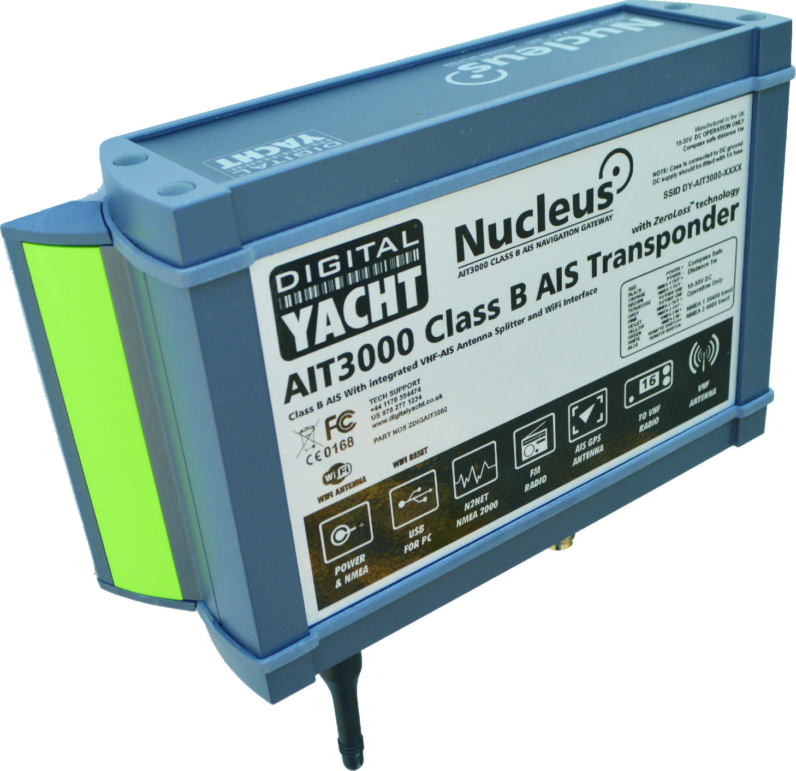
Class B AIS transponders have made a remarkable impact on small craft navigation but many potential users or installers are put off by the requirement for yet another VHF antenna.

The new AIT3000 “Nucleus” from Digital Yacht changes that perception as it incorporates not only a full function Class B AIS transponder but also an antenna splitter allowing the main VHF antenna on the boat to be shared with the AIS and VHF. It’s also been designed with the latest interfacing capability including NMEA 0183, NMEA 2000, USB and a WiFi server to allow tablets and iPads to connect – hence the name Nucleus as it becomes the hub for on board navigation. NMEA data from other on board systems can also be multiplexed by the Nucleus and combined on the WiFi link.

The Nucleus transponder is the World’s first to include patented ZeroLossTM technology for the antenna sharing and a wireless interface for iPad/tablet connectivity. More and more boat owners are utilising an iPad or tablet as either a primary navigation display or as a touch screen repeater for their existing navigation system. Digital Yacht also offer a free AIS viewing app called iAIS as well as more sophisticated charting apps like NavLink. If you’re an Android user, AISView is also compatible. The NMEA interface allows connection to any AIS compatible chart plotter and USB is available for MAC or PC user as well as allowing programming of the unit with your boat details.

Other features include a silence switch option allowing the unit’s transmissions to be stopped while continuing to receive AIS transmissions. It also has an output for a FM stereo radio. The Nucleus is available now and has a list price of £825 plus vat. Further details from Digital Yacht www.digitalyacht.co.uk or call 01179 554474

-Ends-
Digital Yacht – Note’s For Editors
An AIS transponder send your boat’s identity, position, course and speed to other vessels equipped with an AIS unit. This data can then be interfaced to a chart plotter display to present an overlay of targets with their heading information. It greatly aids navigation and helps with collision avoidance. Signals are transmitted over two dedicated VHF frequencies so typical range from a Class B unit is 10-20NM depending upon antenna height. All commercial ships over 300GRT are mandated to carry a Class A AIS transponder. Other users including yachtsmen can opt for the cheaper Class B type units like the Digital Yacht Nucleus. Class B units are fully integrated into the AIS system but have a lower 2W transmit power and only send their data every 30 seconds.

Digital Yacht is a UK based manufacturer of specialist marine electronics with offices in the UK, US and China and a global network of resellers in over 100 countries. We produce a range of innovative products including AIS receivers and transponders, WiFi servers for on board NMEA data, long range WiFi internet devices and a range of sensors including GPS and electronic compasses. Digital Yacht won the prestigious METS DAME Electronic Product Award for iAIS as well as the NMEA Technology Award for BOATraNet in 2011. The GPS150 was nominated for a DAME award at this year’s 2013 exhibition in November. Our blog at www.digitalyacht.net has a range of interesting White Papers on many aspects of marine technology.

For further information, please contact:

Nick Heyes Direct Line 0207 100 9116

Digital Yacht UK

The Technology Centre, Green Lane, Failand. BS8 3TR

TEL 01179 554474

www.digitalyachtamerica.com

