Digital Yacht’s GPS150USB DualNav GPS/GLONASS
sensor now delivers sub 1m accuracy for PCs and MACs

For immediate release: 19th March 2014
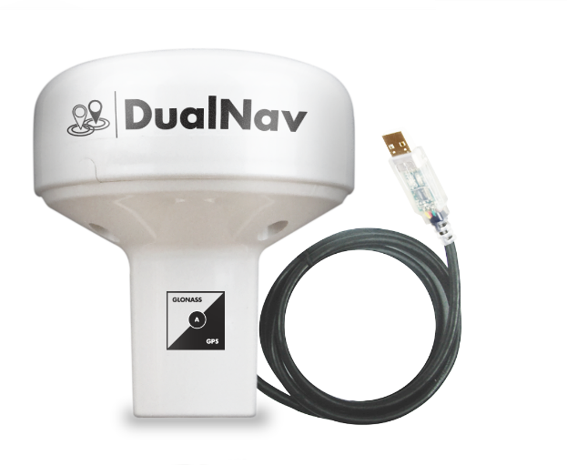
Digital Yacht has introduced a new variant of their DualNav GPS and GLONASS positioning sensor which utilises a USB interface for both data and power allowing direct connection to a PC or MAC. Called the GPS150USB, it’s designed for a growing group of boat owners who use a PC or MAC for electronic charting and navigation rather than a traditional plotter. There’s now a great selection of navigation software available including Digital Yacht’s SmarterTrack program which can utilise popular Navionic’s charts. It’s also ideal for use by charter skippers who want a self-contained, plug ‘n’ sail navigation solution.

DualNav is Digital Yacht’s proprietary technology which utilises GPS and the Russian funded GLONASS satellite systems for enhanced positioning. GLONASS is now global and operational 24 hours per day and like GPS, is free to use. By combining the signal from the two satellite systems you’ll get double reliability and also sub 1m accuracy from this new HD positioning sensor. The sensor can also be programmed to output data at 10Hz for smoother chart positioning and enhanced course and speed updates. It’s self-powered from the computers USB port which makes installation easy with no additional power required. With a sensitive 50 channel receiver design, it will work below decks on GRP boats and comes with a 5m cable for direct connection to the PC or MAC. Drivers are supplied for both operating systems. The GPS150USB is available now and is priced at £165 plus vat. Further details from Digital Yacht TEL 01179 55474 or visit www.digitalyacht.co.uk

-Ends-
Digital Yacht – Note’s For Editors
Digital Yacht is a UK based manufacturer of specialist marine electronics. We produce a range of innovative products including AIS receivers and transponders, WiFi servers for on board NMEA data, long range WiFi internet devices and a range of sensors including GPS and electronic compasses. Digital Yacht won the prestigious METS DAME Electronic Product Award for iAIS as well as the NMEA Technology Award for BOATraNet in 2011. The GPS150 (traditional NMEA version of the GPS150USB) was nominated for a DAME award at this year’s 2013 exhibition in November

For further information, please contact:

Nick Heyes (Direct Line + 44 207 100 9116)

Digital Yacht Ltd.The Technology Centre, Green Lane, Failand, Bristol. BS8 3TR. UK.
Telephone: +44 (0)1179 554474
Email: sales@digitalyacht.co.uk www.digitalyacht.co.uk

