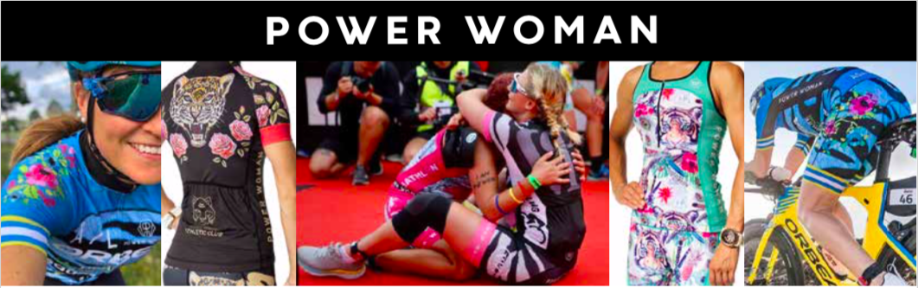
Power Woman Offers Sportswear on Loan Ahead of Races
In its efforts to promote women's health and encourage more people to find the joy in training, Team Power Woman Athletic Club now offers free use of Power Woman sportswear for two weeks.
Power Woman wants to encourage more people get into triathlon, but unfortunately, getting started comes at a rather high cost. This situation is something that the brand wants to amend by means of, for example, free exercise programs and free membership in its Athletic Club.
Team Power Woman Athletic Club is a free association where everyone is welcome – beginners and professionals alike. The only prerequisite for joining the club is that members have a good heart and are kind to their fellow women.
To further lower the bars for entry into the triathlon lifestyle, the brand has now taken the next step by offering second-hand Power Woman sportswear on loan ahead of and during races. Athletic Club members get to borrow and use the garments for two weeks – at no cost whatsoever other than postage. Users are also required to send the clothes back all clean after the race.
Everyone is welcome to join the club by registering at teampowerwoman.com and join the teams Facebook group.
Another, much appreciated, platform supported by the brand Power Woman is their Facebook group "<<pass your power forward>>” a second-hand market place, facilitated by the brand, where everyone is free to buy and sell Power Woman sportswear.

______________________________________________________________________________________
Power Woman
Power Woman is a Swedish high-end sportswear brand. Power Woman design sports apparel that are perfect for the female body and extensively tested by the world's top female athletes. The apparel combine fashion, fit and sports in one. Behind the brand stand entrepreneur and triathlete Anna Wretling who´s passion is to empower women through the brand and through the sports community Team Power Woman Athletic Club.
Team Power Woman Athletic Club – Non profit
Team Power Woman Athletic Club is a team of individuals whose drive, and main goal is to support each other. Founder, serial entrepreneur and triathlete Anna Wretling wanted to create a loving community where everyone always feels welcome. It’s not important if you are a professional or a beginner. ”- The only ”requirement” I have, is that we are kind to each other” says Anna.
A membership at Team Power Woman is free of charge, because we want everyone to have the opportunity to be a part of our team. Team Power Woman Athletic Club has +1100 members and are members of the Swedish National Sports Association, The Swedish Triathlon Association, The Swedish Cycling Federation and The Swedish Ski Federation. This allows you to compete with a license in our Team Power Woman Athletic Club.

Press Contact: Anna Wretling E-mail: press@powerwoman.com

Instagram Website Press Room Youtube
