Press release
Kongsberg Digital adds MarineInsight™ applications by ioCurrents to the Kognifai Marketplace

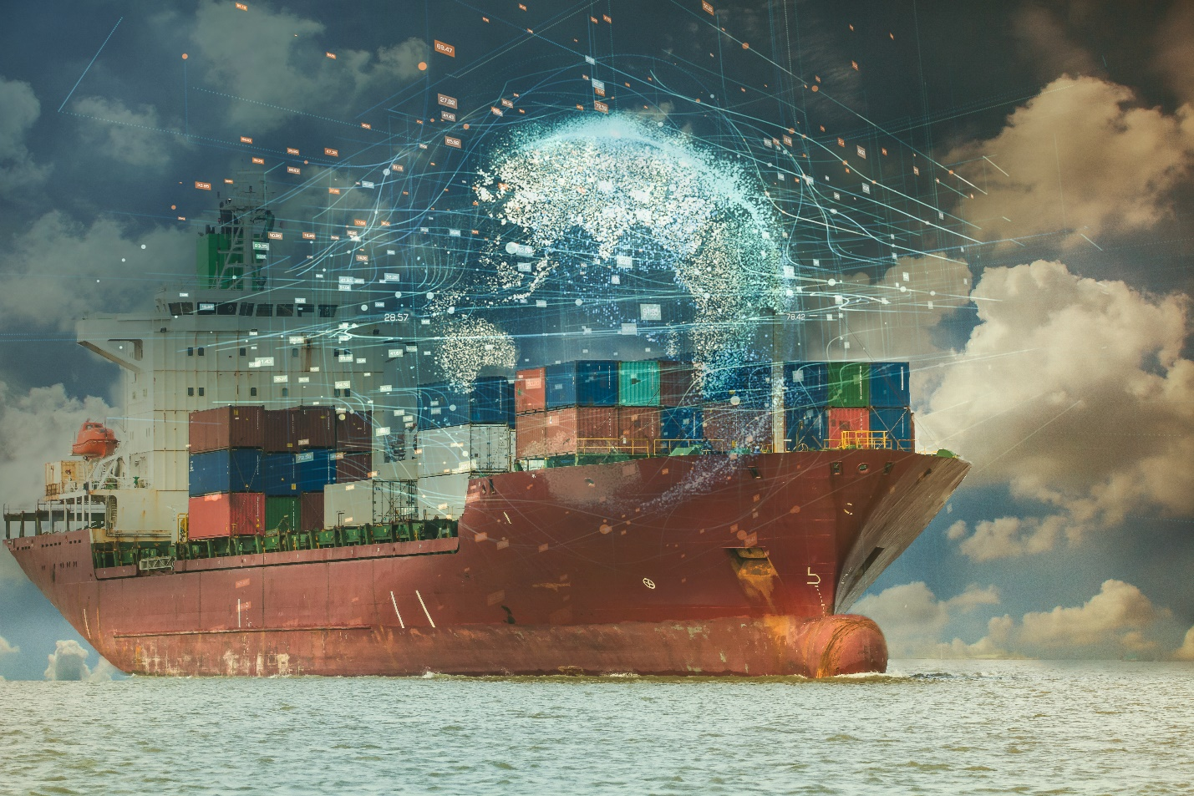
Three applications from MarineInsight™ by ioCurrents – Vessel Health, Automated Reports and Fuel & Emission Optimization – are now available to Vessel Insight subscribers via Kongsberg Digital’s Kognifai Marketplace

Kongsberg Digital are pleased to announce that they have signed a partnership agreement with MarineInsight™ by ioCurrents. The deal will make three new software solutions available to Vessel Insight subscribers via the Kognifai Marketplace: Vessel Health, Automated Reports and Fuel & Emission Optimization. The solutions will, respectively, assist in identifying engine failure through Machine Learning and Artificial Intelligence, create Automated Reports for all departments, and reduce fuel consumption based on proactive recommendations from automated data analysis.

“We are delighted to announce our partnership with ioCurrents and to offer Vessel Insight subscribers their solutions through the Kognifai Marketplace. The demand for solutions to predict failures, to optimize fuel and emissions, and to streamline reporting is increasing both for retrofits and newbuilds entering the market. The MarineInsight solutions can easily be adopted by our subscribers and can solve many problems already identified by our customers,” says Eirik Næsje, Senior Vice President of Vessel Insight, KDI.
MarineInsight is active in the workboat, OSV, bulk, tanker industries, and in other commercial and passenger maritime sectors around the globe. The company focuses on three core competencies, Vessel Health, Automated Reports and Fuel and Emission optimization.

- Vessel Health: By applying Machine Learning (ML) and Artificial Intelligence, MarineInsight provides proactive recommendations to identify failures before they occur. Powered by AI, MarineInsight establishes ML models by understanding the normal operating behavior of each unique vessel. These unique ML models then identify when subsystems are trending towards failure. This gives crews more time to identify failures and enables a proactive approach to preventing them, rather than reactively dealing with critical failures whilst in operation.

- Automated Reports: The InsightHub™ gives access to reports that can be used by all departments including Operations, Engineering and Maintenance, and Compliance and HSSQE. These automated reports reduce manual input by crews, increasing accuracy.

- Fuel and Emission Optimization: MarineInsight optimizes voyages by considering two variables: Time, and Fuel Rates. MarineInsight generates automated reports that provide proactive recommendations based on the fuel index to reduce fuel burn while not sacrificing schedules.

“Partnering with Kongsberg Digital has been a goal of ours for quite some time,” says Cosmo King, co-founder of ioCurrents. “We are confident that by leveraging AI and machine learning, our data analytics platform, MarineInsight, will benefit Kognifai’s Vessel Insight subscribers. MarineInsight will analyze the huge amounts of data coming from their vessels and will turn it into meaningful charts and dashboards, enabling factual decision making to improve individual vessel and fleet performance.”

The three applications from MarineInsight will be available to Vessel Insight subscribers on the Kognifai Marketplace from May 25th, 2021. Customers can activate the MarineInsight platform by sending authorization to KONGSBERG.

About Vessel Insight and the Kognifai Marketplace

There’s a strong push in the maritime industry towards digital transformation. Collecting data from all vital assets on ships is enabling shipowners to innovate and experiment with software applications to improve their operations more quickly.

Kongsberg Digital is offering shipowners a cost-efficient data infrastructure solution, called Vessel Insight. By subscribing to Vessel Insight, shipowners and operators enable their vessel or fleet to reach its highest potential of digitalization, as all data is collected and contextualized to be easily connected to applications already available in the market.

Whilst moving data signals to the cloud is the critical first step in the digitalization of vessels, connecting data from cloud to software applications developed to solve specific tasks is essential to conducting intelligent operations and capturing the full potential of available data. Kongsberg Digital’s Kognifai Marketplace provides access to a range of market-leading third-party applications that can be utilized by Vessel Insight subscribers to operate more sustainably and gain a competitive edge.

KONGSBERG DIGITAL
Kongsberg Digital, a subsidiary of KONGSBERG, is a provider of next-generation software and digital solutions, to customers within maritime, oil and gas, and renewables and utilities. The company consists of more than 500 software experts with leading competence within the internet of things, smart data, artificial intelligence, maritime simulation, automation and autonomous operations. Kongsberg Digital is the group-wide center of digital expertise for the KONGSBERG group. www.kongsbergdigital.com
KONGSBERG
KONGSBERG (OSE-ticker: KOG) is an international, leading global technology corporation delivering mission-critical systems and solutions with extreme performance for customers that operate under extremely challenging conditions. We work with nations, businesses and research environments to push the boundaries of technology development in industries such as space, offshore and energy, merchant marine, defence and aerospace, and more. KONGSBERG has about 11,000 employees located in more than 40 countries, creating a total revenue of NOK 25.6bn in 2020.
MarineInsight™
MarineInsight™ by ioCurrents is an onboard, out-of-the-box solution for the maritime industry, featuring AI-based Predictive Maintenance, Condition Based Maintenance, and onboard Energy Efficiency Optimization. ioCurrents is a leader in maritime data analytics and has installed its systems on OSVs, tugboats, bulk carriers, and tankers, with customers seeing an immediate benefit from the analyzed data sets which can optimize fuel consumption, improve maintenance and predict failures before they happen.

CONTACT:  Mathilde Magnussen  VP Communication and Marketing  Kongsberg Digital  (+47) 456 78 255  mathilde.magnussen@kdi.kongsberg.com  kongsberg.com | David Pugh  Account Manager  Saltwater Stone  (+44) 1202 669244  d.pugh@saltwater-stone.com  saltwater-stone.com

