FRIDAY 4 JANUARY 2019

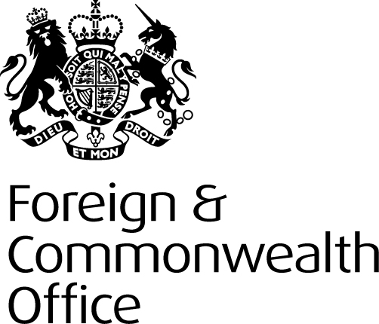
FCO Press Release: Foreign Secretary opens new flagship BT office in Singapore

Jeremy Hunt opens BT’s cyber security hub during three day visit to Asia.

The Foreign Secretary, Jeremy Hunt will visit the headquarters of BT Singapore today (4 January) to officially open their new office and see how UK excellence in cyber security is helping businesses and local government secure their operations for the digital age.

While on the tour of the new office, which is home to around 300 staff, the Foreign Secretary will be shown the company’s new ‘Customer Experience Centre’ which provides an interactive experience showcasing global connectivity services, cloud migration as well as world class cyber security services.

The new BT office will be the hub for the British company to deliver its services across South East Asia, providing cyber security solutions and services to private and public sector organisations.

The clients in the region include, a number of Singapore government agencies, major banks and financial service providers, the Singapore Stock Exchange and leading local and global logistics and shipping operators.

Speaking ahead of the opening Foreign Secretary, Jeremy Hunt said:

“Cyber security is essential to our national security in the 21st Century and British businesses are making a vital contribution against this global threat. The new BT office in Singapore will enable them to further strengthen their position as a leading player by providing expertise on cyber security solutions to countries and businesses across South East Asia.”

James Hennah, Managing Director, BT in South East Asia said:

“It is an honour to welcome the Foreign Secretary to open our regional headquarters in Singapore. The new office is home to almost 300 highly skilled staff, supporting our growing list of customers in the region with resilient connectivity, cloud services and world class security.

“It builds on our established presence with both networking and cyber operations in the wider Asia Pacific region. Just over a year ago we opened a brand new Cyber Security R&D Centre in Sydney, tapping into local talent to help us alleviate the global cyber skills shortage.”

The visit comes after the UK and Singapore signed a Memorandum of Cooperation (MoC) on Cybersecurity Capacity Building at the Commonwealth Summit in 2018 where the two countries agreed to cooperate to deliver cybersecurity capacity building programmes to Commonwealth Member States for a two-year period.

The UK also committed to participate in Singapore’s ASEAN Cyber Capacity Programme (ACCP), originally launched in 2016. A British cyber security expert will shortly start working in the British High Commission in Singapore to support this initiative, which will involve training and sharing best practice with officials working on cyber security in other ASEAN countries.

During his visit to Singapore on 4 January, the Foreign Secretary will meet Prime Minister Lee Hsien Loong and Foreign Minister Vivian Balakrishnan. He will also discuss with student journalists how to fulfil their role in an age of social media and disinformation.

