Press Release

Yanmar Scholarship Programs Support Thai Youth

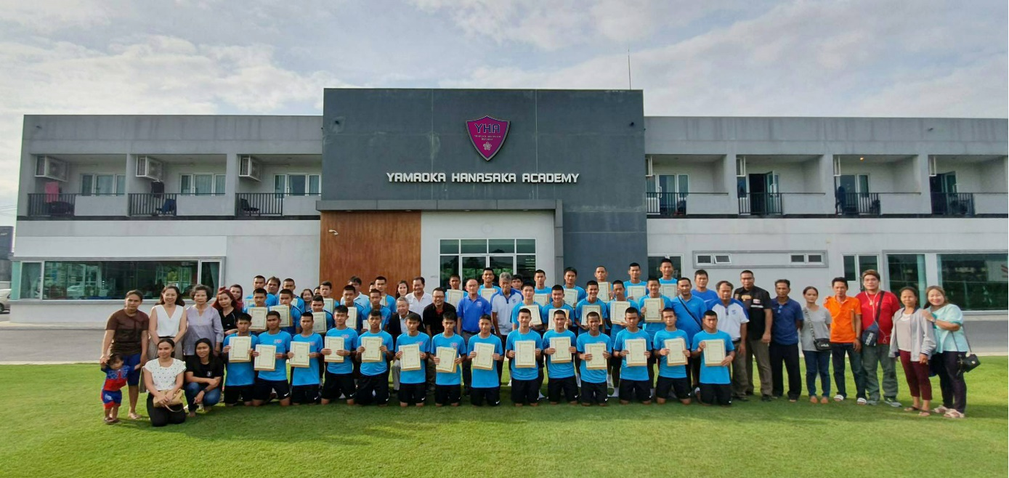
Scholarship recipients gather in front of the Yamaoka Hanasaka Academy.

Bangkok, Thailand - With a range of activities towards realizing its brand statement: A Sustainable Future, Yanmar is committed to developing opportunities for the next-generation and fostering cultural growth under the framework of its businesses both in Japan and internationally.

As part of Yanmar’s efforts to provide greater opportunity for the next-generation, the Yamaoka Scholarship Foundation was established by Yanmar’s founder Magokichi Yamaoka, to provide scholarships to disadvantaged youth thereby enabling them to continue their studies and fulfill their dreams, while the Yamaoka Hanasaka Academy which was established in 2016, seeks to provide both academic and sporting opportunities

Yamaoka Hanasaka Academy (YHA) was established in 2016 by the Yanmar Group in collaboration with Bangkok Glass Group, BG Pathum United Football Club and Cerezo Osaka Football Club, a partner club of BG Pathum United and a top team in the J-League, Japan’s premier professional football league. In 2016, the Yamaoka Foundation established a dormitory on the outskirts of Bangkok. Operated by the Yamaoka Hanasaka Academy, the objective is to focus on developing the football skills of disadvantaged Thai students who have a passion for the sport, by providing both academic and sporting opportunities and giving them the opportunity to realize their dream of becoming professional footballers. It is also hoped that this will raise the level of football in Thailand.

The Yamaoka Hanasaka Academy (YHA) held a ceremony on June 13, 2019, awarding scholarships to 10 junior high school students and 26 high school students. The Yamaoka Hanasaka Academy and the Yamaoka Scholarship Foundation contribute to a combined scholarship of THB 9,000 per month allow the students to attend school and support them in their sporting activities through to graduation, where it is hoped, some will have the opportunity to realize their dreams of becoming professional footballers. Thai football legend and Sports Director of BG Pathum United, Surachai Jaturapattarapong joined with Yamaoka Hanasaka Academy director, Nobuyoshi Fujita in welcoming the students and presenting the scholarships.

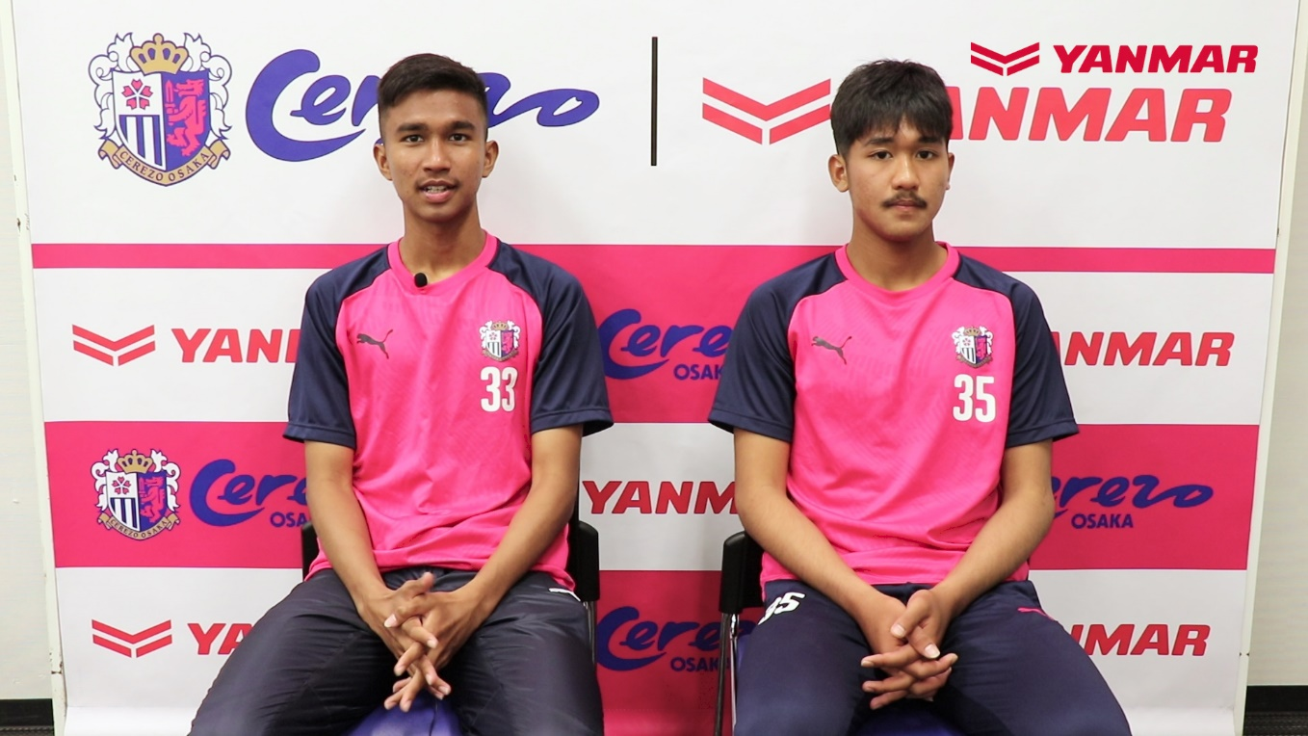
Graduates of the Academy Tawan and Pongrawit, who now play at Cerezo deliver a video message.

The awards event follows on from events earlier this year, when in April, two graduates of the academy had a spectacular start to their careers, going to play in Japan’s J-League with Cerezo Osaka.

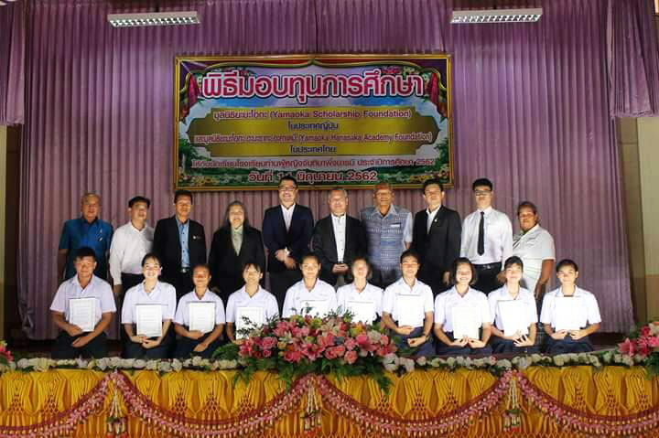
Scholarship recipients and participants in the ceremony
The next day on June 14th, Yanmar was hosting another scholarship awards ceremony, this time in the country’s northeast. In the rural city of Sakon Nakorn, the Yamaoka Scholarship Foundation together with the Yamaoka Hanasaka Academy awarded scholarships for THB 2,000 per month for 10 senior high school students in Than Phu Ying Chanthima Phumg baramee School. Amid trying circumstances, the scholarships will help to alleviate the economic hardship experienced by their families and give the youths the chance to attend school.

Sakon Nakorn is located near the national park that serves as a summer retreat for the Thai Royal Family, but with little in the way of tourism or industry the area is poor, and many exist on less than three meals a day.

Than Phu Ying Chanthima Phumg baramee School was established by H.R.H. Princess Maha Chakri Sirindhorn to provide a quality education together with a nutritious school lunch to raise the quality of life and opportunity of the area’s students.

In support of the Princess’s efforts, the Yamaoka Scholarship Foundation began to offer grants to exceptional students who were in greatest need of assistance, beginning in 2016 with scholarships for 10 students in each year level (total 30). It is hoped that these students will go on to fulfill their potential, contributing to Thailand and the world.
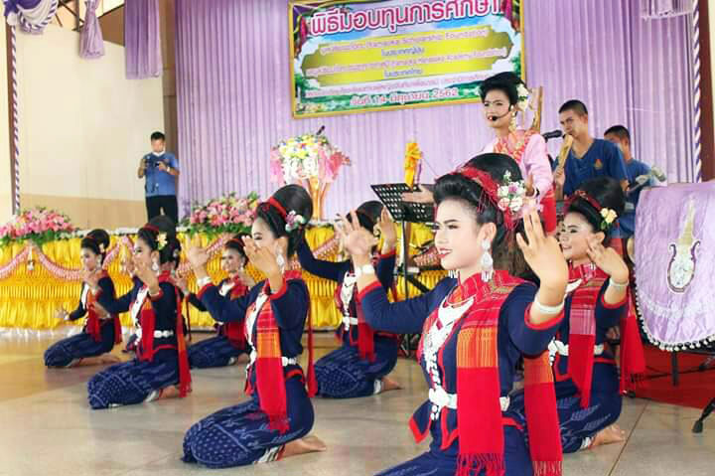
Students from Than Phu Ying Chanthima Phumg baramee School perform a traditional dance.
“Thailand has been an important partner of the Yanmar Group for over 40 years now, and we aim to continue contributing to Thai society through our activities in support of Thai youth and culture.” said Nobuyoshi Fujita, Yanmar Group Director.
“Through both the Yamaoka Scholarship Foundation and the Yamaoka Hanasaka Academy we aim to give the young people of Thailand a chance to realize their potential and build a better future.”

About the Yamaoka Scholarship Foundation
The Yamaoka Scholarship Foundation (YSF) was founded by Magokichi Yamaoka, the founder of Yanmar, in 1950. He founded the organization out of his personal funds - taking as its purpose: “To contribute to the promotion of national prosperity and peace in the world by supporting the development and education of students and young people.” The foundation’s scope was expanded globally, including Thailand.

About YANMAR S.P. CO., LTD.
YANMAR S.P. started operations as part of the former Yanmar Diesel in 1978 in Thailand and manufactures and distributes agricultural machinery such as power tillers, tractors, rice transplanters, combine harvesters and sugarcane harvesters, multipurpose diesel engines, and industrial equipment such as small to large excavators. YANMAR S.P. has a nationwide network of dealers with service centers, as well as a subsidiary, YANMAR CAPITAL (THAILAND) CO., LTD. which offers comprehensive finance to YANMAR customers in Thailand.

About Yanmar Co., Ltd.
With beginnings in Osaka, Japan, in 1912, Yanmar was the first to succeed in making a compact diesel engine of a practical size in 1933. Then, with industrial diesel engines as the cornerstone of its enterprise, Yanmar has continued to expand its product range, services, and expertise to deliver total solutions as an industrial equipment manufacturer. As a provider of small and large engines, agricultural machinery and facilities, construction equipment, energy systems, marine equipment, machine tools, and components, Yanmar’s global business operations span seven domains.

For further information, please visit official website: https://www.yanmar.com/global/

Note: This English news release is a translation of the Thai version. Information contained in the news release is valid at the time of publication and may differ from the most recently available information.

Media Inquiries
Vector Group Co., Ltd. at 02-045-5164

E-mail: info-th@vectorinc.co.jp

