Digital Yacht build new customer
experience at Dekker Watersport’s Amsterdam superstore
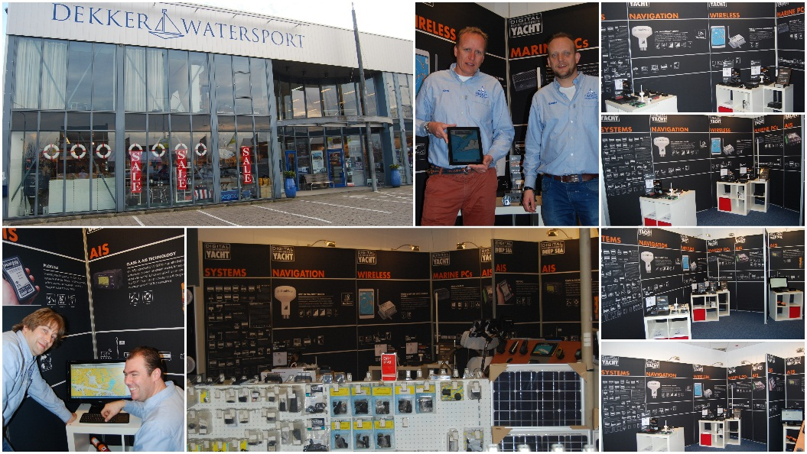
For immediate release: 7th March

Digital Yacht have built a new display of their latest marine electronic products at Dekker’s Amsterdam superstore. This joint venture “shop within a shop” opened this week to coincide with the Netherland’s HISWA boat show and Dekker’s special customer weekend event which starts on 8th March.

Originally established as a sail maker over 130 years ago, Dekker Watersport is Holland’s leading marine super-store with a 1000m2 display area. Digital Yacht is best known for its award winning AIS and wireless navigation products and the new displays will show live views of AIS as well as show-casing all the company’s latest products.

“Digital Yacht is determined to support the best customer experience with expert advisors, interactive displays and local presence. This is the first of a series of global displays that we will implement with our best partners” commented Nick Heyes, CEO of Digital Yacht.

Dekker’s showroom is located in Zandaam and the business is headed up by brothers Marc and Sander Prins. The store is located close to Amsterdam’s Schiphol airport. Last year more than 50m passengers transited through Schiphol, Europe’s 4th biggest airport. The hope is that many overseas customers will also find time to visit the store which is easily accessible by train and road in just minutes from the airport. In 2015, a new Ikea Superstore will also be built adjacent to the Dekker facility.

-Ends-

Digital Yacht – Note’s For Editors
Digital Yacht is a UK based manufacturer of specialist marine electronics. We produce a range of innovative products including AIS receivers and transponders, WiFi servers for on board NMEA data, long range WiFi internet devices and a range of sensors including GPS and electronic compasses. Digital Yacht won the prestigious METS DAME Electronic Product Award for iAIS as well as the NMEA Technology Award for BOATraNet in 2011. The GPS150 was nominated for a DAME award at this year’s 2013 exhibition in November

For further information, please contact:

Nick Heyes (Direct Line + 44 207 100 9116)

Digital Yacht Ltd.The Technology Centre, Green Lane, Failand, Bristol. BS8 3TR. UK.
Telephone: +44 (0)1179 554474
Email: sales@digitalyacht.co.uk www.digitalyacht.co.uk

