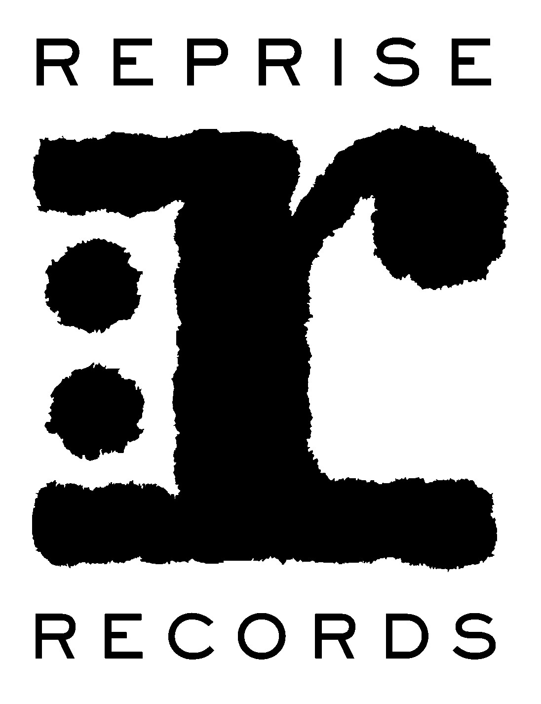

MASTODON’S NEW ALBUM EMPEROR OF SAND IS THE #1 ALBUM OF THE WEEK ON MULTIPLE CHARTS

New Album Debuts At No. 7 On The Billboard
Top 200 Albums Chart

Performance On TBS’ Conan Confirmed For April

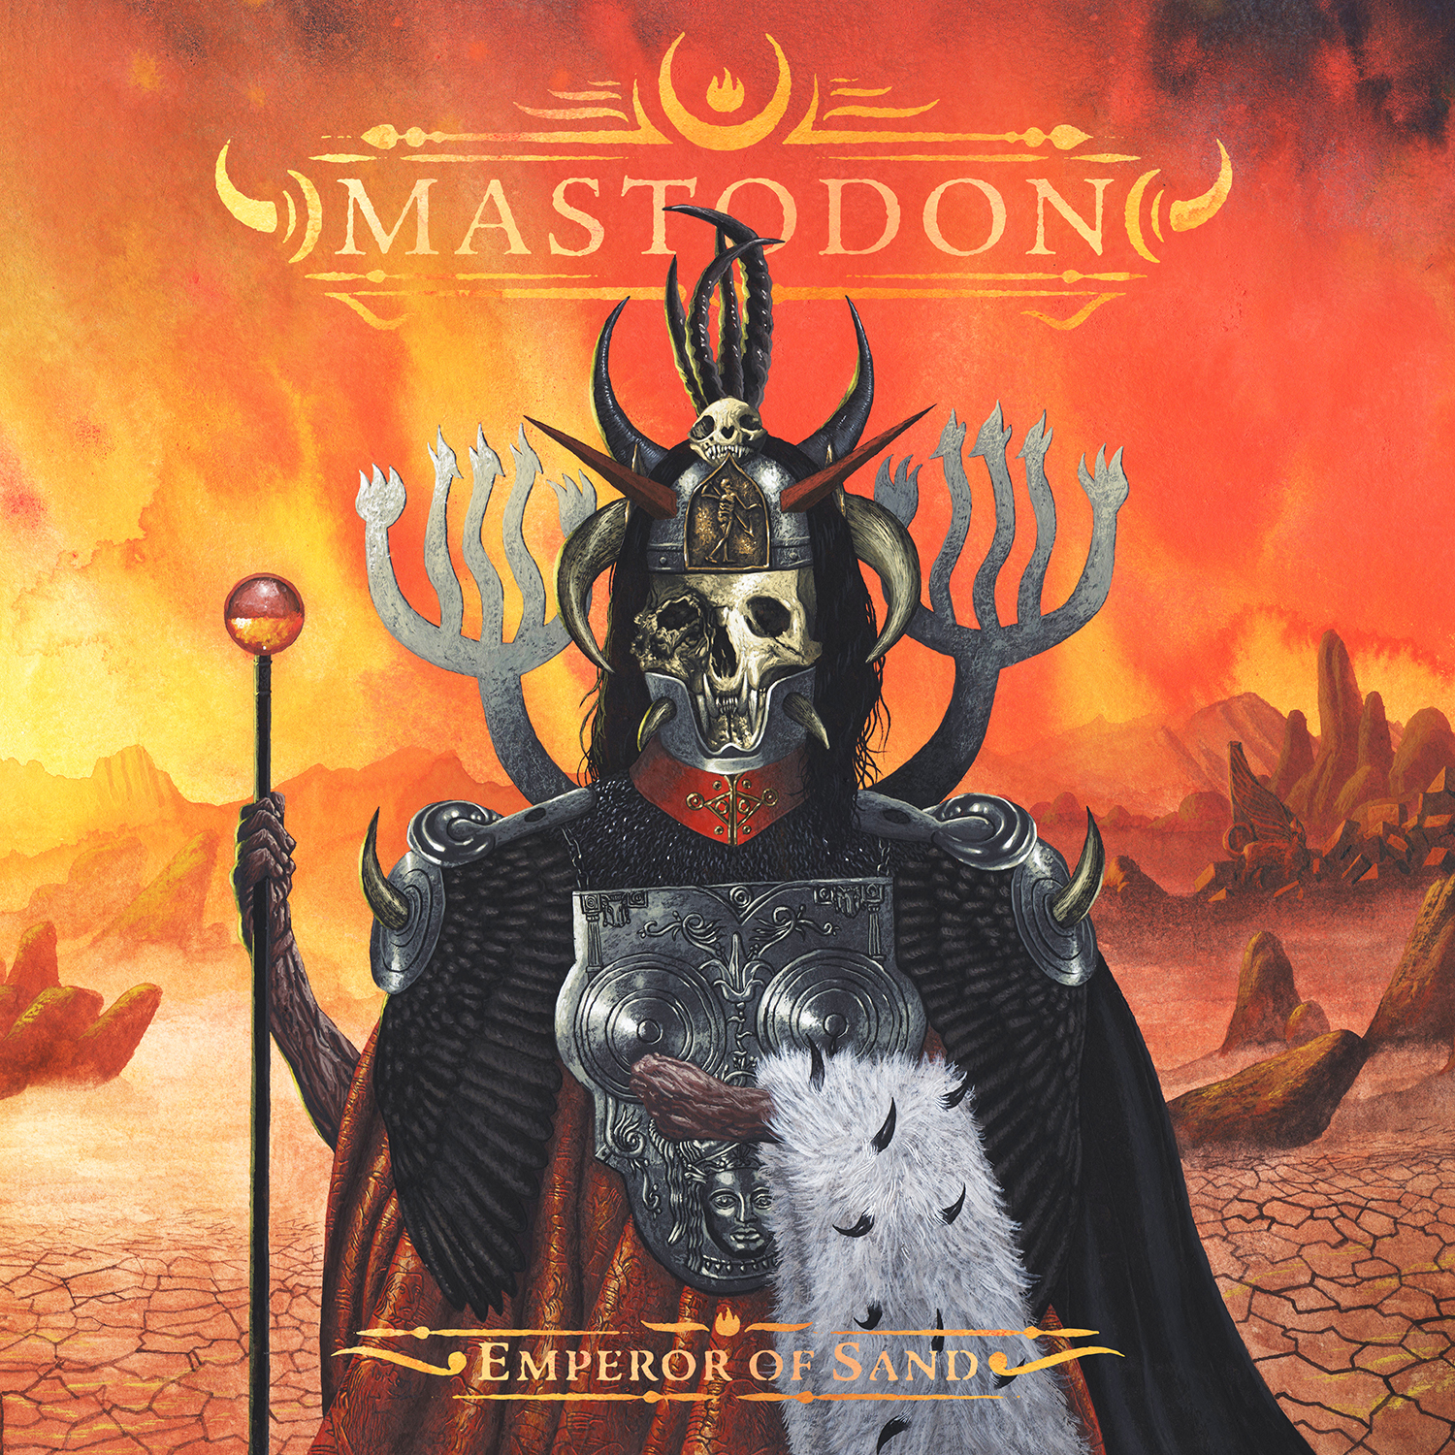

April 10, 2017 (Burbank, CA) — Emperor of Sand, the eighth studio album from internationally celebrated heavy rock icons Mastodon, has entered Billboard’s Top Album Sales Chart at the #1 position, making this not only the best-selling album of the week over all other entries, but also the band’s biggest sales debut in their history. In addition, Emperor of Sand topped the Billboard Alternative Albums, Rock Albums, Hard Music Albums and Physical Albums charts, plus the #1 vinyl selling album of the week completing Mastodon’s biggest debut of their career. Emperor of Sand debuts at the #7 position on the Billboard Top 200 Albums Chart and marks the band’s third consecutive album to enter into the Top Ten, including Once More 'Round the Sun (2014) and The Hunter (2011).

Mastodon had the biggest international debut of their career with first week chart position highs in multiple countries. Emperor of Sand also reached the Top 10 in Canada (#2), Australia (#3), Finland (#4), Sweden (#5), Norway (#6), Ireland (#7), and New Zealand (#9).

Mastodon’s new single “Show Yourself” is currently #8 at rock radio. The band recently performed the hit single on Jimmy Kimmel Live! - click here to watch the performance. They will also perform the song on TBS’ Conan on a later date to be announced soon.

Thrilled with this achievement, the band has offered this statement:
“We want to thank all of our fans for running out and picking up a copy of our new album Emperor Of Sand. The support you guys have shown us has been unbelievable. The album is an important and emotional one for us and it makes us very happy that it is connecting with you. We're excited to play it for you on tour!! See you soon!” - The ‘Don’

The album has received critical acclaim around the globe. Kerrang! (U.K.) called Emperor of Sand “a mature, provocative and at times genuinely beautiful piece of work,” while Rolling Stone said “‘Emperor Of Sand’ harnesses gut-punching catharsis…their most ambitious outing since ‘Crack the Skye’…It’s a glorious metal miasma.”

Paste praised “Emperor of Sand is full of passionate performances and serves as one of Mastodon’s most surprising and relatable releases yet.”

“One hard-hitting album…Mastodon turns tragedy into triumph” quoted Guitar World.
U.K’s Metal Hammer enthused “Being alive is the one thing we all have in common, but it takes a band as special as Mastodon to put life into perspective.”

On April 20, the band will perform at the Hollywood Palladium in Los Angeles as part of their upcoming spring U.S. headline tour, which begins on April 14 in Missoula, MT, with support from Eagles of Death Metal and Russian Circles. The band will also perform at several festivals, including the Carolina Rebellion Festival on May 5. Each pair of tickets purchased online (excluding festival dates and the May 6 Philadelphia show) includes a choice of a physical or digital copy of Emperor of Sand. Tickets are on sale now. Please see below for all tour dates and visit www.mastodonrocks.com/tour to purchase tickets.

Tour Dates:
04/14 Missoula, MT Wilma Theater
04/15 Seattle, WA Paramount Theater
04/16 Portland, OR Roseland Theater
04/18 San Francisco, CA The Warfield
04/20 Los Angeles, CA The Palladium
04/21 Phoenix, AZ Comerica Theatre
04/23 Salt Lake City, UT Complex
04/24 Denver, CO Fillmore
04/26 Kansas City, KS Uptown Theater
04/27 St. Louis, MO Pageant
04/28 Birmingham, AL Iron City
04/29 Jacksonville, F L Welcome to Rockville Festival
04/30 Ft. Myers, FL Fort Rock Festival
05/02 Washington, DC Fillmore
05/03 Toronto, ON Rebel
05/04 Cleveland, OH Agora Theater
05/05 Concord, NC Carolina Rebellion Festival
05/06 Philadelphia, PA Electric Factory
05/08 Boston, MA House of Blues
05/09 Portland, ME State Theater
05/11 New York, NY Hammerstein Ballroom
05/12 Pittsburgh, PA Stage AE
05/13 Chicago, IL Aragon Ballroom
05/14 Cincinnati, OH Taft Theatre
05/16 Detroit, MI Royal Oak Theater
05/17 Nashville, TN Ryman Auditorium
05/18 Memphis, TN Minglewood Hall
05/19 Dallas, TX Gas Monkey Live
05/20 Austin, TX ACL Live

# # #

Mastodon:
Troy Sanders
Brent Hinds
Brann Dailor
Bill Kelliher

Follow Mastodon:
www.mastodonrocks.com
https://www.facebook.com/Mastodon
https://www.youtube.com/mastodonmusic
https://twitter.com/mastodonmusic
https://www.instagram.com/mastodonrocks

Mastodon Press Materials:
http://press.wbr.com/mastodon

