Epson launches new EcoTank Monochrome series printers

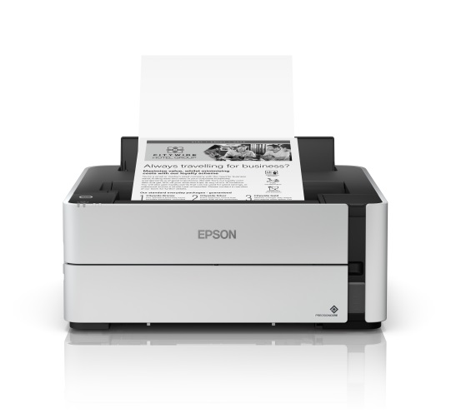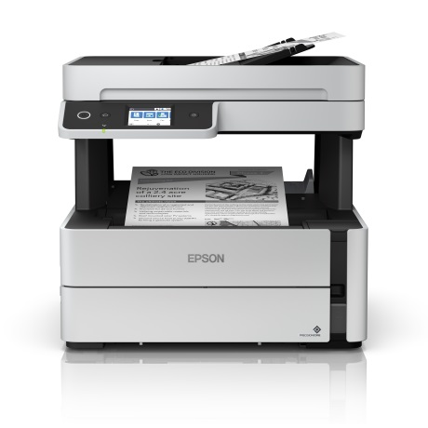
EcoTank Monochrome M1140 (left) and M3170 (right) printers

Malaysia, 21 June 2019 – Epson, a global leader in printing technologies and market leader for ink tank printers, announced the launch of the latest additions to its EcoTank Monochrome series that offer one of the lowest total costs of ownership in the market, the M3170 and M1140 printer.

Both these new printers now incorporate the PrecisionCore printhead, bringing improved nozzle technology with increased print resolutions at 1200 x 2400 dpi, and fast speeds of 20ipm, bringing enhanced value and improved productivity to the workplace.

The multi-function 4-in-1 M3170 EcoTank Monochrome printer comes with auto-duplex printing, scan, copy and fax functions, and is equipped with an automatic document feeder (ADF), as well as Ethernet connectivity while the M1140 printer comes only with printing functions.

The M3170 printer comes with a host of connectivity solutions, enabling printing directly from mobile devices via Epson iPrint. Other connectivity solutions include scanning to cloud, Apple Airprint, Google Cloud print, Mopria Print Service and others.

The EcoTank Monochrome printers offer one of the lowest total cost of ownership, rivalling laser printers in terms of overall total cost of ownership and energy consumption, with the printers having 24 times lower power consumption, and bringing 24 times lower overall cost of ownership compared to laser printers in Malaysia.

The EcoTank Monochrome series printers now come with 4 years or 50,000 pages of warranty, whichever comes first.

Epson launched the first ink tank printer model in Indonesia in 2010, and subsequently in Southeast Asia and globally. The ink tank printer has sold more than cumulative 30 million units worldwide as of July 2017.

***

About Epson
Epson is a global technology leader dedicated to connecting people, things and information with its original efficient, compact and precision technologies. With a lineup that ranges from inkjet printers and digital printing systems to 3LCD projectors, watches and industrial robots, the company is focused on driving innovations and exceeding customer expectations in inkjet, visual communications, wearables and robotics.
Led by the Japan-based Seiko Epson Corporation, the Epson Group comprises more than 76,000 employees in 87 companies around the world, and is proud of its contributions to the communities in which it operates and its ongoing efforts to reduce environmental impacts.
http://global.epson.com

About Epson Malaysia
Epson began operations in Malaysia in 1991 as Epson Trading (M) Sdn Bhd before being incorporated as Epson Malaysia Sdn Bhd. The company has the exclusive rights to market, distribute and support a complete range of leading-edge Epson consumer and business digital imaging products in Malaysia and Brunei. Today, Epson Malaysia has 84 employees and an extensive network of 61 authorised service outlets throughout the country. For more details, please visit www.epson.com.my or connect with us at www.facebook.com.my/EpsonMalaysia .

For media enquiries, please contact:
Chua Li Tinn,
Marketing Communications Manager
Epson Malaysia Sdn Bhd
Tel: (03) 5628 8288 Ext 274
Email: ltchua@emsb.epson.com.my

LEWIS
Natasha Aida / Leong Ee Sa/ Priyanka Raj
Tel: +603 2716 5818
Email: EpsonMY@teamlewis.com

Figures based on average power consumption, when in operation, of the top 3 single function laser printers within a similar speed category found in the market. Results obtained by comparing published specifications of the laser printer brands.

