

**PRESS RELEASE STOCKHOLM, 18-07-2020**

HIGH SUMMER 2020 WITH DAILY SPORTS

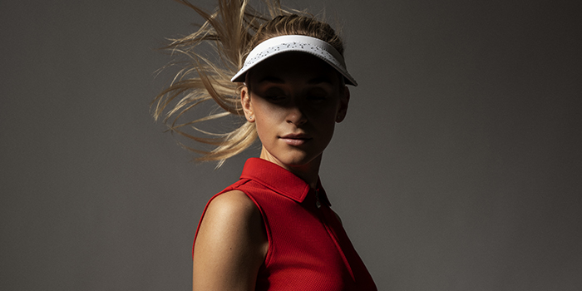

**Daily Sports prioritizes not only freedom of movement but also a feminine cut in the   
golf wear they design.**

Daily Sports, the Swedish family business that’s turning 25 this year, is now bringing out its High Summer collection – something to make summer last a little longer. And who doesn't want that?

It’s golf wear with a feminine cut. But for the company’s designers, it’s just as important to pay attention to optimal comfort and freedom of movement out on the course. As a bonus, this makes the clothes just as stylish and comfortable for everyday wear.   
“We’re very proud to have been involved in developing the women’s golf sector," says Ulrika Skoghag, CEO of Daily Sports.

This is a classic collection accented with cardinal red, an energetic colour that enhances the joy and challenge of being a woman golfer.

“Red and rosehip pink are late summer colours with impact, a feeling of freshness. Rosehip pink is inspired by fiery red summer skies,” says Patricia Trennewall, designer at Daily Sports.

The expressive prints in the collection are designed to create energy and maximum personal potential. And of course, you’ll find the Daily Sports signature – the collection’s matching accessories.

Read more at [www.dailysports.se](http://www.dailysports.se)

**FOR MORE INFORMATION CONTACT:**

Tina Lindkvist

Marketing Project Manager

Tel: +46 722-51 62 30

Email: [tina.lindkvist@dailysports.se](mailto:tina.lindkvist@dailysports.se)

Daily Sports is today one of Sweden’s biggest suppliers of golf clothes for women. We sell our golf and active wear in   
28 countries. Daily Sports clothing is famed for its feminine fit, focus on function and attractive details.  
Featuring designed patterns and matching combinations, the clothing is for both leisure and at work.

The company was founded in Sweden in 1995 with the aspiration to make women want to be active. Our current turnover is about SEK 80 million, of which the Swedish market accounts for about SEK 25 million.

Tulegatan 47 T +46 8 120 105 00

SE-113 53 Stockholm, Sweden

info@dailysports.se www.dailysports.com