APPROVED PRESS RELEASE (3.1094C) 11th March 2019
Rotork electric actuators used in US shale oilfield pipeline’s solar solution
Rotork IQ3 intelligent multi-turn electric actuators have been specified for use in solar powered control stations for water gathering pipelines in the USA.
Located in the oilfields of West Texas and New Mexico, the intelligent systems allow for the remote operation of single-stage isolation and modulating valves to control the flow of produced water in a high-pressure pipeline network. To assist with the water treatment operation, automated valve technology is needed to control flow in the water gathering pipelines, which can often run for miles in areas with no mains power to activate the valves.
The customer wanted valves and actuators to be installed every five miles in areas which were off the grid, so a solution combining individual solar panels with control stations and Rotork IQ3 actuators was devised. Each control station includes an IQ3 actuator to control either a 12 “ or 16 “ ball valve and each assembly is fitted with solar panels to power either a 24, 48 or 120 VDC motor.
Rotork Site Services worked to assemble the solar panel then installed and configured the systems in the field.
The self-contained solar power stations offer an efficient and economical way of powering the control stations, while also preventing harm to the environment and cutting installation costs by removing the need to dig up land in order to install power lines along the length of the pipeline.
The robust solar system provides power for programmable logic controllers (PLCs), as well as the Rotork IQ3 electric valve actuators, to transport contaminants from fracturing sites to water gathering and disposal facilities. The system programme includes a feature that provides a low-voltage alarm to alert pipeline operators if power from the solar system has dropped below the required level for valve operation.
Rotork’s IQ3 actuators include a patented absolute encoder to provide continuous tracking at all times. Even in the event of a power loss, the actuator’s graphical interface, remote indication and datalogger are all maintained and accessible.
The use of solar power in industrial valve automation stretches back several decades but technological improvements in efficiency and storage means the technology has become a reliable and practical alternative for sites in isolated areas.

END

Photo captions
Caption 1: Rotork IQ electric actuators fitted to 12 and 16-inch ball valves with a solar panel.
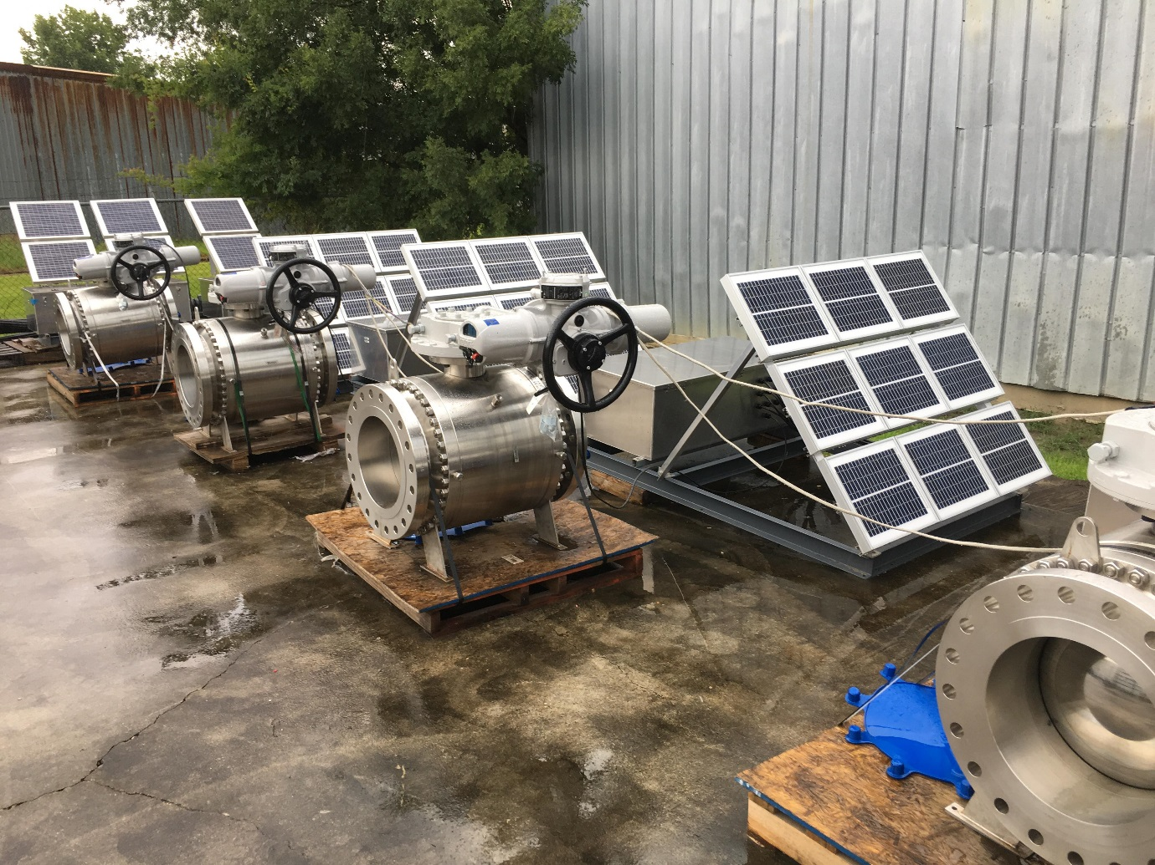

For further information please contact Rotork PLC
Sarah Kellett/Liam Jones Brassmill Lane
Bath
tel: +44 (0) 1225 733200 BA1 3JQ
email: Sarah.Kellett@rotork.com / Liam.Jones@rotork.com UK

About Rotork
Rotork is the market leading actuator manufacturer and flow control company that operates in any market where the flow of gases or liquids needs to be controlled. It has established manufacturing facilities, a global network of local offices and agents who can truly provide a worldwide service. You will be able to locally source Rotork’s products, supported by life-of-plant maintenance, repair and upgrade services.

