Kongsberg Maritime supply SIMRAD sonar equipment for 75m Pelagic trawler Artemis
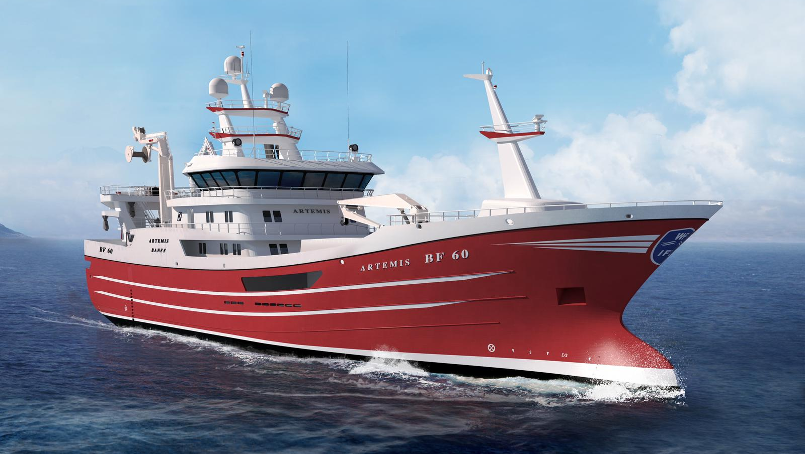Artemis BF-60 will be equipped with a selection of advanced SIMRAD sonar equipment
Kongsberg, Norway, 26th November 2020 – Kongsberg Maritime is pleased to announce that it will be supplying a portfolio of SIMRAD sonar equipment for a new 75m Pelagic trawler, currently in build at Karstensen’s Shipyard in Skagen, Denmark. Commissioned in partnership by Scottish fishing companies Northbay Fishing Co. Ltd and Wiseman Fishing Co. Ltd, the new vessel – to be called Artemis – will be based in Banff, Scotland.
Pelagic trawlers target fish in the mid- and surface water, such as herring and mackerel, and the range of products to be fitted to Artemis reflects this mode of operation. Scheduled for delivery in June 2022, the vessel will be equipped with SIMRAD ST94, SN93 and CS90 fishfinding sonars, providing a range of omnidirectional and targeted fish location and tracking options across multiple frequencies.
Andrew Masson, Sales Director at SIMRAD dealer Echomaster Marine, who concluded the deal, said: “The Artemis vessel owners knew of SIMRAD products already, as they had deployed ES80 fishery echosounders and FS70 trawl sonar on previous vessels. After we presented the SIMRAD sonar portfolio they spoke to other vessel owners in Norway, Sweden and the UK and decided to order SIMRAD acoustic products for this new-build project.
“They were particularly impressed with reports about the ST90, SN90 and new CS90 broadband mid-frequency sonar,” Masson continued. “The feedback from other vessel owners was that CS90 sonar is a leap forward in technology, compared to similar mid-frequency sonar products they have previously deployed.”
Mads Dahl, Manager Marketing & Sales, Fishery, Kongsberg Maritime, added: “This is strategically a very important sale for us, and fully demonstrates the scope and capabilities of SIMRAD equipment available for trawl operations. We are very pleased to have been given this order.”
Artemis will also be fitted with a SIMRAD ES80 split-beam echosounder and fishfinder, FS70 third-wire trawl sonar to monitor net opening and fishing conditions, and the PX Multicatch trawl monitoring system. A Kongsberg Maritime MRU-S Motion Reference Unit completes the order, providing an accurate picture of roll, pitch, yaw and heave motion for enhanced sonar stabilisation, enabling a steady image of the target fish shoals even in rough weather conditions.
Ends

For further information, please contact:
Gunvor Hatling Midtbø, VP Communication
Kongsberg Maritime
Tel: +47 9921 4209
gunvor.hatling.midtbo@km.kongsberg.com
David Pugh
Saltwater Stone
Tel: +44 (0)1202 669244
d.pugh@saltwater-stone.com

About Kongsberg Maritime
Kongsberg Maritime is a global marine technology company providing innovative and reliable ‘Full Picture’ technology solutions for all marine industry sectors including merchant, offshore, cruise, subsea and naval. Headquartered in Kongsberg, Norway, Kongsberg Maritime has manufacturing, sales and service facilities in 34 countries.
Kongsberg Maritime solutions cover all aspects of marine automation, safety, manoeuvring, navigation, and dynamic positioning as well as energy management, deck handling and propulsion systems, and ship design services. Subsea solutions include single and multibeam echo sounders, sonars, AUV and USV, underwater navigation and communication systems.
Training courses at locations globally, LNG solutions, information management, position reference systems and technology for seismic and drilling operations are also part of the company’s diverse technology portfolio. Additionally, Kongsberg Maritime provides services within EIT (Electro, Instrument & Telecom) engineering and system integration, on an EPC (Engineering, Procurement & Construction) basis.
Kongsberg Maritime is part of Kongsberg Gruppen (KONGSBERG), an international, knowledge-based group that celebrated 200 years in business during 2014. KONGSBERG supplies high-technology systems and solutions to customers in the oil and gas industry, the merchant marine, and the defence and aerospace industries.
Web: Kongsberg Gruppen | Kongsberg Maritime
Social media: LinkedIn | Twitter | Facebook

About Karstensen’s Shipyard
Karstensen’s Shipyard started in 1917 as a family business, and since its inception has delivered over 400 new vessels. It is now owned and managed by a third generation of the family and by five employees that acquired 35% of the shares in 2003, turning over around DKK 1 billion annually.
Employing about 375 staff, Karstensen’s Shipyard can construct most vessel types up to approximately 135m in length. The yard also offers ship service, drydock and slipway facilities.
Web: Karstensens Skibsværft A/S

