FOR IMMEDIATE RELEASE

Intellian launches next-generation 2.4m dual-band VSAT antenna and Intelligent Mediator
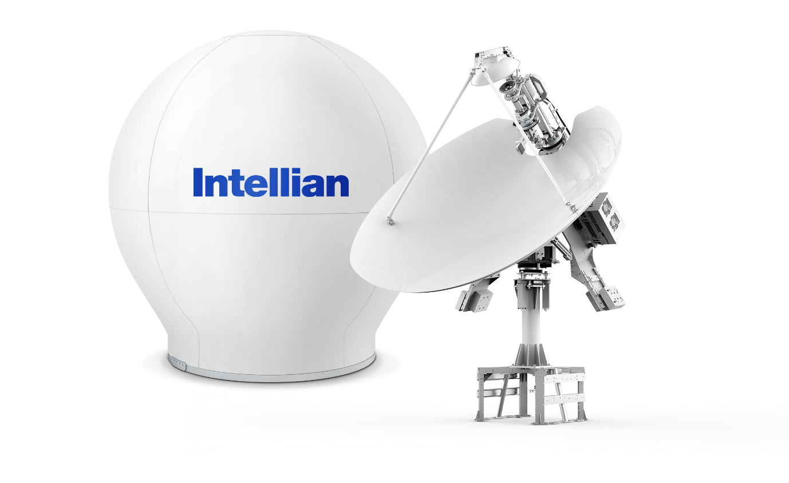
Intellian’s next-generation v240M Gen-II dual band antenna

13 July 2020 – Intellian is proud to announce the launch of the next generations of its v240M dual-band 2.4m antenna and Intelligent Mediator. Together, the new v240M Gen-II and Intelligent Mediator Gen-II enable auto-switching between C- and Ku-band communications, GEO and MEO satellite tracking, and management of up to eight antennas and modems.

Developed from the v240M – the world’s first antenna to provide auto-switching 2.4m performance in both C- and Ku-band on a single reflector – the new v240M Gen-II delivers best-in-class RF performance across both bands without any need for hardware modification. The antenna can be easily adapted to Ka-band for tri-band operation if required. With support for BUCs from 40W to 400W, the v240M Gen-II allows high bandwidth demands to be met, and may also use Intellian’s Fiber Link cable between the above- and below-deck units, minimizing signal loss and simplifying installation.

Combining the v240M Gen-II with the new Intelligent Mediator Gen-II immediately adds support for MEO satellites, in addition to the antenna’s core GEO capability. With the facility to manage up to eight antennas and eight modems – including multi-band units – the unit can dynamically allocate any vendor’s modem to any connected antenna, thus enabling support for any commercial service. The system can be configured to carry out Break Before Make or Make Before Break satellite handovers as required, and supports seamless, hybrid operation across orbits and bands with multiple modes to ensure maximum bandwidth utilization.

In addition to being a perfect match for the v240M Gen-II antenna, the Intelligent Mediator Gen-II can also manage all Intellian NX platforms, the v240MT Gen-II tri-band antenna, and antennas from other brands. Furthermore, it is ready for integration with Intellian’s upcoming Mediation Edge Server (MES) and Orchestra Advanced Antenna Management system, which will enable full asset management, configuration and automatic mediation between connected equipment. This will allow smart blockage mitigation and failure prevention, enabling unmatched connection resiliency.

This vendor-agnostic approach reflects Intellian’s initiative to place the choice of orbit, band and network firmly with the customer. Future-proofed products allow unprecedented flexibility of operation, while streamlined installation through simplified connections and the Aptus suite of browser-based, remotely accessible configuration and diagnostic tools reduces complexity and commissioning costs while improving reliability and facilitating support.

Eric Sung, CEO of Intellian, said: “The v240M Gen-II and Intelligent Mediator Gen-II demonstrate Intellian’s determination to make satellite communications accessible to all. The v240M Gen-II antenna delivers best-in-class dual-band connectivity, while the Intelligent Mediator Gen-II facilitates easy integration with existing systems and support for multiple antennas and modems. With products such as these, ready for the next generation of satellite networks, Intellian is safeguarding its customers’ connectivity for the future. By giving access to the most advanced technology today, we provide a seamless and cost-effective pathway to new services as they come online.”

The v240M Gen-II and Intelligent Mediator Gen-II are now available from Intellian’s global logistics centers.

-Ends-

About Intellian Technologies, Inc.
Intellian is the global leader of mobile satellite communication systems for maritime applications and a leading communication technology innovator for the government, military, energy, cruise and enterprise sectors. Founded in 2004, Intellian continues to invest in cutting-edge design, R&D, Quality Control, and advanced low environmental impact production facilities to deliver bold and pioneering solutions. These include the award-winning v240MT, the world’s first tri-band, multi-orbit antenna system and the future-proof NX series antennas optimized for high performance and low cost of ownership.

Intellian has a global presence with over 400 employees, 12 regional facilities and 5 logistics centers on 3 continents. The Intellian 24/7 global support desk provides dedicated assistance to 550 service provider partners and their customers in mission critical environments. Intellian Technologies Inc. is listed on the Korean Stock Exchange, KOSDAQ (189300:KS).

More information may be found at www.intelliantech.com.

For further inquiries, please contact:

Paul Comyns / VP of Marketing
Intellian Technologies USA
T + 1 949 727 4498 ext. 1301
Paul.Comyns@intelliantech.com

Sadie Brown / Marketing Manager
Intellian Ltd
T +44 2380 019 021 ext. 1612
Sadie.Brown@intelliantech.com

David Pugh
Saltwater Stone
T +44 1202 669 244
d.pugh@saltwater-stone.com

