FOR IMMEDIATE RELEASE

Epson launches new Moverio smart glasses that expands the scope of applications for healthcare, commercial drone piloting, engineering and more
The Moverio BT-35E offers new flexibility for users to connect to their device of choice

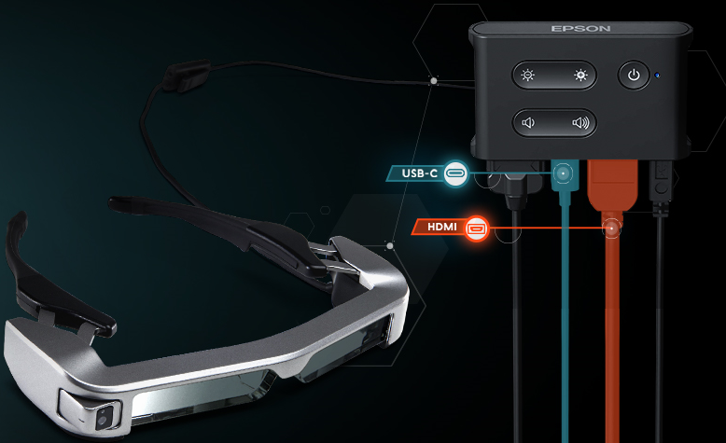

Epson’s Moverio BT-35E smart glasses

Malaysia, 30 November – Epson has announced the release of its latest version of smart glasses, the Moverio BT-35E. The new BT-35E smart glasses is designed to be easily used in combination with existing hardware through HDMI and USB-C connectivity at almost zero latency, enhancing its connectivity for commercial applications. With this, Epson’s optical expertise can be effectively deployed in healthcare, commercial drone piloting, engineering, entertainment and more.

Based on Epson’s patented optical and precision technologies and keeping to its predecessor’s design, the BT-35E augmented reality eyewear delivers vivid HD image quality and is Epson’s first smart glasses with an external Android-based controller unit for external connectivity. The new smart glasses aim to provide users greater access to content on a wearable display through existing output devices and comes with an Android-based controller unit.

“Developed from customer insights, these hands-free Si-OLED-powered binocular see-through smart glasses deliver content at low latency from a range of devices using HDMI or USB-C connectivity. Offering an easy out-of-box experience, the Moverio BT-35E smart glasses provide easy plug-and-play operation with no special software required. With the Moverio BT-35E, we aim to bring our optical expertise to commercial sectors such as healthcare users and commercial drone pilots that can utilise them as a see-through display for their existing hardware,” said Danny Lee, Director, Sales and Marketing, Epson Malaysia.

Some typical uses of the BT-35E include:
- In healthcare, as a first or secondary display. Instead of turning around to look at a monitor, a doctor can keep their focus on the patient and maintain a more natural position.
- For engineering applications, as a first or secondary display for tasks that require low latency and improved efficiency, including remote assistance.
- In entertainment, theme parks and museums can use it to enhance the customer experience to play video content or to act as a heads up display.
- For commercial drones, such as the DJI Phantom 4 Pro, it can be used as a secondary FPV display for controllers with a primary display and an HDMI output.

The BT-35E has been designed with commercial applications in mind. Its durable build and features designed for comfort mean it can be repeatedly worn by multiple users, fitting comfortably for long periods of time, no matter their shape, size, or if they wear glasses.

Epson’s focus on a wide range of commercial applications distinguishes the Moverio range from other smart glasses on the market. Developed with function at the forefront, the range has proved popular with business customers and independent software vendors (ISVs).

Key features:
- Epson Si-OLED display
- 720p HD resolution
- Large array of built-in sensors including a 5MP camera, gyroscope, accelerometer, compass and ambient light sensor
- Interface box with HDMI and USB-C connectivity
- Compact and light design – Can fit a range of head sizes, and can be worn over glasses
- Support for side-by-side 3D content
- Neck strap for a complete hands-free experience
- Unique nose pad suited for over-glasses use
- Adjustable arms for enhanced wearability
- Epson provides the API for the camera and sensors

***

About Epson
Epson is a global technology leader dedicated to connecting people, things and information with its original efficient, compact and precision technologies. With a lineup that ranges from inkjet printers and digital printing systems to 3LCD projectors, watches and industrial robots, the company is focused on driving innovations and exceeding customer expectations in inkjet, visual communications, wearables and robotics.
Led by the Japan-based Seiko Epson Corporation, the Epson Group comprises more than 76,000 employees in 87 companies around the world, and is proud of its contributions to the communities in which it operates and its ongoing efforts to reduce environmental impacts.
http://global.epson.com/

About Epson Malaysia
Epson Malaysia Sdn Bhd was established in Malaysia in 1991 as Epson Trading (M) Sdn Bhd, a sales company of the Seiko Epson Corporation, Japan. The company has exclusive rights to market, distribute and support a complete range of leading-edge Epson consumer and business digital imaging products in Malaysia and Brunei. Today, Epson Malaysia has 84 employees and an extensive network of 59 authorised service outlets nationwide. For more info, please visit www.epson.com.my or connect with us at www.facebook.com.my/EpsonMalaysia

Media Enquiries:
Epson Malaysia Sdn Bhd  Chua Li Tinn  Manager – Marketing Communications  Tel: (03) 5628 8288 Ext 274  Email: ltchua@emsb.epson.com.my | LEWIS Communications  Anoushka Bhar  Tel: (03) 2716 5800  Email: EpsonMY@teamlewis.com

