Haglöfs Fall / Winter 2020
Haglöfs raises the bar and the altitude for Fall Winter 2020 with innovative products and first of their kind technologies.
Stockholm, SE, January 2020 - For more than a century, Haglöfs has developed outstanding outdoor products that combine a strong sense of Swedish heritage with a commitment to sustainability and innovation. For Fall Winter 2020 the brand concentrates its energy on products engineered for mountaineering, steep descents and varying trekking terrain. This is complimented with groundbreaking insulation technologies and new approaches to how one uses the standard hiking boot.
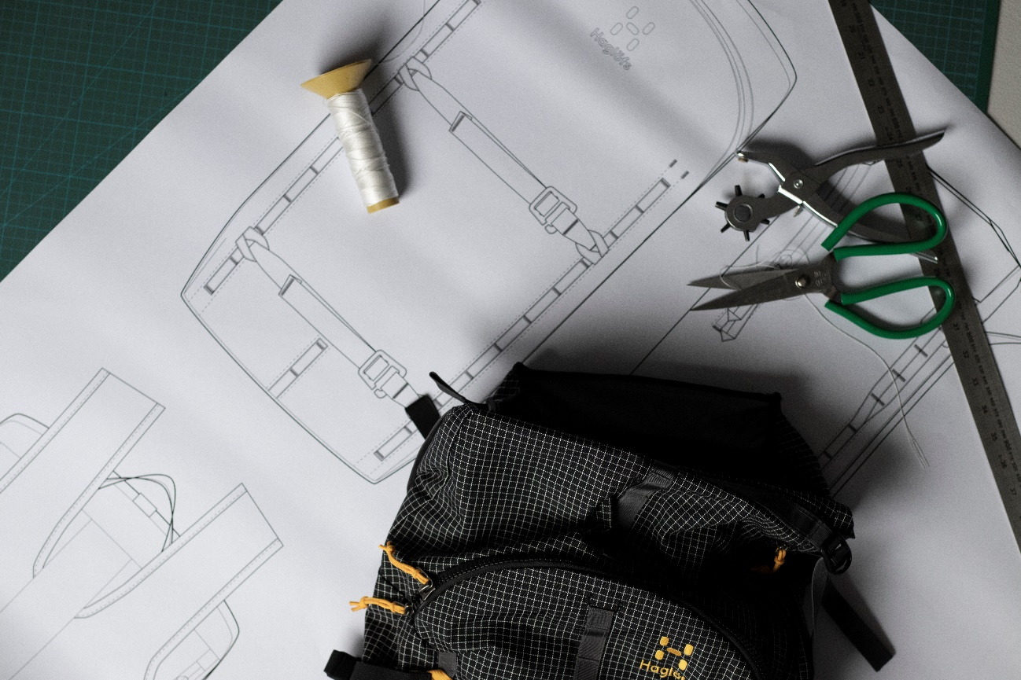
Graphene - The ‘Super Material’
Haglöfs introduces Graphene infused mimic insulation in the Platinum level Mimic Products. Graphene is a single-atom-thin layer of carbon that forms a grid with unparalleled strength and conductivity. The result is an insulation that does not make any compromises. Graphene insulates with heat faster, contains the warmth longer and decreases the amount of insulation (by volume) previously needed due to the technology and performance. Essentially, a superior insulation experience with less material.
Graphene will be featured in the V series Mimic, Nordic Mimic and Roc Mimic. All three are intended for deep trekking into rugged and cold terrain as well as high assents into the mountains. For journeys that rely on technology just as much as morale, Graphene is a significant addition to these products that will change the game for mountaineering and expeditions. Outdoor enthusiasts will be able to get warmer faster, stay warmer longer and decrease the bulk and space in their bags and on their bodies. The technology will be put to the test in the extremes of Arctic and by Haglöfs’ ambassador Antti Autti.
Roc Nordic 30 – The ultimate companion
Whether you’re a skier, a boarder or a mountaineer, this might be the ultimate companion for your upcoming adventures. The Roc Nordic 30 is made with 600D HT-polyamide/400D-Spectra ripstop, bluesign®-approved and features a separate compartment for your snow safety equipment. To make it extra durable Haglöfs have reinforced the main material with 6mm Spectra thread, which is one of the strongest manmade fibers available. The adjustable straps and webbing let you tailor the backpack according to your needs and lets you carry all essentials needed for a day in the backcountry.
Duality AT1 - Versatile Trekking Footwear
The name says it all; Duality. The Haglöfs Duality AT is intended to take on drastically different terrains that would traditionally require two different pair of shoes to conquer. The trick is that Haglöfs went deeper than the insole and all the way into the midsole. Duality AT comes equipped with two interchangeable midsoles. One that offers more robust support for rockier trails and heavier loads. One that is for lighter trekking, for general day in and day out use. The result is an extremely comfortable outdoor shoe that can transition from the most technical terrain to the most basic weekend excursion.
Vassi - The Next Generation
Haglöfs dares you to straight line it with the next generation of Vassi; their professional level free ride collection. Vassi is a relaunch of Haglöfs’ iconic range from the early 2010’s inheriting the collection’s name from a remote and technical mountain in northern Sweden. The collection is built for the rugged harsh conditions of winter up north that consist of intense wind and freezing cold temperatures.
The collection comes in both men’s and women’s styles with a jacket and bib pants that are equipped with the latest technologies and functions. A built in RECCO® reflector, GORE-TEX Pro membrane, and functional features tailor this range to the experienced backcountry rider. The collection is created by skiers for skiers and is durable, breathable and water resistant under the harshest conditions.
GTX Pro
GORE-TEX Pro is a 3-layer material that is highly breathable with superior wind- and waterproofing. It is backed up with the GUARANTEED TO KEEP YOU DRY™ promise and ensures the most durable, long-lasting protection, even when you’re exposed to the harshest weather conditions. Products made with GORE-TEX Pro are the perfect choice for the outdoor adventurer.
About
In 1914, Wiktor Haglöf made the first stitch in a backpack that went on to inspire generations of people to get outside. From Haglöfs’ Swedish heritage, with a commitment to sustainability and innovation, they continue to create progressive outdoor products at the highest level for hiking, mountaineering and freeriding. The Haglöfs brand is currently marketed to the Nordic region, Europe, North America and Asia, and has been owned by ASICS Corporation since 2010. For more info, please visit www.haglofs.com.

HAGLÖFS FALL / WINTER 2020 – PRODUCT SHEET

V series Mimic

Key Features:
Filled with Mimic Platinum for superb warmth and excellent performance, even when wet Ultra-light 7D Face fabric from Pertex® for superior weight. DWR-treated face fabric for great weather protection. GORE-TEX INFINIUM™ lining for the best moisture management and temperature regulation. Insulated placket behind the front zip to eliminate cold spots. Adjustable hood for comfort and to help keep the elements out. Two zippered hand pockets and one zippered chest pocket, all with Vislon zippers Elastic piping at sleeve and hem: for comfort, and to keep cold air out. Centre back length 78cm (Men’s size L).

Fabrics:
Pertex® Quantum, 100% Polyamide, 7D, super light yet durable mini ripstop fabric, 24 g/m², bluesign® Insulation: Mimic PLATINUM Ultracluster Graphene mixed with Recycled polyester, light, lofty, synthetic fibre cluster insulation with down-like feel.

Weight: 166g (size L).

Available in size range:
Women: XS-XXL
Men: S-XXL

RRP: 300 EUR

Nordic Mimic

Key Features:
Durable and protective shell layer at hood, shoulder and chest areas insulated with Primaloft Aerogel. A lightweight tear- and wind-resistant fluorocarbon free DWR-treated Pertex® shell fabric insulated with Mimic Platinum, for superior warmth even when wet. Stretchy side panels for movement, made from durable FlexAble fabric. Chest pockets can be accessed while wearing harness/backpack. Square quilted construction. Articulated sleeves with elasticated cuffs and adjustable hem for heat retention Vislon front zip – easily manageable with gloves on Centre back length 80cm (Men’s size L).

Fabrics:
Pertex® Quantum, 100% Recycled Polyamide, 20D down and fibre proof, super light yet durable mini ripstop fabric, 36 g/m², bluesign® approved, PROOF™ 2-layer 100% Recycled Polyester, rip-stop weave with soft face, 106 g/m² Hydrostatic head: >15,000 mm; Moisture Permeability (inverted cup): >10,000 g/m²/24h FlexAble™ 50% Polyamide, 43% Polyester, 7% Elastane, 4-way stretch double weave fabric with durable Polyamide face and Polyester backing for enhanced wicking, 275 g/m², bluesign® approved Insulation: Mimic PLATINUM Ultracluster Graphene mixed with Recycled polyester, light, lofty, synthetic fibre cluster insulation with down-like feel. PrimaLoft® Gold Insulation with Cross Core™ Technology 80% Recycled Polyester 20% Polyester is a revolutionary fusion of multiple technologies to create a product with warmth and comfort protection never achieved before. Aerogel is composed of more than 95% air and has the lowest thermal conductivity of any known substance. Blended with PrimaLoft® proprietary microfibers to create a synthetic powerhouse delivering unprecedented lightweight warmth. PrimaLoft® proprietary fiber finish ensures wet weather protection for comfort during the harshest conditions.40g/m² bluesign® approved.

Weight: 438g (Size L)

RRP: 280 EUR

Available in size range:
Women: XS-XXL
Men: S-XXL

Roc Mimic

Key Features:
Filled with Mimic Platinum for extreme warmth and excellent performance, even when wet 30D face fabric from Pertex®, DWR treated for great weather protection. Adjustable hood for comfort and to keep the elements out Insulated placket behind front zip to avoid cold spots. Two zippered hand pockets behind protective plackets. Two zippered chest pockets, one Aerogel insulated mobile pocket. Brushed chin guard: less chafing, more comfort Elastic sleeve, cord adjustment in waist Centre back length 75cm (Men’s size L)

Fabrics:
Pertex® Quantum, 100% Recycled Polyamide, 30D fibre proof, ripstop fabric, 53g/m², bluesign® approved, Insulation: Mimic PLATINUM Ultracluster Graphene mixed with Recycled polyester, light, lofty, synthetic fibre cluster insulation with down-like feel. Mimic weight: 177g (size L)

Weight: 512g (Size L)

Available in size range:
Women: XS-XXL
Men: S-XXL

RRP: 250 EUR

Roc Nordic 30

Key Features:
Fold top opening to the main compartment. Main compartment is accessible from both the back panel and the top of the bag. Main material reinforced with 6mm Spectra thread for extra durability. Webbing for A-frame ski carry doubles as compression system. Holds skis with a tail width of up to 150mm. Separate compartment containing extensive feature webbing strap set. The additional straps allow you to carry skis diagonally, attach a snowboard or snowshoes, there is also straps included for attaching two ice axes. Separate divider inside the bag with the possibility to keep your essentials easily accessible, i.e. helmet, goggles or wind jacket.

Webbing strap on top of pack for rope attachment. Separate compartment for avalanche safety equipment. Waist belt strap. Hydration system compatible Safety whistle on the chest strap. Internal zipped stash pocket. Fluorocarbon free DWR-treated surfaces help repel water & dirt

Fabrics:
600D HT-polyamide/400D-Spectra ripstop, bluesign®-approved

Weight: APPROX 1297G (30L)

RRP: 250 EUR

Duality AT1

Key Features:
Exchangeable midsole, allowing all-terrain use. An extra pair of midsoles is included: giving you the option to enjoy a comfortable shoe for daily use, and a tougher one for terrain and/or a heavier backpack load. The exchangeable midsoles come in two different densities and are shaped for maximum comfort and support. GORE-TEX® Extended Comfort with stretch offers ideal breathable waterproofing. Extensive heel support and toe protection for stability and durability. Premium leather from a tannery audited by the Leather Working Group. Fluorocarbon free DWR-treated surfaces help repel water & dirt. Engineered patterned outsole provides high traction and stability AHAR™ Plus (ASICS® High Abrasion Resistance Rubber) on the outsole heel adds durability Algae-based BLOOM FOAM™ in midsoles for excellent comfort, saving fresh water and CO2. Knitted upper with sock comfort, made from 100% recycled polyester. Finger loop webbing on heel and tongue for easy use. Webbing and laces made from 100% recycled polyester. Waterproof flex test: 200,000 steps.

Fabrics:
Upper: Fluorocarbon free water repellent 1.4 -1.6 mm nubuck from LWG audited tannery (Gold/Silver rated) with lower environmental footprint. Recycled polyester (knitting and laces). Lining: GORE-TEX® Extended Comfort Midsole: Bloom Foam Heel encounter: Bio TPU Outsole: WET GRIP Rubber™ / AHAR™ Plus on heel area.

Weight: 394G ½ PAIR (SIZE UK 8) Everyday Midsole 81G ½ PAIR (SIZE UK 8) Mountain Midsole 81G ½ PAIR (SIZE UK 8)

RRP: 260 EUR

Vassi GTX Pro jacket

Key Features:
Made from 40D GORE-TEX Pro - highly breathable, for superior wind- and waterproofing. Slanted front ventilation to avoid interfering with your backpack. Two zippered front lower pockets positioned so as not to interfere with hip belt. Two chest pockets, one discretely hidden behind placket with goggle wipe attached. One ski pass pocket on lower sleeve. Two open mesh inner pockets RECCO® reflector for searchability 3-way adjustable helmet compatible hood 2-way water resistant Vislon zip. Unique inner placket with laser cut ventilation holes. Brushed lining in chin guard and neck for warmth and comfort. Snow skirt with stretch and rubber grip to keep the snow out. Cord adjustment in waist. Articulated sleeves with large Velcro adjustment in cuff, for comfort when wearing gloves Centre back length 85,1cm (Men’s size L)

Fabrics:
GORE-TEX Pro most breathable, 3-layer 100% Polyamide, 40D semi dull, double rip stop face laminated to a ePTFE membrane and a solution-dyed grid backer, 113 g/m², bluesign® approved. Hydrostatic head: >28,000 mm, RET: <6

Weight: 681g (Size L)

Available in size range:
Women: XS-XXL
Men: S-XXL

RRP: 650 EUR

Vassi GTX Pro Pants

Key Features:
Made from 40D GORE-TEX® Pro - highly breathable, for superior wind- and waterproofing. Articulated knees and full side ventilation with 2-way water-repellent zippers. Velcro adjustment straps at lower leg. Two zippered thigh pockets with bellow and webbing loop for transceiver RECCO® reflector. Reinforced instep and internal gaiter with rubber grip and adjustment. Higher waist to keep the snow out, with integrated and adjustable suspenders for a perfect fit. Zip fly under protective placket. Stretch panel in back for extra comfort and moisture management.

Fabrics:
GORE-TEX Pro most breathable, 3-layer 100% Polyamide, 40D semi dull, double rip stop face laminated to a ePTFE membrane and a solution-dyed grid backer, 113 g/m², bluesign® approved. Hydrostatic head: >28,000 mm, RET: <6 Reinforcement weave: 76% Polyamide, 24% Aramid, heavy duty Polyamide with a liquid crystal polymer featuring extreme strength and modulus as well as good abrasion resistance, 245 g/m².

Weight: 714g (Size L).

Available in size range:
Women: XS-XXL
Men: S-XXL

RRP: 550 EUR

