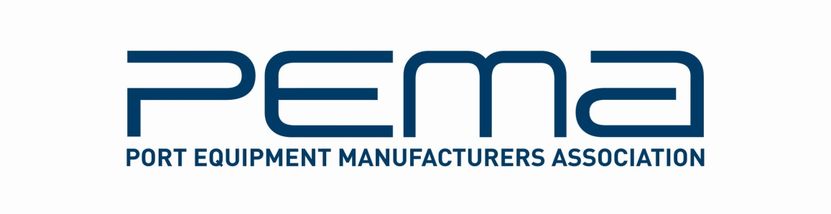

Media Release

PEMA 4th Student Challenge at TOC Europe 2016 to focus on new SOLAS VGM rules

Port Equipment Manufacturers Association (PEMA), the global industry body for port equipment and technology, will host the 4th Student Challenge on 16 June at TOC Europe 2016 in Hamburg

23.05.15 – The Port Equipment Manufacturers’ Association (PEMA) will host the finals of its 4th Student Challenge during the 40th TOC Europe conference and exhibition, taking place in Hamburg, Germany, from 14-16 June.

Founded in 2004, PEMA provides a forum and public voice for the global port equipment and technology sectors. The Association has seen strong growth in recent years, and now has over 100 member companies representing all facets of the industry, including crane, equipment and component manufacturers, automation and software and technology providers.

As part of PEMA’s education outreach, the Student Challenge provides a fun and lively way to expose students to the real business of the ports and terminal world, as well as to highlight university programmes and student talent to the ports business community.

This year, the finalists are University of Hamburg, King Abdulaziz University of Saudi Arabia and French Business School of Normandie, who will each have 25 minutes to present their ideas on the 2016 theme - Compliance Options for IMO SOLAS VGM Regulations.

The judges will confer on the spot and the winning team will be awarded with a cheque for €1000. This year’s judging panel consists of consultants, media, port and terminal industry representatives from DP World Institute, HHLA, FEPORT, TBA and World Cargo News

The PEMA Student Challenge takes place on 16 June from 12:00-14:00 in the TECH TOC Theatre on the TOC exhibition floor and is free to attend for all delegates, speakers, visitors and exhibitors. In PEMA will also be exhibiting at Stand D124.

For details of PEMA events at TOC Europe 2016, visit: www.pema.org/pema-events. To register as a TOC attendee, visit www.tocevents-europe.com

** Ends **

About PEMA
Founded in 2004, PEMA provides a forum and public voice for the global port equipment and technology sectors. The Association has seen strong growth in recent years, and now has over 100 member companies representing all facets of the industry, including crane, equipment and component manufacturers; automation, software and technology providers; consultants and other experts. www.pema.org

For more information on this media release, please contact Rachael White, PEMA Secretary General at rachael.white@pema.org

