Contact Details:
For more information, contact Mike Williams, Press Officer on 07748620235 or newsdesk@ukbjja.org

*For immediate release*

How a Brazilian martial art became a lifeline for one Sheffield woman.

An athlete from Sheffield has just returned from a unique Brazilian Jiu Jitsu (BJJ) training camp in Tenerife. Maia Holmes was offered a sponsored place to train at the prestigious Bulldog Gym in Tenerife, at a camp run by black belt, Ben Poppleton. The camp ran for four days from 30 September to 4 October, 2016.

Maia, a Brazilian Jiu Jitsu blue belt who normally trains at Forge Martial Arts in Sheffield was selected for the all expenses paid trip because of her natural talent and competitive spirit.

Ben Poppleton, one of the UK’s first BJJ black belts, said: ” After discussions with the gym owners where the camps take place, it was agreed that we would sponsor a female athlete to train on the camp, with the objective being to help promote the females in BJJ and women in sport in general. Having contact with a lot of clubs in the UK I selected a young woman who trains at a friends academy who competes regularly, and although she's only been at this 'game' for a short time I believe her demeanour, attitude towards training and general desire to become the very best she can will make her a good role model for other women and girls wanting to train in the art, not to mention the fact that if she continues on the path she's on she'll be one to watch in the future even though she is making waves already on the UK competition circuit.

Maia has only been training for about 18 months. Her first competition was in October 2015. Since then she's competed in 12 more tournaments, winning 17 golds, 3 silvers, and 1 bronze medal.

Maia, who when not training works from home as a beautician, explained how she got into the world of martial arts: “I’ve always been interested in martial arts. I started karate when I was younger, but found it boring but then I tried Thai boxing which I absolutely loved and still do. But then I wanted to do something totally different as well. I’ve always watched the UFC so I knew about Jiu Jitsu, but I’d never tried It myself. So I thought I’d give it a go.”

She claims that BJJ quite literally saved her life, helping her to overcome debilitating depression and anxiety: “at this point in my life, I’d been so isolated from other people, for so long, that even speaking to anyone was quite difficult for me. So you can imagine how hard it was to roll in such close proximity with so many different people. It was overwhelming… but at the same time it intrigued me. I wanted to understand more about this sport that sparked so much passion in everyone I met. After a few months I was hooked. Where antidepressants and counseling had failed; Jiu Jitsu had succeeded. The mats became my therapy. They helped heal me. They gave me the confidence to reclaim my life. For that, I will be forever grateful.”

While in Tenerife she had a unique opportunity to test her skills: “On the third day there was a tournament, organised by another gym. The guys came down one morning and said we’re doing a tournament and if you want to fight in it you’re welcome to - and I thought why not?”

“On the day of the tournament I was eyeballing all the girls, trying to figure out who I’d have to fight - I always work myself up and I get really nervous! Then they called me over and said there are no blue belt women for you to fight. Ben casually says, ‘let’s stick her in the men’s category’. So I ended up having to fight in the blue belt men’s category!”

Maia lost her match on points, but enjoyed the experience. “My opponent was really good. I couldn’t believe how flexible he was and he was strong and fast and I was defending the whole fight. But it was a good experience, it was different to any other fight I’ve had!”

Although relatively new to the UK, Brazilian Jiu Jitsu is now one of the fastest growing sports in the world with over 10,000 people regularly training in gyms across the UK. The governing body is the UKBJJA (http://www.ukbjja.org) which aims to get more youngsters and women active in the sport through regular kids’ competitions and the recently launched Unstoppable Girl programme.

Maia’s current plans involve training hard, competing as often as possible and saving up so that she can compete at the European Championships in Lisbon, Portugal in January 2017.

She also keeps a blog, in which she talks about martial arts, mental health and motivation. You can read about her journey here: https://battlegirlblog.wordpress.com

If you are interested in sponsoring this promising young athlete, you can contact her via the UKBJJA Sponsorship and Communications Director, Francis Lambert: francis.lambert@ukbjja.org

*ENDS*

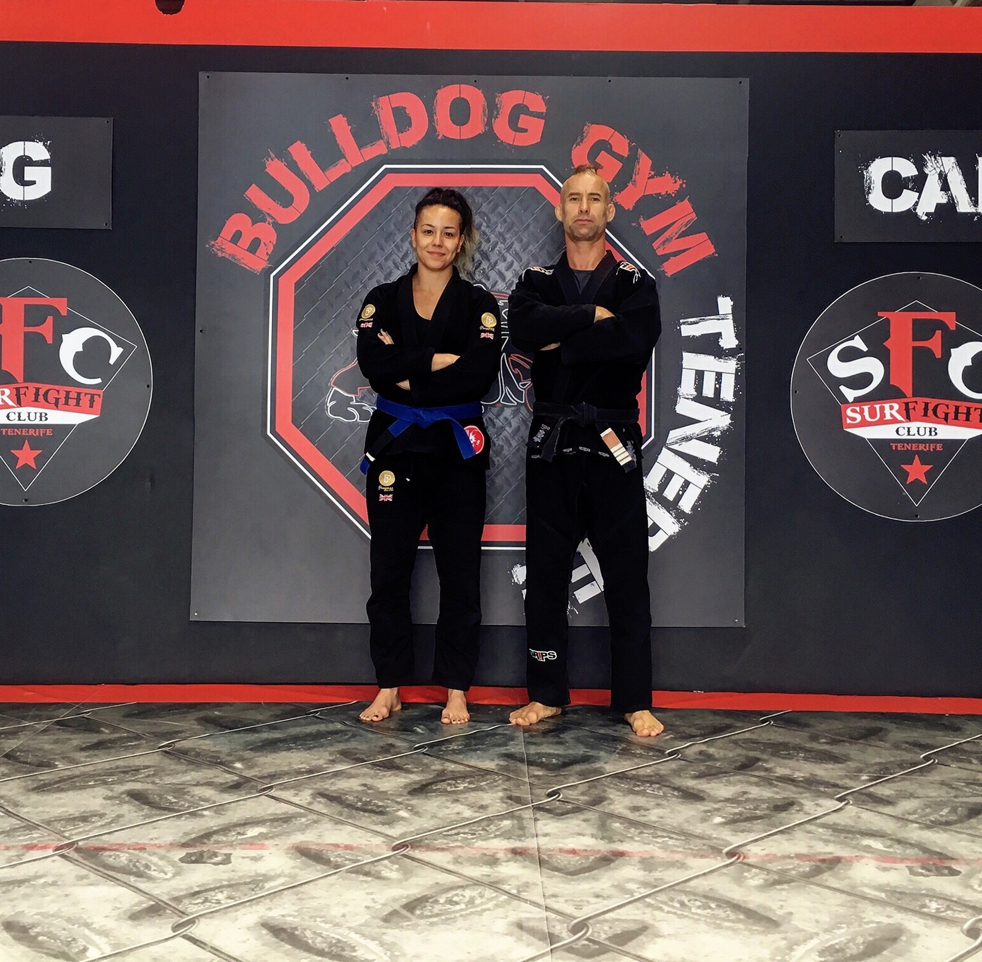
Maia Holmes and Ben Poppleton at the Bulldog Gym, Tenerife.

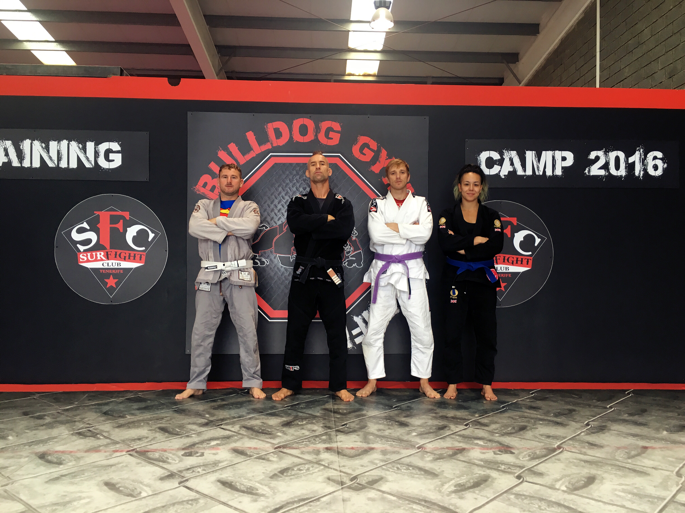
Maia Holmes ( R) and teammates in Tenerife

About the UKBJJA:
The UKBJJA (www.ukbjja.org) is a not-for profit organisation which aims to provide a governance structure for the martial art of Brazilian Jiu-Jitsu, that promotes and develops the sport while allowing individual clubs and practitioners the space and freedom to practice the martial art in the way they enjoy. The UKBJJA is currently under assessment to be recognised by Sport England as the governing body for Brazilian Jiu Jitsu in the UK.
The UKBJJA was formed in 2013, and the association’s goal is to foster the development of BJJ at elite, community and grassroots levels, raising the profile of the sport but also providing pathways for development and involvement across communities in the UK. Visit UKBJJA at www.ukbjja.org or follow us on Twitter @ukbjja.

Additional Info:
Forge Martial Arts: http://www.forgemac.com/index.html
Maia Holmes Blog: https://battlegirlblog.wordpress.com/
Bulldog Gym Tenerife: http://www.bulldoggymtenerife.com
Contact Details:
For more information, contact Mike Williams, Press Officer on 07748620235 or newsdesk@ukbjja.org

