‘Felix’ and ‘Fido’ are in for a treat: colors sourced from nature for pet food
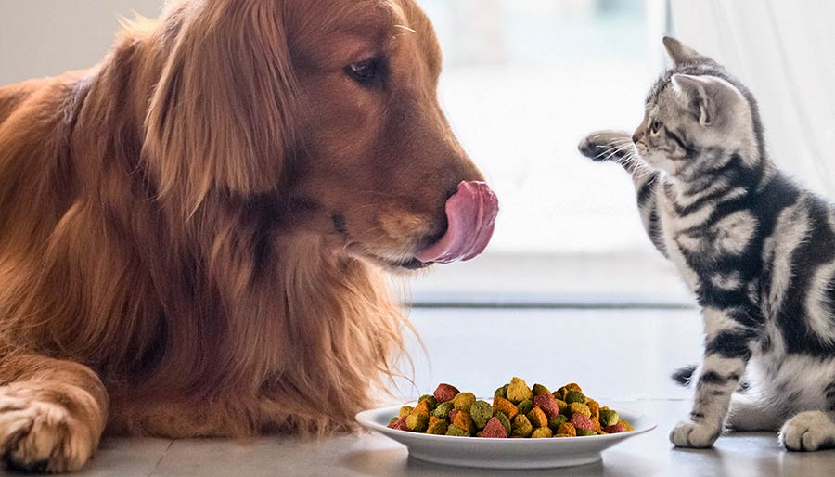

With the launch of a whole new range of ingredients with coloring properties for dog and cat food, Chr. Hansen uses it’s 140-years of formulation and application know-how to support the pet food industry
A full product range is being launched for use in multiple dog and cat food applications – including dry, semi-moist and treats.
The solutions consist of 28 products sourced from nature with coloring properties. The extensive range provides the most common shades for pet food – yellow, orange, red and brown. The range is available in the US and in Europe.
“In partnership with some of the largest manufacturers of pet food – we have gained deep expertise in pet food applications. Together with the launch of this new product range, we provide support for the formulation needed to convert from artificial colors, to natural. With our products and know-how, we help customers achieve the shades that are right for their brand,” explains Rikke Sakstrup Frandsen, Industry Business Manager, Pet Foods.
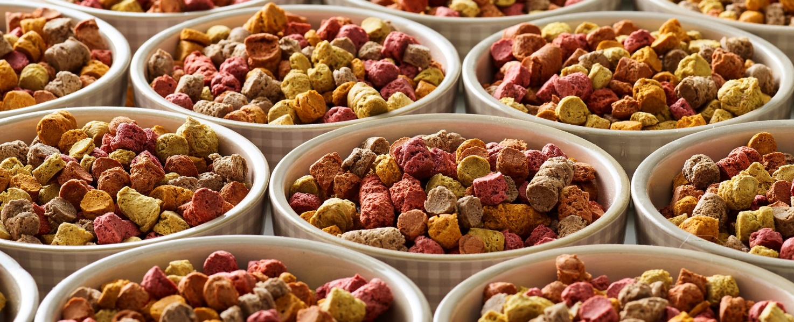
Man’s best friend
Dogs are the most popular pet in the world, owned by one in three people. With nearly 70 million dogs in the US alone, and half of these sleeping in their owner’s bed, it’s no wonder that dogs are big business. Cats are not far behind in popularity, with 23% of people globally living with a pet cat¹. The dog and cat food industries have a combined retail value of approximately EUR 65,5 billion².
Just as consumers are increasingly demanding healthy, natural and safe food for themselves, so too are pet owners increasingly seeking foods for their pets that don’t include artificial ingredients or preservatives³. Pet food manufacturers are responding to consumer demand with premium pet food and pet products.
Following human trends
“Pet trends are closely following human trends. This means that consumer willingness to buy premium pet food products is increasing, with ‘pet parents’ often using similar criteria to select pet food as they use when purchasing food for themselves,” explains Klaus Bjerrum, executive vice president, Natural Colors Division.
“At Chr. Hansen, it is our business to develop natural solutions that meet changing market trends. This enables our customers to boost consumer trust and gives them the leading edge to protect and nurture their brand by meeting changing market preferences. It is in light of these latest market trends in pet food that we have decided to support this industry, using our strong foundation of formulation and application knowledge from over 140-years in the food & beverage industry,” adds Bjerrum.

- Data from a survey by GFK/SCIENTIFIC REPORTS VOLUME 7
- Euromonitor and Chr. Hansen data, 2017
- The Nielsen Company (US), LLC. Trends in pet care mirror those of pet owners, 2018

