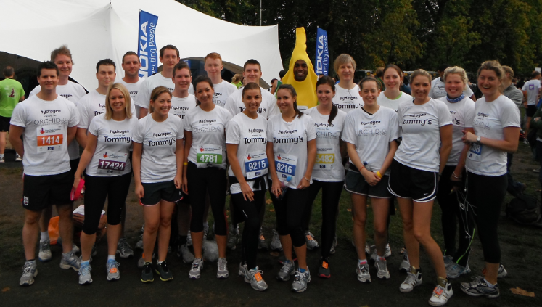

Global recruiters, Hydrogen, get an early morning wake up call to raise over £17k for charity

London, 19th October 2011. It’s not easy like Sunday morning for global recruiters, Hydrogen. After a busy week in the office, Executive chairman, Ian Temple, and non exective director, Ian Fallmann, led a 26 strong employee team, to run the Royal Parks Half Marathon together.

Raising money for UK based local charities, Tommy’s; who fund medical research into miscarriages, premature and still births, and Orchid; who focus on research into and supporting sufferers of male specific cancers, the group were up for the challenge. Comms executive, Debra Forte, said “Knowing 12,000 runners were taking part and 40,000 supporters were lining the route to cheer everyone on motivated me to get across the finish line. Our guys dressed up as bananas got a particularly warm response”.

Hydrogen’s team was made up of runners across all departments, ages and fitness levels. Working well to support each other, fellow colleagues even stepped in to cover for last minute injuries.

Hydrogen has long been committed to giving something back to the community. Earlier this year they set up a company sponsorship fund incentivising employees to fundraise for charities of their personal choice, by offering them each a starting donation of £150. This has proven to be successful in getting more people involved in charity work and embedding its importance into their company culture.

So far this year employees have raised over £20k, and donated computer equipment, for numerous charities.

Talking about the run, Temple said “We’re all delighted to have finished. It may not be the Olympics but 13.1 miles is not an easy task when you’re used to sitting at your desk all day. There’s been a lot of competition between us, with prizes for the fastest male and female, and I was determined not to be last. So far, we’ve generated an overwhelming response to our donation requests and I’m extremely proud of everyone who’s been involved”.

About Hydrogen
We are Hydrogen, a publicly quoted global recruitment consultancy with a focus on mid to senior level opportunities. We believe in building relationships with exceptional candidates that clients can’t find themselves.

We are structured around global practices that combine international reach with local
expertise and specialist knowledge.

We deliver on our promises and we are always professional, straightforward and positive.
This is what makes us Hydrogen and why people love working with us.
For more information visit: www.hydrogengroup.com

About Tommy’s Charity
Funds medical research into miscarriage, stillbirth and premature birth and provides information on having a healthy pregnancy.
For more information visit: www.tommys.org

About Orchid Charity
Formed in 1996 by former testicular cancer patient, Colin Osborne, Orchid is the only UK registered cancer charity to focus entirely on the male-specific cancers; prostate, penile and testicular. They offer support and information to people affected by or interested in male cancer through a dedicated medical research programme, education and awareness campaigns and a range of support services.
For more information visit: www.orchid-cancer.org.uk

