KONGSBERG and ABB announce digitalization collaboration on edge data collection

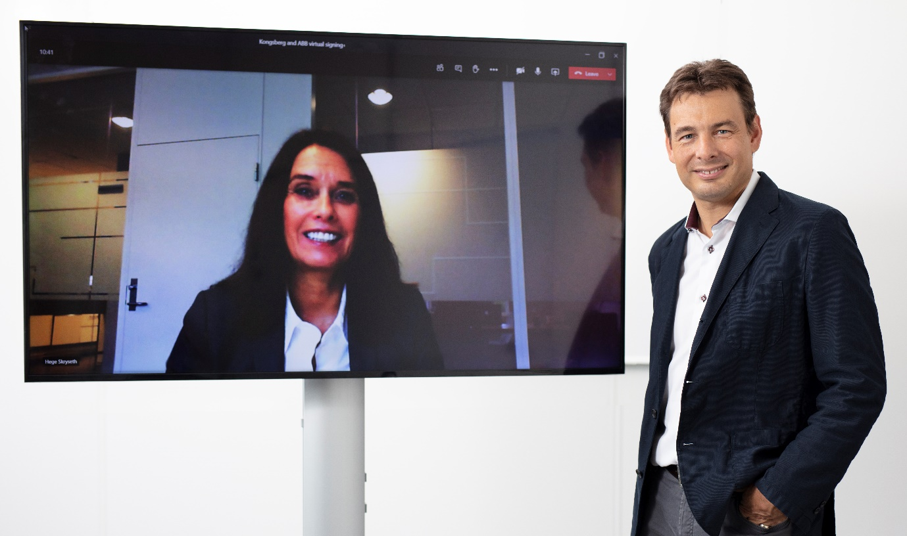
Hege Skryseth, Kongsberg Digital and Cristian Corotto, ABB Turbocharging, digitally shake hands
Oslo/Baden, August 26th, 2020 – Kongsberg Digital and ABB Turbocharging have signed a cooperation agreement on edge data collection and ship engine performance analysis. The companies will work towards a common data infrastructure and accelerate the development of value-added digital applications and services.
The agreement will enable ABB Turbocharging to use Kongsberg Digital’s data infrastructure solution for vessels, Vessel Insight – which runs on Kongsberg Digital’s Kognifai ecosystem – as an additional data infrastructure service for ABB Turbocharging’s digital solutions. Such exchange of data between cloud platforms is fundamental to enabling remote diagnostics on vessel engines. The recent introduction of continuous performance evaluation functionality in ABB’s advisory software for engines, ABB Ability™ Tekomar XPERT, allows time-series engine data to be transferred between platforms.
“Partnerships between major players are key in bringing about high value digital solutions to the maritime sector at a lower cost and faster pace. With Kongsberg Digital and ABB working together to increase the value offering to customers, we can deliver an even more attractive return on investment to vessel owners and operators. We are excited about working together with ABB Turbocharging and our customers to accelerate their digitalization journey,” says Hege Skryseth, President of Kongsberg Digital.
Kongsberg Digital and ABB Turbocharging have a common interest in accelerating the adoption of digital technologies in a safe, reliable and sustainable manner, with the aim of bringing solutions for a safer, smarter and greener maritime industry. The partnership will enable fully automated solutions where all sensors are installed, giving transparency and confidence in data that can be easily shared with other parties and OEMs for value generating purposes. This translates into less workload for the crew.
“This collaboration between two players driving maritime digitalization will take our customers further, faster. Our goal is to empower ship owners and operators to extract the maximum value from their engine data. This cooperation will help to deliver the tools and insights needed to make their vessel operations better, their fleet management more efficient and their businesses more profitable and sustainable,” says Cristian Corotto, Vice President Digital Customer Solutions, ABB Turbocharging.
Vessel Insight is an out of the box solution to solve ship-to-cloud data transmission, and combined with Tekomar XPERT our customers benefit from a fully automated engine performance diagnostics system. Available anywhere, anytime. Although both systems are fully independent and able to integrate with other data sources or share data with other parties, the offered package works seamlessly and comes tailor-made for each ship. The cooperation has a focus on keeping the projects as lean as possible and to deliver with short lead times.
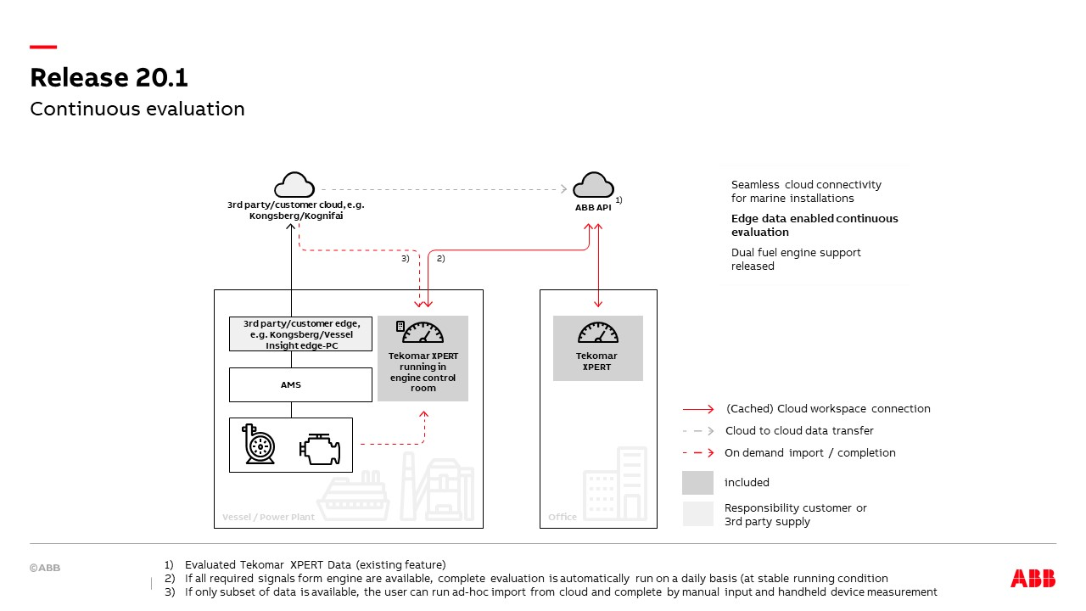
As both ABB’s and KONGSBERG’s solutions have a strong market position in their respective areas, we are convinced that this partnership will provide a tremendous benefit to ship owners, managers and operators who are looking for a state-of-the-art implementation. Highest cyber security standards, interoperability and profound knowledge of marine propulsion, power generation and automation make this combination a simple and valuable choice for a next step towards operational transparency and the digitalization of shipping.
ABB has an industry-leading portfolio of digital solutions – ABB Ability™ - which brings together over four decades of industrial digital leadership, advanced connectivity and the latest digital technologies to create unparalleled customer value.
For further information, please contact:

Mathilde Vik Magnussen
VP Communications & Marketing
Kongsberg Digital
Tel: +47 4567 8255
mathilde.magnussen@kdi.kongsberg.com

Mei Lee
Senior Global Marketing Communications Manager
ABB Turbocharging
Tel: +41 585 85 1874
mei-jiuan.lee@ch.abb.com
David Pugh
Saltwater Stone
Tel: +44 (0)1202 669244
d.pugh@saltwater-stone.com

About Kongsberg Digital
Kongsberg Digital is a provider of next-generation software and digital solutions to customers within maritime, oil and gas, and renewables and utilities. The company consists of more than 500 software experts with leading competence within the internet of things, smart data, artificial intelligence, maritime simulation, automation and autonomous operations.
Kongsberg Digital is subsidiary of KONGSBERG (OSE-ticker: KOG), an international, knowledge-based group delivering high-technology systems and solutions to clients within the oil and gas industry, subsea, merchant marine, defence and aerospace. KONGSBERG has 11,000 employees located in more than 40 countries.
Web: Kongsberg Gruppen | Kongsberg Digital
Social media: LinkedIn | Twitter | Facebook

About ABB Turbocharging
ABB Turbocharging is at the helm of the global industry in the manufacture and maintenance of turbochargers for 500 kW to 80+ MW diesel and gas engines. Our innovative leading-edge technology enables our customers to increase their performance; producing lower emissions, and improving fuel consumption even in the toughest environments. Approximately 200,000 ABB turbochargers are in operation across the globe on ships, power stations, gen-sets, diesel locomotives and large, off-highway vehicles. We have over 100 Service Stations in more than 50 countries globally and a wide service portfolio that guarantees Original Parts and Original Service anytime, anywhere.
ABB (ABBN: SIX Swiss Ex) is a leading global technology company that energizes the transformation of society and industry to achieve a more productive, sustainable future. By connecting software to its electrification, robotics, automation and motion portfolio, ABB pushes the boundaries of technology to drive performance to new levels. With a history of excellence stretching back more than 130 years, ABB’s success is driven by about 110,000 talented employees in over 100 countries.
Web: ABB Group | ABB Turbocharging

