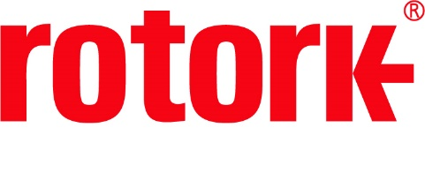
APPROVED PRESS RELEASE 1.268 5th August 2020
Rotork launches Lifetime Management Services
The new Lifetime Management service changes the way that Rotork Site Services (RSS) operates, with a stronger focus on ensuring the most appropriate response based on the criticality of the customer’s application.

The new four tiered approach proves optimal for identifying the unique needs of a customer and providing appropriate support. These tiers are Health Checks, Planned Maintenance, Enhanced Warranty and Predictive Maintenance.

A Health Check is an assessment of actuator asset condition relative to design specification and operational use. Through this, we can help the customer to identify the condition of their current assets and suggest an appropriate maintenance plan moving forward.
The Planned Maintenance tier encompasses thorough, intrusive product inspections and pro-active repair management. The data logger and configuration will be benchmarked, environmental O-rings and batteries may be replaced (if necessary) and functional tests (manual, remote and local) will be carried out. Additionally, Planned Maintenance provides access to spare parts as part of our obsolescence programme.
Enhanced Warranty provides an extended warranty period and condition-based monitoring. This encompasses at least two Health Checks a year and a review of historic performance, obtained through data logger interrogation.
The final tier, Predictive Maintenance encompasses everything that the previous tiers provide, with the added provision of identifying potential problems before they are able to manifest. Data logger records are compared through machine learning and the patterns which occur prior to failures are identified. If these patterns are later identified within functioning actuators, we work with customers to proactively implement mitigation plans.
Dave Godfrey, Rotork’s Services & Aftermarkets Product Manager, commented: “Lifetime Management centres around maximising process uptime and asset availability for our customers. The different levels of support on offer allow our customers to mix and match in order to design a truly bespoke level of support to best match their individual site needs. Having Rotork involved in the management of their assets will allow them to keep up to date with product support and service as their installation base matures.”

END
Photo captions
A Rotork engineer works to ensure the efficient running of key assets.

For further information please contact Rotork PLC
Sarah Kellett Brassmill Lane
Group Marketing Communications Manager Bath
Telephone: +44 (0) 1225 733492 BA1 3JQ
Email: Sarah.Kellett@rotork.com UK

About Rotork
Rotork is a market-leading global provider of mission-critical flow control and instrumentation solutions for oil and gas, water and wastewater, power, chemical process and industrial applications. We help customers around the world to improve efficiency, reduce emissions, minimise their environmental impact and assure safety.

