Epson High-Capacity Ink Tank Inkjet Printers Exceed Cumulative Global Sales of 30 Million Units
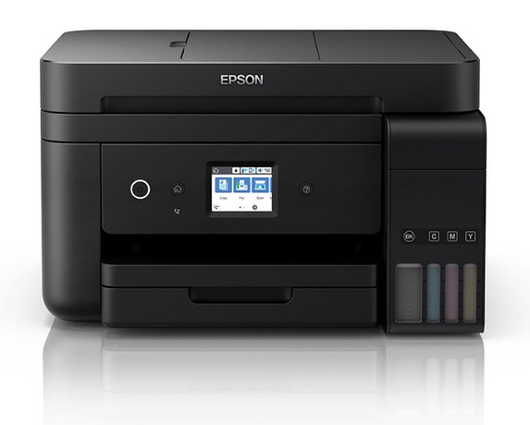

High-Capacity Ink Tank Inkjet Printer
(Photo: L6190/ET-4750*¹)

Kuala Lumpur, Malaysia, 26 July 2018, –

Seiko Epson Corporation (TSE: 6724, “Epson”) announces that cumulative global sales of Epson’s high-capacity ink tank inkjet printers have reached 30 million units.

Epson first launched high-capacity ink tank inkjet printers in October 2010 in Indonesia. The company had by the end of FY2017 (ended March 2018) introduced the printers in about 150 countries and regions, with growth in emerging economies causing the proportion of high-capacity ink tank products in the overall inkjet printer market to grow annually. Epson has continued to maintain the number one share of the market*² in these products due to its strong brand recognition in the market and its abundant line-up.

In FY2018 (ending March 2019), Epson will further accelerate the shift from conventional ink cartridge models to high-capacity ink tank models with the aim of establishing the latter as the inkjet printer mainstream. In both emerging and advanced economies, the company will also continue to promote the replacement of laser printers with high-capacity ink tank inkjet printers by enhancing its line-up with products with overwhelming cost performance and enhanced ease-of-use. Through these efforts, Epson plans to sell 9.5 million high-capacity ink tank products in FY2018 – an increase of 20% compared to the previous fiscal year. This is expected to account for about 55% of total Epson inkjet printer sales.

Koichi Kubota, Director, Senior Managing Executive Officer and Chief Operating Officer, Printing Solutions Operations Division of Seiko Epson commented, “High-capacity ink tank inkjet printers have a low environmental footprint, have lower running costs, and take less time to print compared to laser printers and ink cartridge printers. Epson has transformed the printer business model and will continue to provide comfortable printing environments that allow our customers around the world to demonstrate their creativity and enjoy high productivity.”

*¹ Note that Epson products and services vary by region.
Please refer to your local Epson sales company for details of products and services available in your region: http://www.epson.com.my.my

*² The number of global high-capacity ink tank products sold from 2010 to 2017. This is based on IDC Worldwide Quarterly Hardcopy Peripherals Tracker 2018Q1.

***

About Epson
Epson is a global technology leader dedicated to connecting people, things, and information with its original efficient, compact, and precision technologies. With a line-up that ranges from inkjet printers and digital printing systems to 3LCD projectors, watches and industrial robots, the company is focused on driving innovations and exceeding customer expectations in inkjet, visual communications, wearables, and robotics.
Led by the Japan-based Seiko Epson Corporation, the Epson Group comprises more than 76,000 employees in 87 companies around the world and is proud of its contributions to the communities in which it operates and its ongoing efforts to reduce environmental impacts.
http://global.epson.com/

About Epson Singapore
Since 1982, Epson has developed a strong presence across major markets in Southeast Asia and South Asia. Led by the regional headquarters Epson Singapore, Epson’s business in Southeast Asia spans an extensive network of 11 countries with a comprehensive infrastructure of close to 500 service outlets, 7 Epson solution centres and 7 manufacturing facilities.
http://www.epson.com.sg

About Epson Malaysia
Epson Malaysia Sdn Bhd was established in Malaysia in 1991 as Epson Trading (M) Sdn Bhd, a sales company of the Seiko Epson Corporation, Japan. The company has exclusive rights to market, distribute and support a complete range of leading-edge Epson consumer and business digital imaging products in Malaysia and Brunei. Today, Epson Malaysia has 84 employees and an extensive network of 59 authorised service outlets nationwide. For more info, please visit www.epson.com.my or connect with us at www.facebook.com.my/EpsonMalaysia

Media Enquiries:
Epson Malaysia Sdn Bhd  Chua Li Tinn  Manager – Marketing Communications  Tel: (03) 5628 8288 Ext 274  Email: ltchua@emsb.epson.com.my | SWOT Communications Sdn Bhd  Vino Nair  Tel: 016 365 6268  Email: vino@swotcommunications.com

