Press Release
Stockholm, October 31, 2017

Svenskt Tenn opens furnishings studio

This autumn, Svenskt Tenn will open a furnishings studio to provide even better customer service and shorter delivery times. The atelier is staffed by three skilled craftsmen, all of whom have recently fled to Sweden.

Set to open on October 30, the furnishings studio is located at Strandvägen 57 in Stockholm, only a few steps from the Svenskt Tenn store. The services offered will include made to measure cushions and drapes with details such as fringe bands and hand stitched rings, as well as other types of specialty sewing. The work is performed by three tailors under the direction of Andrea Bernström, a professional dressmaker who used to run her own studio before joining Svenskt Tenn in 2016.
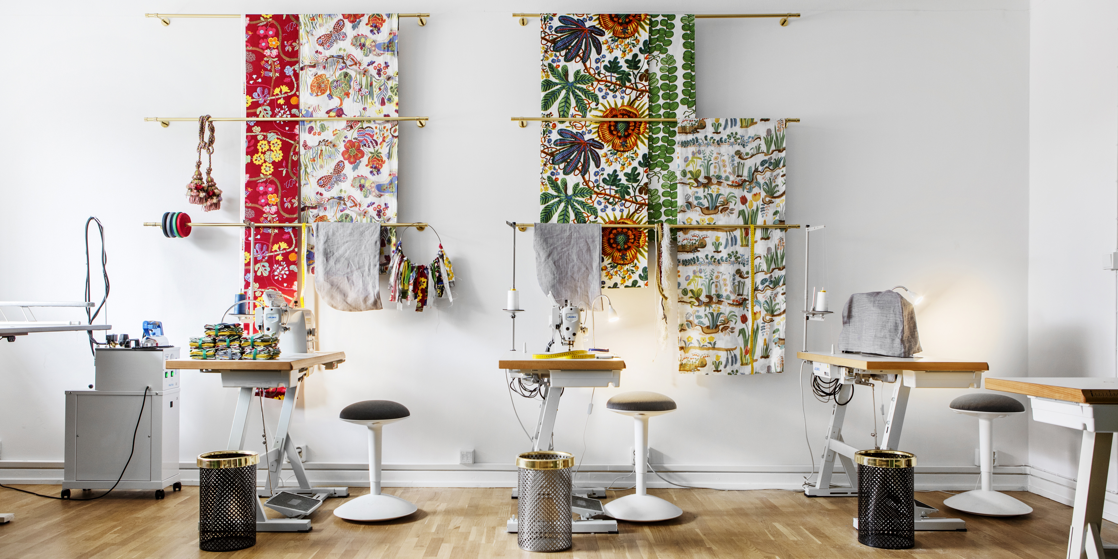
Shakib Aloto, a native of Aleppo, Syria, is one of the new tailors at Svenskt Tenn. Aged 27, he came to Sweden a year ago. Lacking formal schooling, he has been sewing since childhood and has previously been employed by a jeans manufacturer. Preparing himself for the opening of the furnishings studio, Shakib has stayed with Caravanserai in Gävle for professional introduction. A partner of Svenskt Tenn, Caravanserai offers home improvement services such as sewing, masonry, painting and wallpapering, by craftsmen from around the world.

The furnishings studio at Strandvägen is an educational and integration program developed together with Pia Lundström, social worker and founder of Caravanserai, who has many years of experience from integration efforts. Employees will have the opportunity to study Swedish part-time during work hours.

”This is a fine opportunity for us to absorb the skills of craftsmen who have found refuge in Sweden, just as Estrid Ericsson did with Josef Frank in the early 1930s,” says Maria Veerasamy, CEO of Svenskt Tenn.

Jewish architect and designer Josef Frank had then left his homeland Austria by account of the rampant anti-Semitism in Europe at that time. Svenskt Tenn’s founder offered Josef Frank a platform for continuing his design work in Sweden.

”This became her way of confronting the bigotry and xenophobia of that era, while contributing to establish Svenskt Tenn as the premium brand recognised today. We are committed to building on this legacy,” says Maria Veerasamy.

For further information, please contact:

Vicky Nordh, Marketing Assistant: +46 8-670 16 23 or vicky.nordh@svenskttenn.se

Thommy Bindefeld, Marketing Director: +46 8 670 16 02 or thommy.bindefeld@svenskttenn.se

Images can be downloaded from svenskttennpress.se. Username: Press. Password: Tenn

Svenskt Tenn is an interior design company with retail stores at Strandvägen in Stockholm and online. Since 1975, Svenskt Tenn is owned by the Kjell and Märta Beijer Foundation, which provides research grants within ecology, medicine and the preservation of Swedish interior design tradition.

