FOR IMMEDIATE RELEASE

Intellian’s innovative new v45C antenna brings VSAT to smaller vessels

Compact and lightweight 45cm antenna solution enables
advanced and reliable VSAT connectivity for all
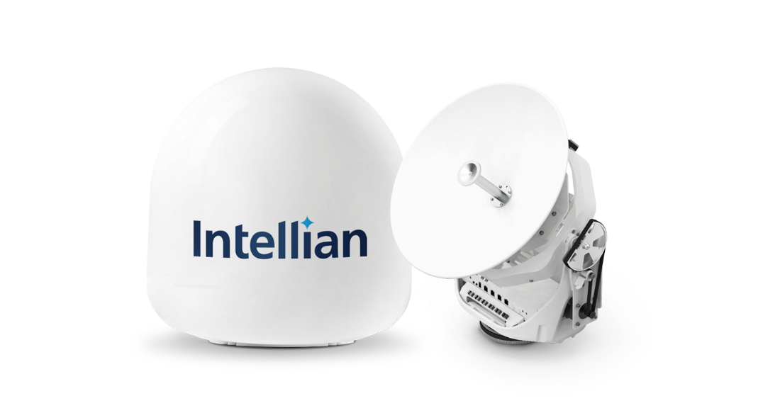
Intellian’s innovative v45C antenna offers a compact VSAT solution for space-limited installations

15 February 2021 – Intellian is proud to announce the v45C, the smallest antenna the company has yet developed for the maritime satellite communications market. The C in the product name represents its compact form factor: this new 45cm unit will bring VSAT to new markets where there is limited space available for communications equipment, such as workboats, leisure craft, fishing boats, small commercial and government vessels.
Intellian is committed to empowering connectivity for all, and recent launches have focused on enhancing user experience and capabilities with smaller VSAT solutions; first with the 60cm v60E antenna launched last year, and now the v45C. The v60E has been a global success across multiple markets, with a significant volume of installations and sustained growth demonstrating that small VSAT is a key area of interest for both new and existing customers. The v45C extends the portfolio still further, opening up a new market of smaller vessels which have yet to benefit from the data speeds and capacity delivered by VSAT.
Both the v60E and the v45C draw on the advanced technology developed for Intellian’s NX Series antennas, which range in size from 85cm to 150cm. Installation is made straightforward by single-cable, dome-on connection, while commissioning is facilitated by the built-in, browser-based AptusNX antenna management and diagnostics software. This enables the installer to follow a simple wizard to get the system up and running, and permits both local and remote diagnostics.
Eric Sung, CEO, Intellian Technologies, said: “We’re delighted to launch the new v45C antenna, which is an innovative and keenly anticipated addition to our maritime VSAT product portfolio. The v45C antenna will deliver compact, cost-effective connectivity to multiple customer segments, especially those which have been unable to install VSAT in the past owing to space considerations or performance constraints. We expect the v45C to open up new markets, and look forward to collaborating with new customers to help them make the most of the many advantages that VSAT connectivity with Intellian products has to offer.”
Smaller antennas have been made possible through Intellian’s innovative design and the introduction of new high-throughput (HTS) satellite technology by multiple network operators. HTS satellites use spot beam technology to deliver focused, high-power service to smaller areas. This enables frequency re-use across the satellite’s coverage area and reduces cost, and for service providers means that a small antenna can deliver connectivity and performance at reasonable cost to the customer. Intellian are now leveraging these advances to bring their innovation and reliability to transform connectivity for all.
-Ends-

For further enquiries, please contact:
Sadie Brown / Marketing Manager
Intellian Ltd
T +44 2380 019 021 ext. 1612
Sadie.Brown@intelliantech.com
David Pugh
Saltwater Stone
T +44 1202 669 244
d.pugh@saltwater-stone.com

About Intellian Technologies
Intellian is a leading global technology and solutions provider for satellite communications, empowering connectivity for the maritime, government, military, energy, cruise and enterprise sectors. Founded in 2004, Intellian is renowned for its innovative design, future-proofed technologies and outstanding customer support, which combined with continued investment in its partners, logistics network, quality control and low environmental impact production facilities make it a trusted enabler within the satellite communications industry. Its bold, pioneering solutions include the award-winning v240MT – the world’s first tri-band, multi-orbit antenna system – and the future-proof NX series antennas, optimized for high performance and low cost of ownership.
Intellian has a worldwide presence with over 400 employees, 10 global offices and five logistics centers on three continents. Intellian Technologies Inc. is listed on the Korean Stock Exchange, KOSDAQ (189300:KS).

