For Immediate Release

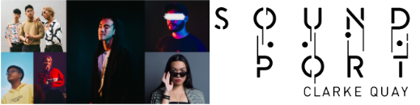

Sound Port Clarke Quay to feature Singapore’s Fastest-Rising Artists
- Expect a brand-new audio-visual spectacle at the iconic Clarke Quay Fountain Square 14 - 16 November

Press Release 24th October 2019, Singapore - In a move to feature creative collaborations and support rising stars in the local music scene, Clarke Quay will be launching a new music series called Sound Port, a brand new audio visual spectacle held at Clarke Quay’s Fountain Square. The first edition will take place 14 to 16 November (Thursday to Saturday), 7pm - 1130pm, with a stellar lineup of exciting electronic artist and DJS - MYRNE, A/K/A Sounds, brb., Duumu, Shye and YAØ.

MYRNE is no stranger to the international electronic music scene. He performed at Tomorrowland (Belgium), one of the most revered and popular EDM festivals in the world and was also the first Singaporean to perform at Ultra Miami. Currently on a ten-city tour in the US to promote his latest album “In Search of Solitude”, MYRNE will be returning fresh to Sound Port on 15 & 16 November to unveil a never-seen-before live performance of his latest material in Singapore.

DJ and producer, Duumu, who has since reached over five million plays on Spotify and Soundcloud, will turn heads with his fresh take on electronic music. Joining him on the second night of Sound Port are some of the youngest breakthrough artists in Singapore. Winner of the first-ever Singapore Youth Music Awards 2019 “ New Kid on the Block” category, singer-songwriter and producer YAØ will ease the crowd into the mood with hits such as “Scenery” and “RHCF” which has since garnered 700,000 streams on Spotify. Shye, winner of 2018’s Vans Musician Wanted, will showcase her signature mix of bedroom indie and electronic pop.

The music continues on 16 November with R&B, Hip-hop and Soul collective brb. comprising Auzaie Zie, Clarence Liew Oliveiro and Marc Lian who have amassed more than 90,000 Spotify listeners in the short span of a year. Making waves across Asia with their iconic sound, the trio will treat party-goers to a sneak peak of their upcoming EP. Not to be outdone, DJ and co-founder of ATTAGIRL! + BAOWBAOW- A/K/A Sounds will amp up the atmosphere with her inimitable presence and distinct style of electronic music.

Sound Port Clarke Quay will be completed with an immersive, experiential and dynamic environment. Hanging neon-lit geometry, an infinity optical-illusion mirror hypercube, holographic photo walls and illuminated multi-layer visuals are some of the visually spectacular design infrastructures one can expect at Sound Port. As part of the instalment, pop-up food and drinks stalls from new outlets Live at the Crossroads and Gabbar will be serving fusion food and drinks to fuel party-goers.

Sound Port Clarke Quay is the first of a three-part music series presented by Clarke Quay in collaboration with music media company Bandwagon. Admission is free. The first 100 party goers will receive a complimentary drink on the 14th of November.
######

*Every effort has been made to ensure that the information here is accurate at the time of publication. However, changes to the information may have occurred since going to press. Please check www.clarkequay.com.sg for the latest information.
Pg 1 of 4

Media Contact: Yvonne Phua | Empower Marketing Asia | yvonne.phua@empowerasia.biz +65 9236 5356
High resolution images are available at this link: http://bit.ly/ClarkeQuaySoundPort
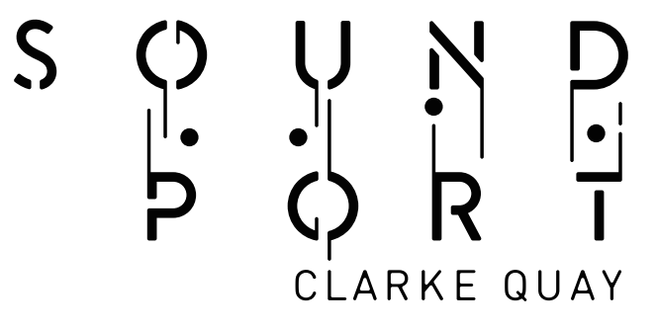
Sound Port Clarke Quay Event Information
Date: 14 - 16 November 2019, Thursday to Saturday
Time: 14 Nov – 7pm to 9pm, 15 Nov – 7pm to 11:30pm, 16 Nov – 7pm to 11:30pm
Venue: Clarke Quay Fountain Square
Event Website: https://www.capitaland.com/sg/malls/clarkequay/en/events/sound-port-clarke-quay-2019.html
Media Preview: 14 November, Thursday
7pm - 9pm Duumu
Day 1: 15 November, Friday
7pm - 7:45pm YAØ
8pm - 8:45pm SHYE
9pm - 9:45pm Duumu
10pm - 11pm MYRNE
Day 2: 16 November, Saturday
7pm - 7:45pm YAØ
8pm - 8:45pm brb
9pm - 9:45pm A/K/A Sounds (ATTAGIRL!)
10pm - 11pm MYRNE

Artist Bios
MYRNE
Known for his intersections in Pop, Bass and high- energy Electronica, MYRNE began his journey in 2015 with the release of his 'Softsins' EP on dance music behemoth Mad Decent, inaugurating himself as the first Asian on their roster. His experiences in isolation growing up in Singapore, coupled with his classical training, has granted him a unique outlook on electronic music - with support from the likes of Diplo, Madeon and Martin Garrix as a testament to that fact. An artist of varied influences ranging from Erol Alkan to Rustie, his musical versatility shines through his collaborations, remixes, and writing credits. In 2017, he released the seminal electronic-indie LP “B4NGER PROJECT” with long-time collaborator Gentle Bones on Universal Music, followed by co-production work on RL Grime's “I Wanna Know” in 2018 - with the latter going on to rack up over 30,000,000 streams on Spotify alone.
Instagram: https://www.instagram.com/myrnemusic/
Spotify: https://open.spotify.com/artist/41DKMtAnhVo7aDeluAHDJg?si=KFfMPEXpQciFCWGTovAeyg

A/K/A SOUNDS Amanda Keisha Ang
Tattoo apprentice/designer/lecturer by day, and bedroom party fiend by night, A/K/A SOUNDS - also known as Amanda’s early foray into music was through the influence of her father, who bought her very first guitar and provided a constant appetite of sounds from his immense vinyl collection, art movies and books. This enthusiasm naturally led her discovery of electronic music, and eventually sealed her love in the genres of House, Hip-hop, Dancehall, Footwork, Jungle and Drum & Bass. Still a youngling to the scene, Amanda continues to show an impressive work rate, guest DJing in cities such as London, Antwerp, Brussels, Berlin, Munich, Amsterdam, Bali,Tokyo, Mumbai etc. and playing at festivals like ZoukOut, Outlook Japan and St Jerome’s Laneway Festival.
Instagram: https://www.instagram.com/akasounds/
Pg 2 of 4

brb.
Formed in a home studio in central Singapore, brb. is the product of what started out as a passion project between three like-minded individuals and their love for R&B, Hip Hop and Soul. Comprising of Auzaie Zie, Clarence Liew Oliveiro and Marc Lian, brb creates music that amalgamates the nostalgia of the 80s and 90s with the sounds of today. Since their debut in late 2018, they have garnered listeners from across Asia with their iconic songs, “Cool With It” and “Talking To Myself”. Heavily inspired by their personal stories and emotions, each song is a sonic representation of a moment, a feeling, a state of mind. With only a handful of singles out, the up-and-rising trio is set to carve out a unique identity with their upcoming EP slated for early 2020."
Instagram: https://www.instagram.com/holdonbrb/
Spotify: https://open.spotify.com/artist/2XBiI8PjCnjJ3XKWtiKcvc?si=xUQYRm24TXa-E_UyQ93Wcw
Duumu
At just 20 years of age, Duumu is at the forefront of a new breed of electronic music producers marked as ones to watch. With a fresh take on the future sounds of electronic music, DJ and producer Duumu has been turning heads with his releases over the past year, already having released six singles and an EP on taste making Canadian label: Monstercat (responsible for breaking artists such as Marshmallow) and recently Bitbird (San Halo’s label). With over 5 million plays on Spotify and Soundcloud, he shows no signs of slowing down. Born Charlie Kurata, this energetic French producer was influenced by his upbringing around jazz and rock musicians in Paris and London. Duumu draws from the old and new to create a refreshing sound, full of finesse and and never short of energy. He is currently touring the festival circuits and will be DJ-ing at Sound Port’s media preview.
Instagram: https://www.instagram.com/duumu_/
Spotify: https://open.spotify.com/artist/6q8cRPrSLahGAZSVnjIYjF?si=3dRVlnDCRCSjQhjM3lt5Ww
SHYE
Shye is a 17-year-old artist from Singapore. In the solitude of her bedroom, Shye experiments, writes and produces everything by herself. She has been likened to artists such as Clairo and Billie Eilish. Shye’s music can be described as a mixture of dream pop, and bedroom pop, with a dash of electro-pop. Her performances are light-hearted but always carry the important message of loving oneself. Shye was the winner of Vans Musicians Wanted 2018 and has performed at Baybeats Festival 2019, Whabby Music Festival 2019 and opened for international artists such as Clairo and Superorganism.
Instagram: https://www.instagram.com/shye.mp3/
Spotify: https://open.spotify.com/artist/1aqEk77J220IxgnGsgEz9T?si=eLIeQdlVRtGzpmBflI7EnQ
YAØ
YAØ is a R'&'B singer, informed by a keen love for 80’s New Wave and Japanese City Pop. His musical confections sound like a lovechild of urban soul and anime theme songs. His 2018 tune ‘No Stress’, with underground rapper Ae$Op Ca$H, has gone heavy rotation on Singapore’s radio station 987. The single has won support from Canadian, American and Australian music sites like Uranium Waves, Chill N Trap and Asian Pop Radio. ‘No Stress’ has been added onto Deezer Asia’s Singapore Sound playlist. His latest single ‘RHCF’ hit over 100,000k streams just a month after it’s release. As an upcoming music act, YAØ is definitely making steady waves in the music scene. In 2017, his debut single 'Wish U The Best' is a house/ pop-inspired number aimed for the dancefloor.
Instagram :https://www.instagram.com/yaogotwav/
Spotify: https://open.spotify.com/artist/65ZzuNL3HmtwhF9akIKXuJ?si=s2faAJrQRsK5CQaLIIiVtg
High resolution images are available at this link: http://bit.ly/ClarkeQuaySoundPort
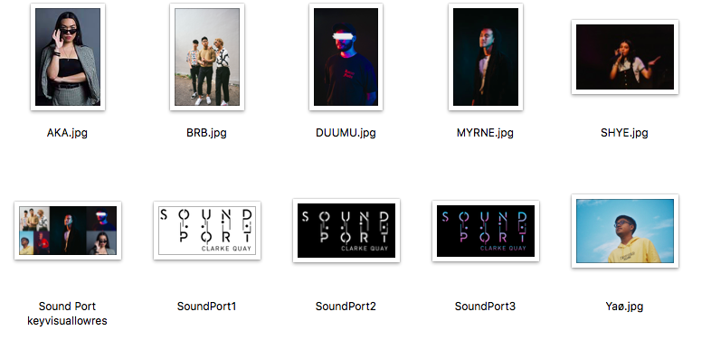
Pg 3 of 4
About Clarke Quay
Clarke Quay is a unique conserved landmark located along the Singapore River. It is within walking distance of Clarke Quay and Fort Canning MRT Station, making it accessible by public transportation. Comprising five blocks of restored shophouses and warehouses, Clarke Quay plays host to more than 60 restaurants, wine bars, and entertainment spots. Day and night, you can savour a mix of international cuisines at established dining concepts. When the sun goes down, have drinks at the widest selection of bars with live music or party at some trendiest nightspots in Singapore.
Experience wine, dine and good times only at Clarke Quay.
Website: www.clarkequay.sg
Like us on Facebook: http://www.facebook.com/ClarkeQuay
Follow us on Instagram: http://www.instagram/clarkequaySG

Festive Promotions with CapitaStar
Spend and Win Lucky Draw
Duration: 31 October to 31 December 2019
Stand a chance to win 1,000,000 STAR$ (worth $1,000 CapitaVouchers), staycations at lyf Funan, Party Experience Package at Yang Club and ZOUK, Power Beats Pro and complimentary dining treat at Octapas Spanish Tapas Bar, Talay Thai & more in the CapitaStar in-app Lucky Draw with every $80.00 spent at Clarke Quay, simply scan and win!

Dine with the STAR$
Seeing STARS? Earn up to 20,000 STAR$® when you wine & dine at Clarke Quay! From 3pm daily
- Receive 5,000 STAR$® (worth $5 CapitaVoucher) when you spend $80.00 and above (below $150) in a single receipt.
- Receive 15,000 STAR$® (worth $15 CapitaVoucher)when you spend $150.00 and above (below $200) in a single receipt.
- Receive 20,000 STAR$® (worth $20 CapitaVoucher) when you spend $200.00 and above in a single receipt.

CapitaStar New Member Sign-up promotion
Duration: 31 October to 31 December 2019
Receive a $38 e-voucher from Spice World Hot Pot 香天下火锅 when you sign up to be a CapitaStar member using the promo code "CQS38". Limited to the first 500 sign ups.

On-going Promotions
Lunch by the Quay
Lunch along the Singapore River with over 25 deals of set lunches for under $25. You can receive 5000 STAR$® when you scan 2 lunch receipts (between 12pm to 3pm) from 2 different Clarke Quay outlets within a month via the CapitaStar Mobile App or earn 2x STAR$® or lunch receipts scanned in Clarke Quay.
Details: https://www.capitaland.com/sg/malls/clarkequay/en/Lunch-by-the-Quay.html

Sunday Play Dates
On the first Sunday of every month, kids get to eat for free for every 2 paying adults at selected restaurants (Fremantle Seafood Market, Hot Sones, McGettigan’s and Talay Thai) and can enjoy playing at the bouncy castles, inflatable slides and children’s games around the Fountain Square from 12pm to 5pm.
Details: https://www.facebook.com/events/376873729737254/

Pg 4 of 4

