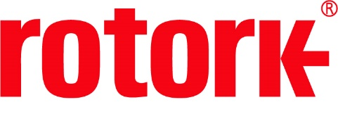
APPROVED PRESS RELEASE (3.1163) 30th October 2020
Rotork aids production of carbon-free hydrogen with CVL actuators on electrolysis skids
Rotork CVL linear process control actuators have been provided to French equipment manufacturer AREVA H₂Gen where they will play a critical role within a hydrogen generator.
AREVA H₂Gen have a unique method of producing carbon-free hydrogen through water electrolysis, which involves the use of proton exchange membrane (PEM) technology. They are the first French manufacturer to make hydrogen generators using this method. Each electrolysis skid is equipped with multiple CVL actuators which are mounted on globe valves and regulate the pressure and level of the water that is at the heart of the process.
Electrolysis of water is the process of applying an electrical current to water to create hydrogen and oxygen. The electricity that is applied to the water is sourced from surplus wind and solar energy producers. The carbon-free hydrogen that is produced can replace fossil fuel-based hydrogen and is easy to store in a way in which electricity isn’t. It is therefore easily transportable and can be injected into existing gas networks or used in transport networks.
In order for the process to be completed successfully, very precise control is needed. CVL-500 actuators were chosen for their high movement frequency and their quick reactivity. The fail-safe functionality (using built in supercapacitors) of the actuators was important to prevent potential disaster on loss of power. Additionally, their ATEX IIC certification was a further requirement; this is essential in an environment where hydrogen is present. The robust design of CVL actuators ensures that they will have a long lifetime in this application, helping to mitigate the cost by reducing the need for replacements.

END

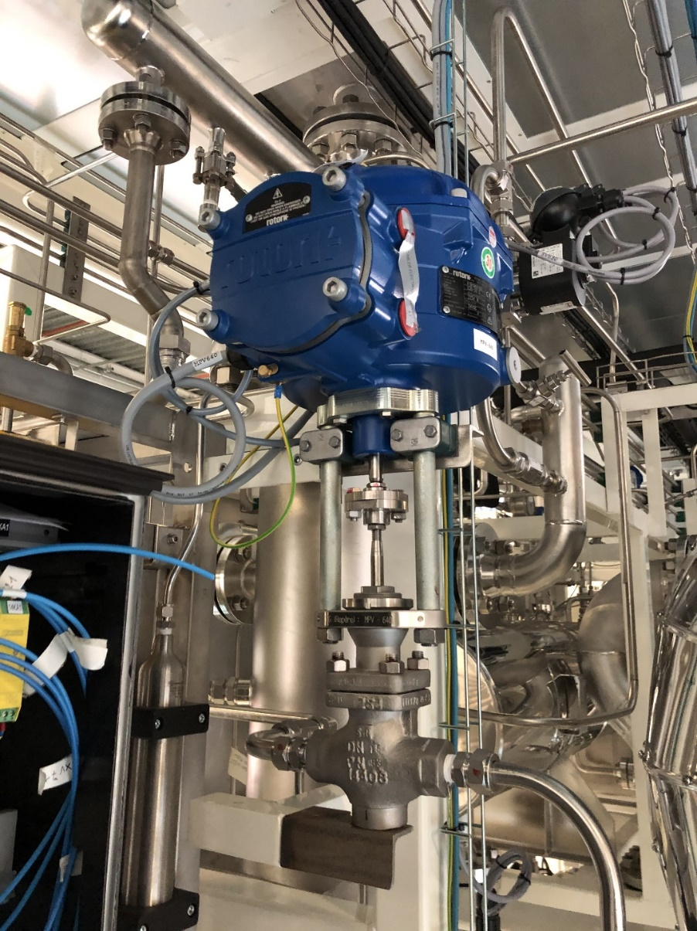

Photo caption
A CVL linear electric process control actuator controlling the flow of hydrogen in a hydrogen generator.

For further information please contact Rotork PLC
Sarah Kellett Brassmill Lane
Group Marketing Communications Manager Bath
Telephone: +44 (0) 1225 733492 BA1 3JQ
Email: Sarah.Kellett@rotork.com UK

About Rotork
Rotork is a market-leading global provider of mission-critical flow control and instrumentation solutions for oil and gas, water and wastewater, power, chemical process and industrial applications. We help customers around the world to improve efficiency, reduce emissions, minimise their environmental impact and assure safety.

