UNDER EMBARGO UNTIL JAN. 21, 2020
@ 9AM ET / 2PM BST / 9PM TAIPEI

SteelSeries Launches the Rival 3 Gaming Mouse, Apex 3 and Apex 5 Gaming Keyboards

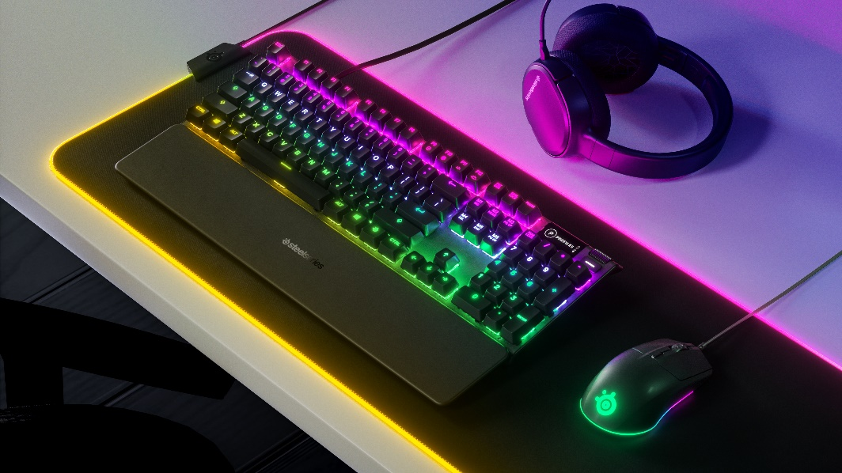

SteelSeries goes after boring office peripherals with new line of high-performance gaming gear accessible for any gamer

CHICAGO – January 21, 2020 – SteelSeries, the leader in gaming and esports peripherals, today announces the Rival 3 gaming mouse, and Apex 3 and Apex 5 gaming keyboards – high performance gaming peripherals approachable for any gamer. With these products, SteelSeries has sought to bring the innovation and performance of its most premium offerings to a wider audience of gamers.

“There are so many gamers out there that are stuck using boring, traditional office peripherals for gaming,” said Ehtisham Rabbani, SteelSeries CEO. “With these new products, we set office products in our sights and sought to retool our cutting-edge technologies and put them into products that are accessible for every gamer. No one should have to be stuck using run-of-the-mill office products for gaming.”

Rival 3 – Outshine the Competition

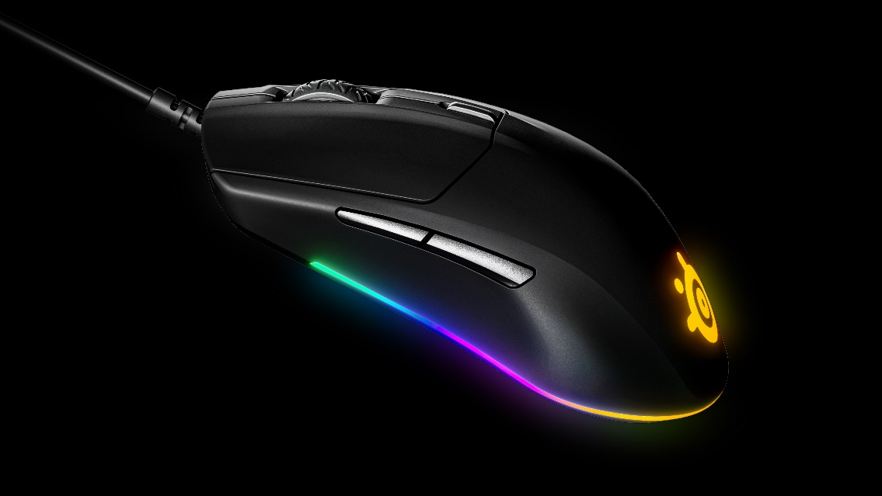

Featuring unique and brilliant RGB lighting, a new performance-focused sensor and unreal levels of durability, the Rival 3 outshines the competition. The Rival 3 is a full-fledged gaming mouse with cutting-edge technology purposefully designed at an affordable price for gamers.

The Rival 3 is built of a hyper-durable polymer for incredible durability, in a lightweight 77g form factor. The Rival 3 features SteelSeries’ new TrueMove Core optical sensor. The TrueMove Core is a huge leap in sensor performance at this price range. Traditionally, gaming companies use regular desktop sensors in mice at this price point, but SteelSeries, in collaboration with PixArt, has built a brand-new gaming sensor just for the Rival 3. The TrueMove Core 8,500 CPI sensor was designed for precise performance with true 1-to-1 tracking, so the exact motions of the mouse are perfectly replicated on the screen.

The Rival 3 also features switches that are rated for 60M clicks and on-board memory to save up to five CPI profiles and is fully customizable through SteelSeries Engine.

For mouse and sensor specifications, click here.

The Rival 3 is available now globally for $29.99/€39.99/$39.99 at https://steelseries.com/

Apex 3 – Outshine the Competition

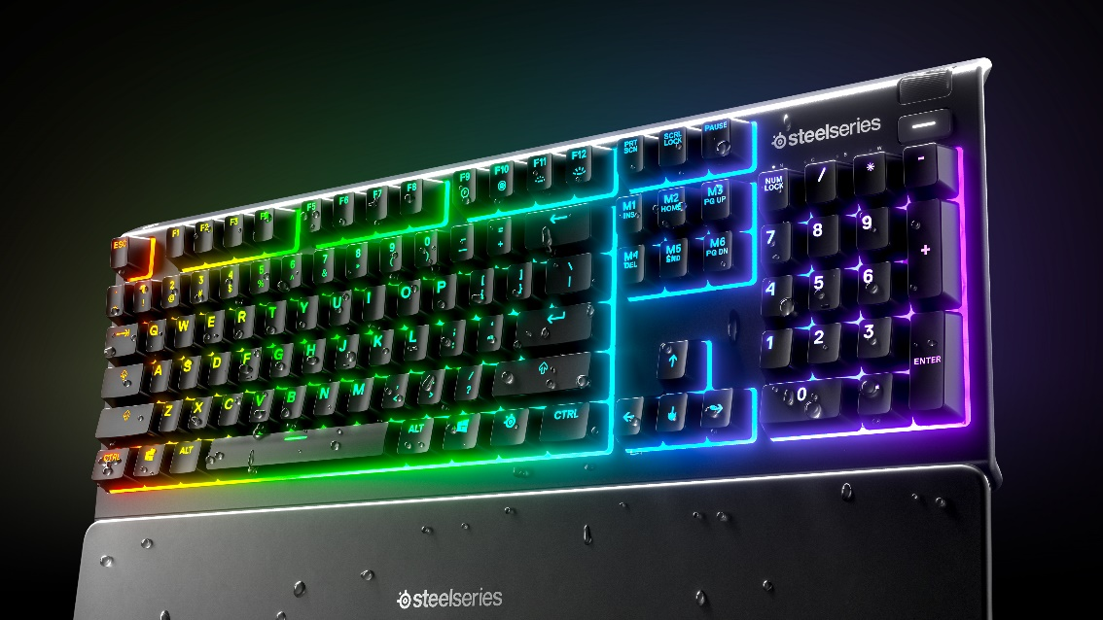

The water-resistant Apex 3 is a full-fledged gaming keyboard created by combining SteelSeries’ cutting-edge technology with 10-zone RGB lighting, whisper-quiet gaming switches and gaming-grade anti-ghosting – making it a keyboard truly built for gaming. The Apex 3 is IP32 water resistant to prevent damage from accidental spills. The Apex 3 uses SteelSeries’ new low-friction switches for near silent use and unmatched durability, with performance guaranteed for over 20 million keypresses.

Just like the premium Apex Pro line, the Apex 3 comes with a similar high-quality magnetic wrist rest, the same dedicated media keys and clickable metal roller, and three-way cable routing system underneath the board. Its gaming-grade anti-ghosting also ensures the keyboard will always correctly register every press, so gamers can play faster and more accurately.

The Apex 3 is available now globally for $49.99/79.99/$69.99 at https://steelseries.com/

Apex 5 – The Best of Both Worlds

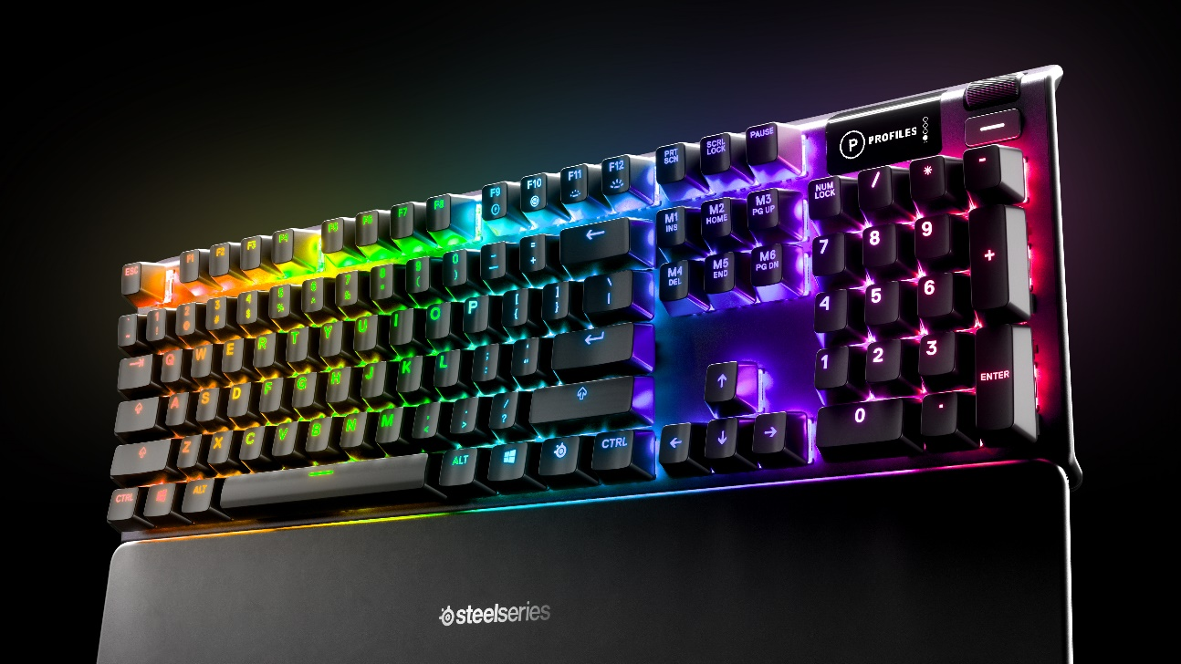

The Apex 5’s hybrid switches combine the smoothness of a membrane switch, with the added durability, performance and satisfying tactile click of a blue mechanical switch for a gaming experience that combines the best aspects of membrane and mechanical switches.

Built using the same cutting-edge technology as our Pro line, the Apex 5 also includes a premium magnetic wrist rest, aircraft-grade aluminum build, OLED Smart Display, media controls and volume roller, and customizable per-key RGB lighting. Users can customize the OLED screen with GIFs, view on-the-fly information from games like CS:GO and Dota2, view song information on TIDAL, incoming Discord messages, settings and more.

The Apex 5 is available now globally for $99.99/€129.99/$119.99 at https://steelseries.com/

For more information about the Rival 3, Apex 3 and Apex 5, vis.

For high-resolution images, click here.

# # #

About SteelSeries
SteelSeries is a leader in gaming peripherals focused on quality, innovation and functionality, and the fastest growing major PC gaming headset brand in the US. Founded in 2001, SteelSeries improves performance through first-to-market innovations and technologies that enable gamers to play harder, train longer, and rise to the challenge. SteelSeries is a pioneer supporter of competitive gaming tournaments and eSports and connects gamers to each other, fostering a sense of community and purpose. SteelSeries’ team of professional and gaming enthusiasts help design and craft every single accessory and are the driving force behind the company.

To learn more about SteelSeries’ products and esports partnerships, visit http://SteelSeries.com or follow us on social media for the latest updates at http://facebook.com/steelseries and be a part of the conversation on Twitter @SteelSeries.

Media Contacts:
Rasmus Parelius
SteelSeries
rasmus.parelius@steelseries.com
(+45) 51333390

