Kongsberg Maritime unveils new, integrated waterjet control systems for optimal craft operability
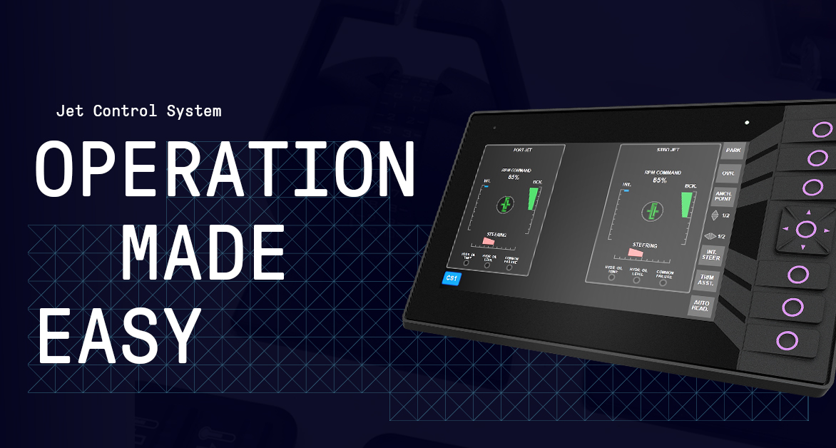
KONGSBERG’s JCS Compact and JCS Extended systems offer optimal waterjet control for a wide range of craft
Kongsberg, Norway, 3rd June 2021 – Kongsberg Maritime is pleased to announce the launch of two innovative waterjet control systems based on its new JCS (Jet Control System) common technology platform: JCS Compact and JCS Extended. The use of standardised components across both systems keeps costs down and enhances operational simplicity.
JCS Compact is a tailored, closed-loop control system solution designed to manage the steering, reversing bucket and optional interceptor functions on small- to medium-sized waterjets. It can be used with either one or two control stations and a single waterjet propulsion unit or, for full redundancy and operational safety in the event of unforeseen issues, a dual-waterjet configuration.
Each JCS Compact, complete with waterjet unit and hydraulic components, is factory tested and pre-calibrated before delivery. Its modest dimensions, plug-in assembly and easy-to-follow system start-up instructions make installation and commissioning simple.
In use, the system works together with the waterjet propulsors to provide accurate, smooth and reliable control. A high-contrast 2.8” display panel provides a visual representation of the steering angle and reversing bucket position and shows informational parameters and alarms, with a variable brightness control to ensure optimal visibility in both direct sunlight and night-time operations.
JCS Extended applies the same seamless functionality but on a larger, more advanced scale. Just like its smaller sibling, JCS Extended is used to control waterjet steering, reversing bucket and optional interceptor functions, but can accommodate up to three control stations and four waterjet propulsion units. Similar to the JCS Compact, the integrated feedback signals provide maximum accuracy in operating the waterjet hydraulic valves. In addition, the Extended system allows for an optional GNSS antenna.
JCS Extended also offers a variety of advanced, built-in optional functions for optimal operational smoothness and stability. Auto Positioning, Anchor Point, Auto Heading and Trim Assist provide optimal craft operability and can lead to lower operational costs in terms of fuel savings. Park Mode enables hydraulic cylinder rods to be withdrawn to prevent fouling when vessels are docked in areas with a high concentration of bio-organisms.
Each control station used with the JCS Extended solution will have its own high-contrast 7” display, with dedicated views providing detailed information for each specific function. On the bridge, design factors such as joystick and armrest integration have been ergonomically updated, while an optional secure remote access solution provides users with high-level KONGSBERG servicing support and enhanced alarm traceability.
“These sophisticated but tough new waterjet control systems are constructed with our usual care to ensure top performance even in the most extreme conditions,” says Gunder Norrbygård, Technical Product Manager, Kongsberg Maritime. “Flexibility is also key, with advanced optional functionalities and the ability for customers to adapt the systems to fulfil their requirements.”
Ends

For further information, please contact:
Gunvor Hatling Midtbø, VP Communication
Kongsberg Maritime
Tel: +47 9921 4209
gunvor.hatling.midtbo@km.kongsberg.com
David Pugh
Saltwater Stone
Tel: +44 (0)1202 669244
d.pugh@saltwater-stone.com

About Kongsberg Maritime
Kongsberg Maritime is a global marine technology company providing innovative and reliable ‘Full Picture’ technology solutions for all marine industry sectors including merchant, offshore, cruise, subsea and naval. Headquartered in Kongsberg, Norway, Kongsberg Maritime has manufacturing, sales and service facilities in 34 countries.
Kongsberg Maritime solutions cover all aspects of marine automation, safety, manoeuvring, navigation, and dynamic positioning as well as energy management, deck handling and propulsion systems, and ship design services. Subsea solutions include single and multibeam echo sounders, sonars, AUV and USV, underwater navigation and communication systems.
Training courses at locations globally, LNG solutions, information management, position reference systems and technology for seismic and drilling operations are also part of the company’s diverse technology portfolio. Additionally, Kongsberg Maritime provides services within EIT (Electro, Instrument & Telecom) engineering and system integration, on an EPC (Engineering, Procurement & Construction) basis.
Kongsberg Maritime is part of Kongsberg Gruppen (KONGSBERG), an international, knowledge-based group that celebrated 200 years in business during 2014. KONGSBERG supplies high-technology systems and solutions to customers in the oil and gas industry, the merchant marine, and the defence and aerospace industries.
Web: Kongsberg Gruppen | Kongsberg Maritime
Social media: LinkedIn | Twitter | Facebook

