PRESS RELEASE
For Immediate Release
Joyful Spring Reunion at PARKROYAL on Beach Road
Usher in a prosperous new year with a delectable feast at Ginger and Si Chuan Dou Restaurant, and send auspicious blessings with our Lunar New Year takeaway goodies
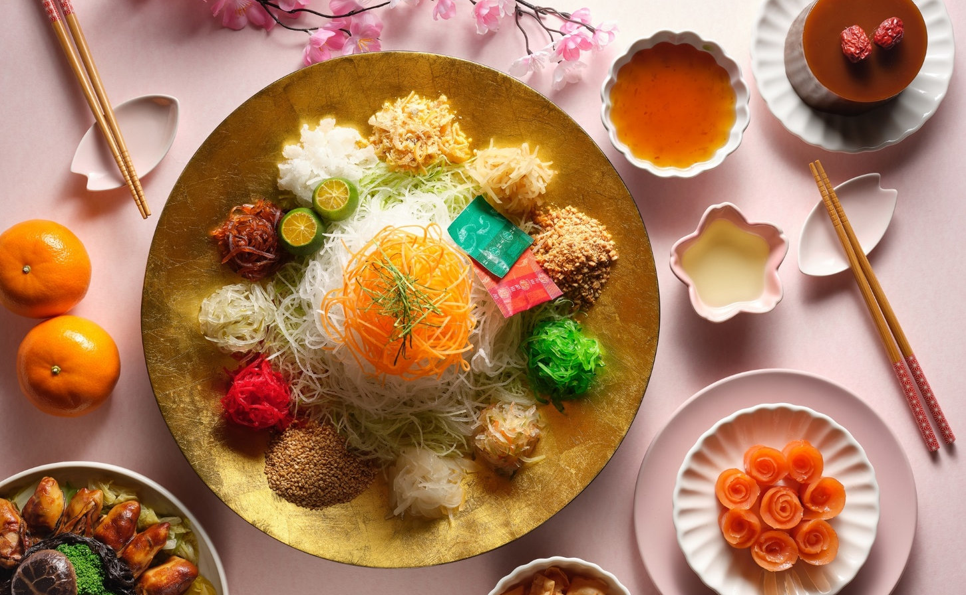

[Singapore, 13 December 2019] Ring in the prosperous Lunar New Year with your loved ones at PARKROYAL on Beach Road! Bond over a sumptuous feast at Ginger, our all-day dining restaurant, featuring a ‘no pork, no lard’ buffet menu of Asian and Western delicacies; or opt for traditional Lunar New Year delicacies at Si Chuan Dou Hua Restaurant. Share bountiful blessings with our decadent Lunar New Year takeaway goodies, or revel in auspicious moments with celebration packages available at The Ballrooms. For the ultimate indulgence, escape the hustle and bustle and book yourself a Lunar New Year Staycation with exclusive perks or pamper yourself at the award-winning St. Gregory spa.
Fortune Feast at Ginger
Spend cherished moments with your loved ones at Ginger as you indulge in a bountiful line-up of sumptuous Lunar New Year specialities such as Crab Meat and Five Treasures Soup in Claypot, Braised Herbal Duck with Wolfberries and Stir-Fried Baby Lobster with Salted Egg.
Make your very own Yu Sheng with your preferred ingredients at Ginger’s Yu Sheng Counter and complete the prosperous feast with a tantalising array of carvings, seafood on ice, local delicacies, cheeses, desserts and Lunar New Year goodies. The Lunar New Year buffet at Ginger features a ‘no pork, no lard’ menu for a more inclusive celebratory dining experience.
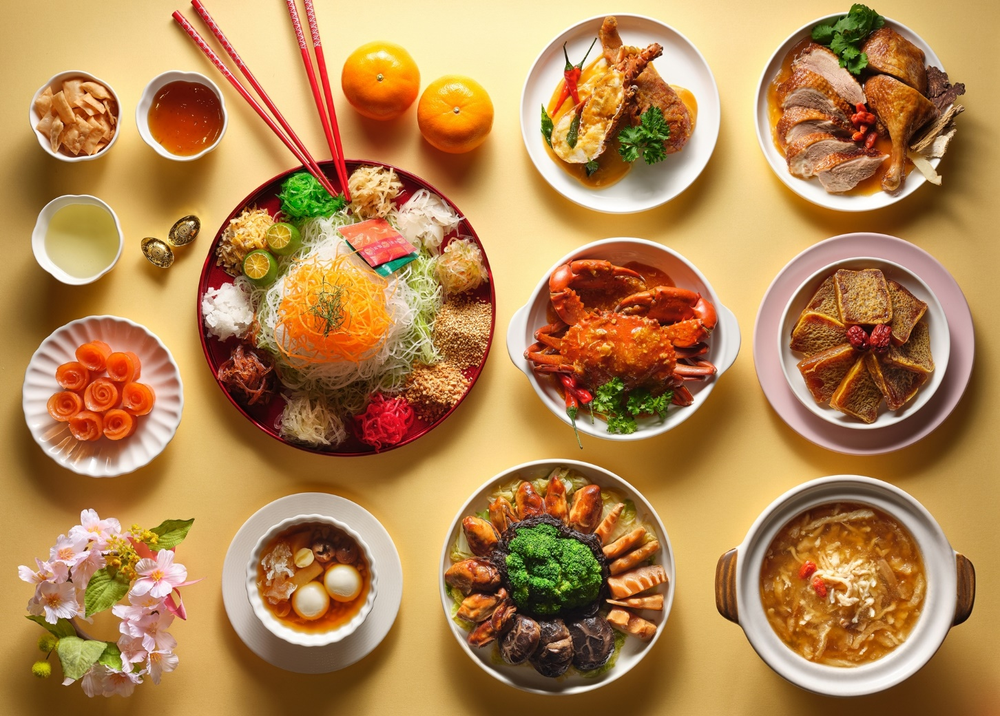
Lunar New Year Buffet |  | Per Adult (SGD) | Per Child (SGD)
10 January to 8 February 2020  (excluding 24 to 26 January 2020) | Lunch  12:00pm to 2:30pm | 48 (Mon-Fri) | 24 (Mon-Fri)
 |  | 68 (Sat-Sun) | 34 (Sat-Sun)
 | Dinner  6:00pm to 10:00pm | 68 (Mon-Thur) | 34 (Mon-Thur)
 |  | 78 (Fri-Sun) | 39 (Fri-Sun)
Lunar New Year’s Eve  24 January 2020 | Lunch  12:00pm to 2:30pm | 68 | 34
 | Dinner  6:00pm to 10:00pm | 108 | 54
Lunar New Year  Day 1 and Day 2  25 and 26 January 2020 | Lunch  12:00pm to 2:30pm | 68 | 34
 | Dinner  6:00pm to 10:00pm | 88 | 44

10 January to 8 February 2020 (excluding 24 to 26 January 2020)
Enjoy 15% savings* on Lunar New Year Buffet
24 to 26 January 2020
Enjoy 10% savings* on Lunar New Year Buffet
(book with pre-payment by 18 January 2020)
Dining reservations at Ginger can be made at dining.prsin@parkroyalhotels.com, or please speak with us at +65 6505 5710.
*Offer is valid when payment is made with a BOC, Citibank, Maybank. OCBC or UOB Credit/Debit Card. Highlighted menu items are featured on a rotational basis and are subject to change. All prices are subject to a 10% service charge (for dine-in) and GST, unless otherwise stated. Child prices apply to six to 12 years old.

Joyful Beginnings at Si Chuan Dou Hua Restaurant
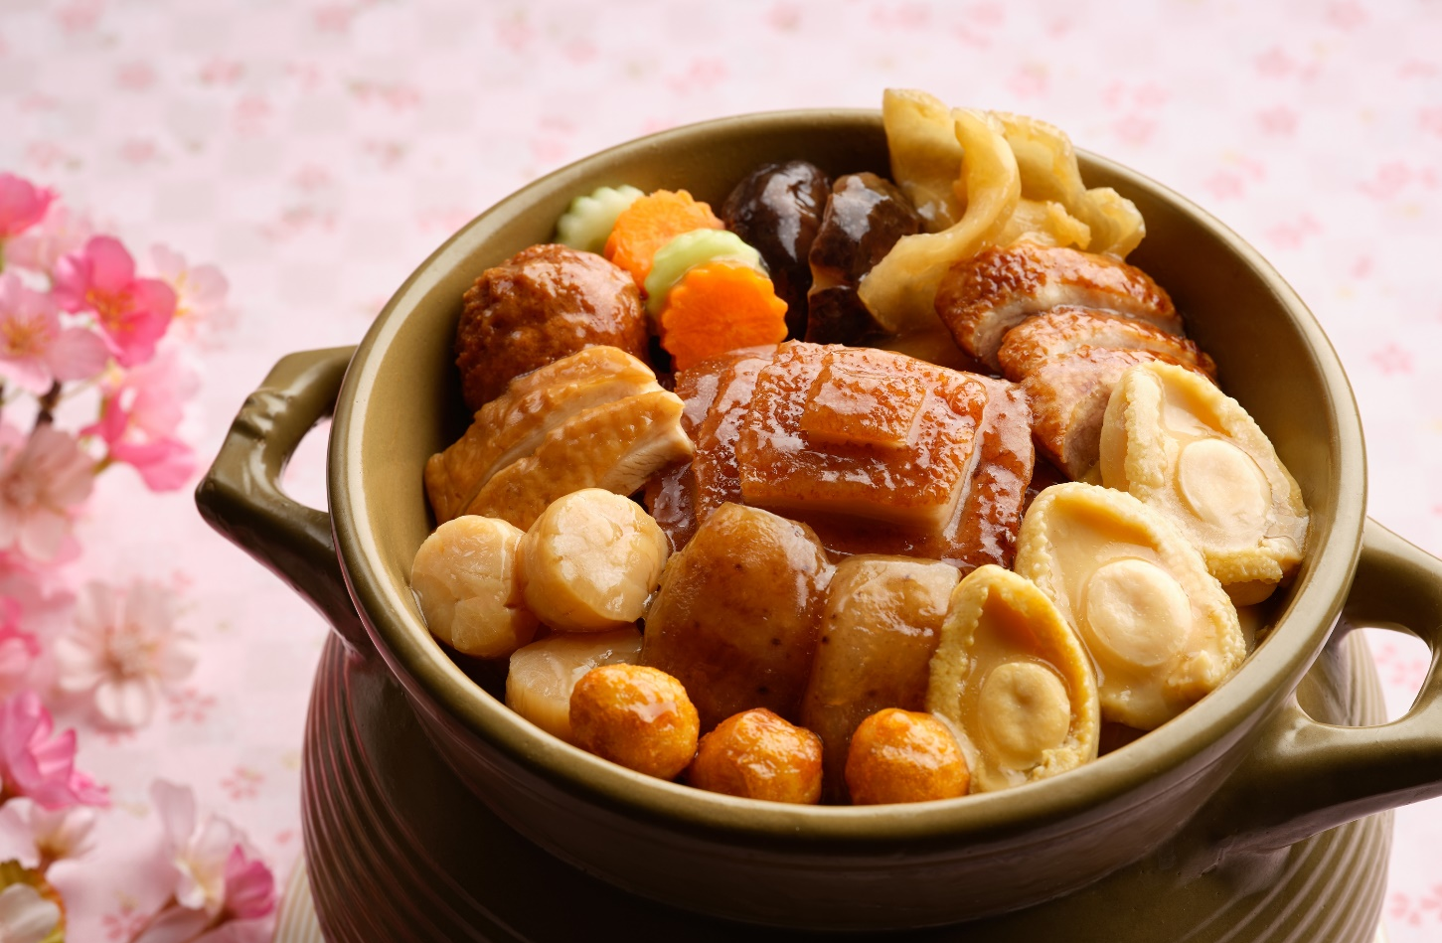
Toss to a prosperous new year with an authentic Sichuan spread at Si Chuan Dou Hua Restaurant from 3 January to 8 February 2020. Priced from SGD88 per person and SGD65 per person (vegetarian set menu), choose from the delectable selection of Lunar New Year set menus featuring Double-boiled Sakura Chicken Soup with Eight-head Abalone and Matsutake Mushroom, Prosperity Smoked Salmon Yu Sheng with Crispy Fish Skin, as well as the traditional Premium Sichuan Claypot Treasures which signifies abundance and includes premium ingredients such as abalone, fish maw and sea cucumber, simmered for a minimum of three hours in an earthen jar before serving.
Enjoy a complimentary bottle of house red wine worth $75 for set menus above $888 or a complimentary bottle of house red wine with exclusive wine carrier worth $135 for set menus above $1,288.
Eager to curate your own Lunar New Year menu to impress your guests? Choose from Si Chuan Dou Hua Restaurant’s Lunar New Year a la carte menu available from 13 January to 8 February 2020. The Lunar New Year a la carte menu includes top favourites such as the Deep-fried Spare Ribs in Sichuan Spices, a special creation by Executive Chef Zeng Feng. The spare ribs are simmered over small fire for 40 minutes and thereafter deep-fried to golden brown perfection along with peppercorn, fresh green and red chillies. Other culinary highlights include Braised Fresh Fish Maw with Spiked Sea Cucumber in Oyster Sauce, Braised Scallops and Large Prawns with Dumplings in Sichuan Bean Paste, and Braised Bird’s Nest Soup with Crab Roe and Crab Meat.
Conclude your Lunar New Year feast on a sweet note with guilt-free desserts, such as the Double-Boiled Peach Resin with Red Dates and Wolfberries for a triple health boost! The amber-coloured peach resin is known to be extremely beneficial to the skin with its rich amino acid that enables quick absorption of collagen.
Vegetarian set menu and a la carte options are also available.

Lunar New Year Set Menus at Si Chuan Dou Hua Restaurant (PARKROYAL on Beach Road)
3 January to 8 February 2020
Price:
From $88 per person (set menu)
From $65 per person (vegetarian set menu)
Lunch: 11.30am to 2.30pm
Dinner: 6.30pm to 10.30pm
(Two seatings available on Lunar New Year Eve, 24 January 2020: 6pm to 8pm and 8.30pm to 10.30pm)

Lunar New Year A La Carte Menu at Si Chuan Dou Hua Restaurant (PARKROYAL on Beach Road)

13 January to 8 February 2020
Lunch: 11.30am to 2.30pm
Dinner: 6.30pm to 10.30pm

Enjoy 20% savings* on Lunar New Year a la carte menu during the first three days and weekends of the first 15 days of the Lunar New Year (25 to 27 January 2020, 1, 2 and 8 February 2020)
Dining reservations at Si Chuan Dou Hua Restaurant (PARKROYAL on Beach Road) can be made at douhua.prsin@parkroyalhotels.com, or please speak with us at +65 6505 5722.
*Offer only valid when payment is made with a UOB Credit/Debit Card. All prices are subject to a 10% service charge (for dine-in) and GST, unless otherwise stated.
Bountiful Blessings
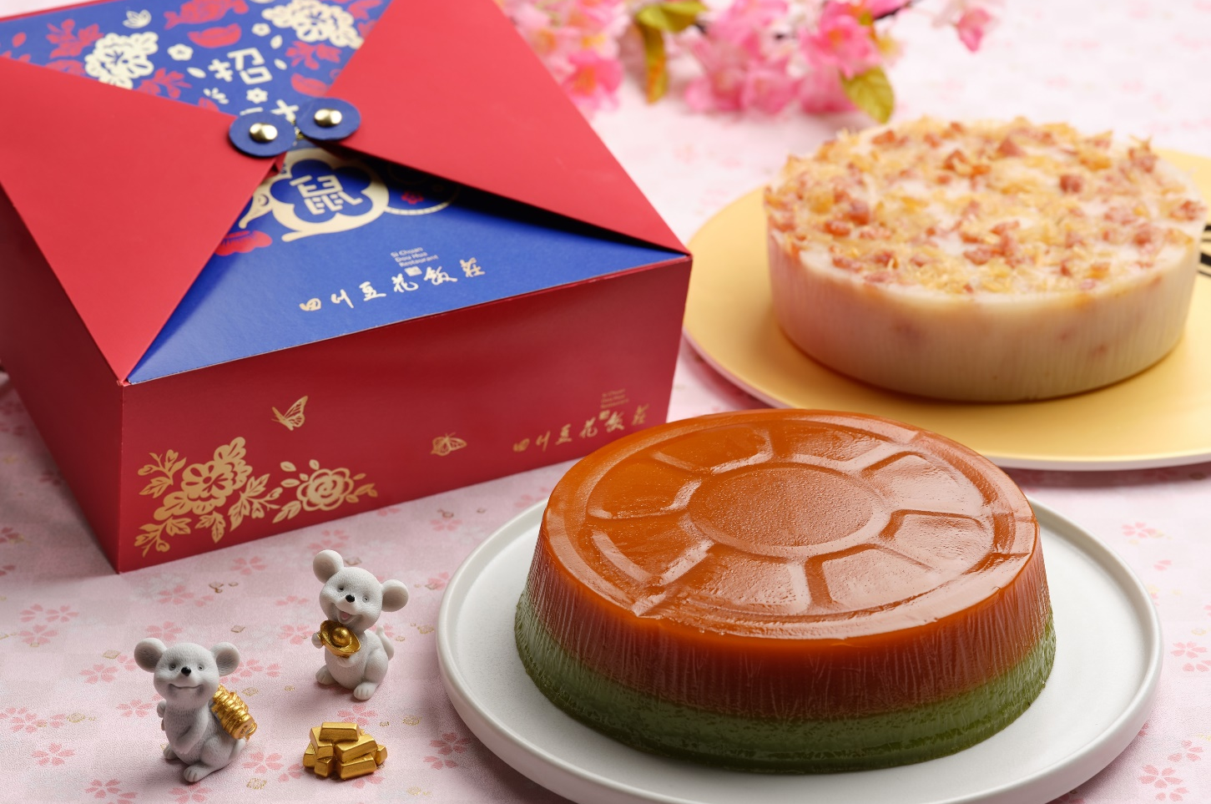
Having your Lunar New Year Reunion at home? Save the hassle of cooking and bring home our freshly prepared culinary delights from Si Chuan Dou Hua Restaurant! Share auspicious blessings with decadent takeaway items such as the Auspicious Lohei with Sliced Abalone and Crispy Sweet Potato, and Premium Sichuan Claypot Treasures. Surprise your guests or hosts with our Bi-coloured Prosperity New Year Cake gift box!
Lunar New Year Takeaway Goodies
3 January to 8 February 2020
Enjoy 15% savings* on Lunar New Year takeaway goodies.
For orders and enquiries, please speak with us at +65 6505 5722 or email douhua.prsin@parkroyalhotels.com.
*Offer is only valid when payment is made with a UOB or AMEX Credit/Debit Card. All prices are subject to a 10% service charge (for dine-in) and GST, unless otherwise stated.

Reunion Imperial High Tea at Tian Fu Tea Room
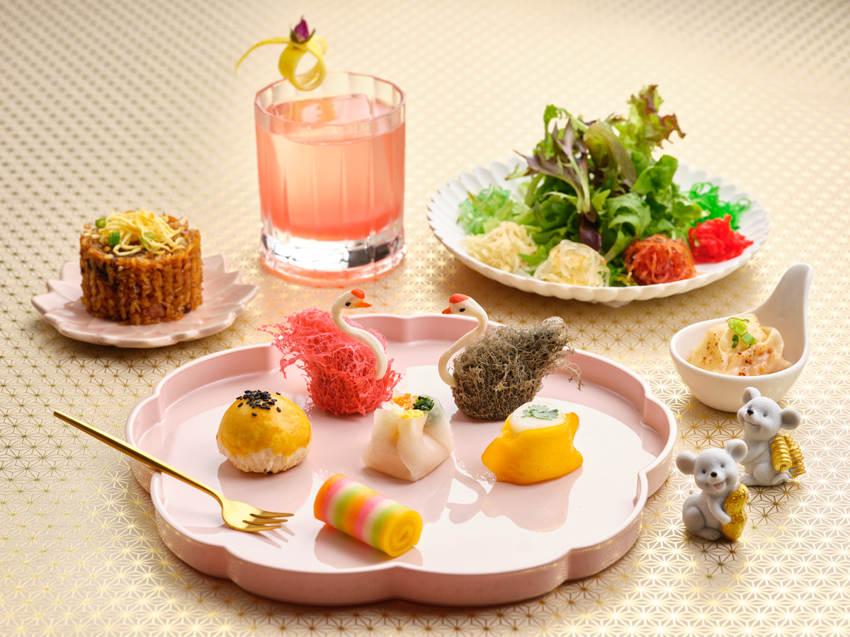
The oriental Reunion Imperial High Tea set menu at Tian Fu Tea Room features a thoughtful line-up of festive must-haves such as Prosperity Vegetarian Lohei, Deep-fried Crispy Dumpling with Foie Gras, and Homemade Rainbow Noodles with Fresh Prawn. Available from 13 January to 8 February 2020, the exquisite high tea set is served with a complimentary glass of mocktail.
Reunion Imperial High Tea at Tian Fu Tea Room
13 January to 8 February 2020
2.30pm to 6.00pm
Price: $40 per adult, inclusive of one complimentary mocktail
One dines free* with every three paying adults
For reservations and enquiries, please speak with us at +65 6505 5722 or email douhua.prsin@parkroyalhotels.com.
*Offer only valid when payment is made with a UOB Credit/Debit Card. All prices are subject to a 10% service charge (for dine-in) and GST, unless otherwise stated.

Lunar New Year Celebrations at The Ballroom
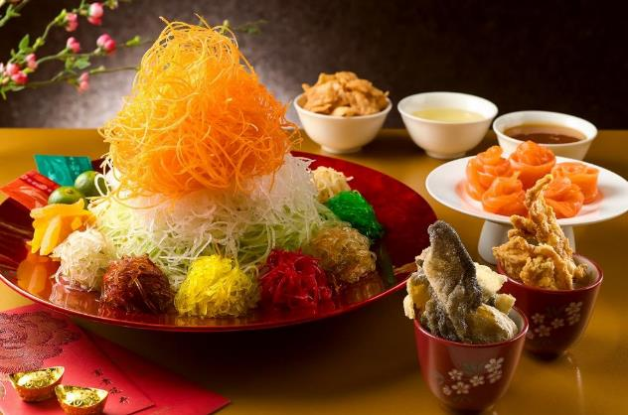
Prosperous Reunion Gathering
Renew bonds and strengthen relations with your loved ones this Lunar New Year! Book your reunion dinner celebration with us on 24 January 2020 at the Grand Ballroom at PARKROYAL on Beach Road. Indulge in a sumptuous Lunar New Year buffet spread with Mini Abalone, Scallop and Crispy Fish Skin and Smoked Salmon Yu Sheng, Baked Whole Salmon with XO Sauce and Fish Floss and Stir Fried Rock Lobster with Kam Heong Sauce prepared by our culinary team!
Reunion Dinner Celebration at The Ballroom
24 January 2020 (Lunar New Year’s Eve)
SGD118 per adult
SGD60 per child
Included in this package:
- Sumptuous Lunar New Year buffet spread with complimentary Yu Sheng by our culinary team
- One set of premium a la carte dishes per table
- Complimentary free flow soft drinks and mixers throughout the event
- Lunar New Year entertainment activities and lucky draw prizes to be won
Book early to enjoy the following:
- 10% savings for bookings and full payment made by 17 January 2020.
For enquiries, please speak with us +65 6505 5697 or email us at celebrate.prsin@parkroyalhotels.com.
*Valid for bookings and dinner held on Lunar New Year’s Eve, 24 January 2020 only. All prices are subject to a 10% service charge (for dine-in) and GST, unless otherwise stated.
Auspicious Celebrations
Toss to a wonderful start of an auspicious new year in one of our stunning pillar-less ballrooms! Feast on a sumptuous eight-course Cantonese cuisine featuring Harvest Yu Sheng, Five Treasures Seafood Soup and Braised Pork Knuckle with Chestnuts. Enjoy additional privileges when you book your Lunar New Year celebrations with us.
Priced from SGD898 per table of 10 persons (minimum 15 tables and above)
Included in this package:
- Free-flow soft drinks and mixers throughout the event
- Complimentary use of an exclusive private function room
- One complimentary 20-litre barrel of beer
- One complimentary bottle of wine per confirmed table
- Chinese New Year fortune cookies for all guests
- Complimentary car park passes for up to 30% of your confirmed attendance
- One-night weekend stay as part of your lucky draw

Exclusively for American Express® Proprietary Cardmembers, book your Lunar New Year celebration events to be held between 6 January to 8 February 2020 (excluding 24 to 27 January 2020) to enjoy complimentary upgrade to ‘Premium’ Yu Sheng (Mini Abalone, Scallops and Smoked Yu Sheng with Crispy Fish Skin).
For booking and enquiries, please speak with us +65 6505 5697 or email us at celebrate.prsin@parkroyalhotels.com.

*Valid for new bookings and for events held from 6 January to 8 February 2020, excluding 24 to 27 January 2020. All prices are subject to a 10% service charge (for dine-in) and GST, unless otherwise stated.

Lunar New Year Staycation at PARKROYAL on Beach Road
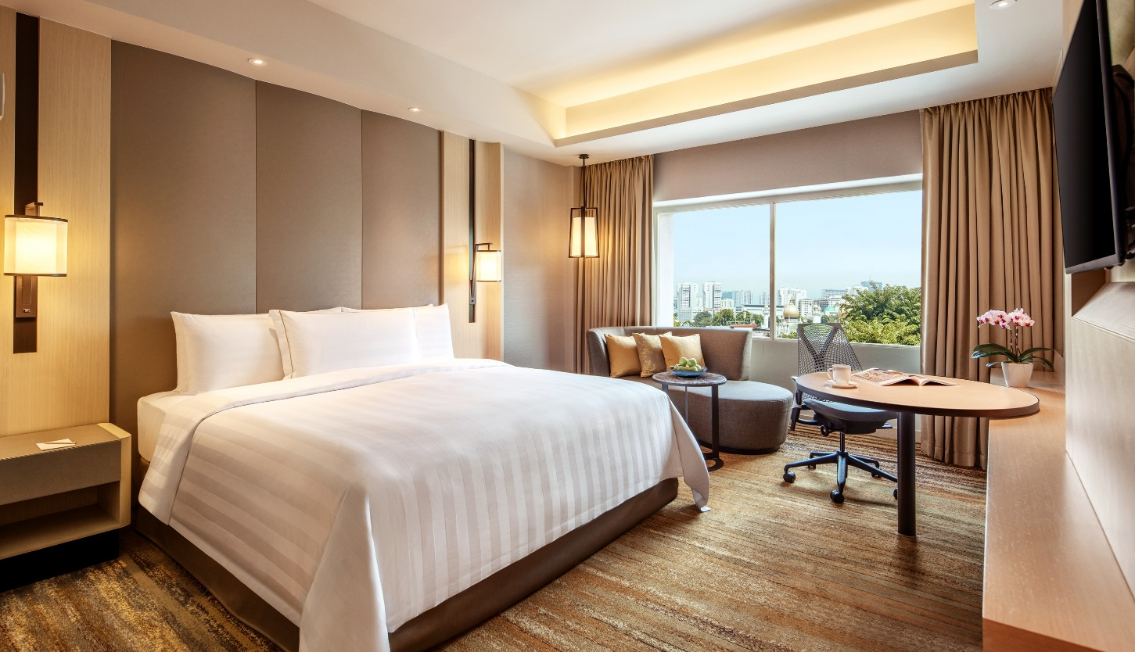
Celebrate the Spring festivities with a memorable Lunar New Year getaway with your family and loved ones at PARKROYAL on Beach Road. Enjoy 20% savings on Best Available Rate, complete with complimentary breakfast for two persons and special festive amenities.
Relax and refresh your senses with a dip in our outdoor swimming pool with a scenic view of the Singapore skyline on our Wellness floor, and explore the little alleys in the adjacent Haji Lane while soaking up the perfect mix of heritage and hip culture in the Kampong Glam vicinity.
For room reservations and enquiries, please speak with us at +65 6505 5656 or email us at reserve.prsin@parkroyalhotels.com.

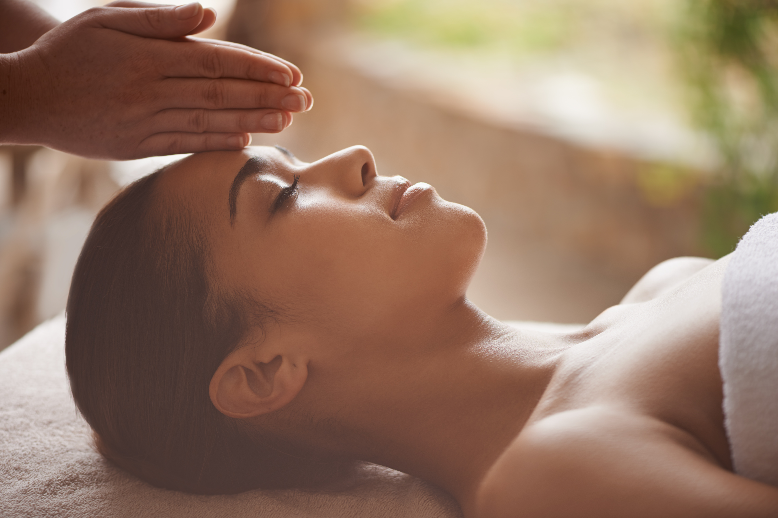Glow of the Season at St. Gregory
Escape from your busy lifestyle to the decadent sanctuary and get the ultimate pampering session that you deserve by prepping yourself for a spa day like no other. Get your glow of the season with St. Gregory's facial treatments or relax your muscles with resort-style massages from our skilled therapists from 1 December 2019 to 29 February 2020.

Spa Package | Promotional Price (SGD)
Festive Glow for Face: Purifying  - One 45-minute Purifying Detox Facial  - One 30-minute Anti-Stress Massage | 168 (U.P. 240)
Festive Glow for Face: Firm & Lift  - One 75-minute Thalion Firm and Lift Facial | 188 (U.P. 260)
Festive Glow for Body: Recharge  - One 60-minute Abhyangam  - One 45-minute Shirodhara | 188 (U.P. 300)
Festive Glow for Body: Refresh  - One 60-minute Balinese Massage/ABBM  - One 15-minute Scalp Massage  - One 30-minute Choice of Body Scrub | 218 (U.P. 305)

Enjoy 30% savings* when you purchase six of the same a la carte treatment above SGD160.
Enjoy up to 20% savings* on Elemis, Thalion and Kawasaki products when you bring your pampering session home!
For orders, reservations and enquiries, please speak with us at +65 6505 5755 or email us at stgregory.prsin@parkroyalhotels.com.
*Offers are valid from now until 29 February 2020. All spa prices quoted are in Singapore dollar and nett prices.
Stay Fit and Fabulous with PARKROYAL on Beach Road
Welcome the new year with a better you! Get started on your health and wellness resolutions for 2020 with our Fitness packages and utilise our cutting-edge fitness amenities at PARKROYAL on Beach Road. Pamper and care for yourself and your loved ones’ wellbeing, and surprise them with a wellness package!

Fitness Package | Promotional Price (SGD)
Annual Fitness Membership | 2,200 (U.P. 2,500)
Renewal of Annual Fitness Membership | 1,900 (U.P. 2,250)
Annual Couple Fitness Membership | 3500
3-Month Fitness Membership | 500 (U.P. 700)
MIHA Training Session | 560 (U.P. 800)
Personal Training Session | 700 (U.P. 1,000)

For bookings and enquiries, please speak with us at +65 6505 5755 or email us at stgregory.prsin@parkroyalhotels.com.
All prices quoted are in Singapore dollar and nett prices.

– END –

Note to editors:
All letters of the PARKROYAL brand should be capitalised. If your publication’s house style does not allow this, please ensure that PARKROYAL appears as one word – ‘Parkroyal’.
For high resolution images, please download them here.
For media enquiries, please contact:
Tricia Quak
Senior Marketing Communications Manager
PARKROYAL on Beach Road, Singapore
DID: +65 6505 5608
Email: tricia.quak@parkroyalhotels.com
Regine Goh
Assistant Marketing Communications Executive
PARKROYAL on Beach Road, Singapore
DID: +65 6505 5678
Email: regine.goh@parkroyalhotels.com

PARKROYAL Hotels & Resorts
A big city or cosy enclave – where there is a PARKROYAL hotel, resort or serviced suite, there is a celebration of people. Our passion for creating real connections and joyous moments can be felt when you enter any of our properties across Asia and Australia. After all, this is the place to bring out the best of you, by us.

About Pan Pacific Hotels Group
Pan Pacific Hotels Group is a member of Singapore-listed UOL Group Limited, one of Asia’s most established hotel and property companies with an outstanding portfolio of investment and development properties.
Based in Singapore, Pan Pacific Hotels Group owns and/or manages nearly 50 hotels, resorts and serviced suites including those under development in 29 cities across Asia, Oceania, North America and Europe.
Voted “Best Regional Hotel Chain” by readers in Asia from 2017 to 2019, Pan Pacific Hotels Group comprises three brands: Pan Pacific, PARKROYAL COLLECTION, and PARKROYAL.
Sincerity is the hallmark of Pan Pacific Hotels Group. The Group is known to its guests, partners, associates and owners for its sincerity in people and the sense of confidence which alleviates the stresses of today’s complex world.

