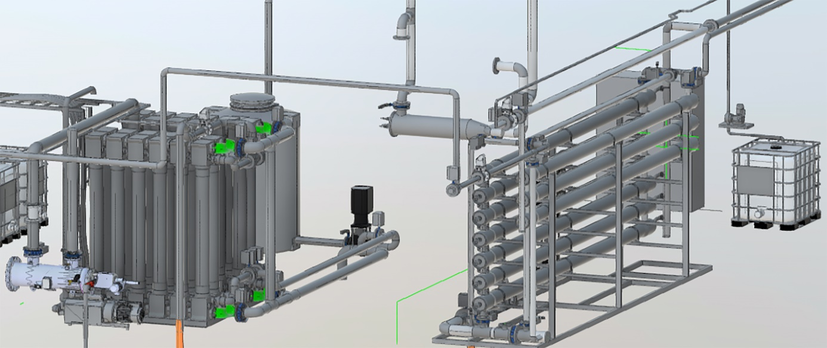
BIOVAC DELIVERS SYSTEM FOR RECYCLING WATER TO LEADING NORWEGIAN INDUSTRIAL COMPANY
Fully automated recycling plant designed for a leading Norwegian industrial Norwegian company, with a significant water-consuming production line
Biovac Environmental Technology AS (Biovac) has signed an agreement for the delivery of a fully automated recycling plant to a leading Norwegian industrial company. The company is a leader in the food industry and has a significant water-consuming production line.

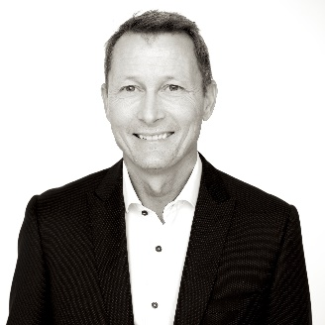
«For this customer, the ability to deliver large amounts of water that maintains high hygienic quality is critically important. In addition, comes the environmental aspect, and not least the economic side of recycling large amounts of the water they consume "says Eskil Møllegaard, CTO at Biovac. "It's a big investment, but not in an overall picture. It will be significantly more expensive to buy the entire water requirement from the drinking water network, and then pay to discharge the used water to the municipal sewer, "says Møllegaard.
Eskil Møllegaard, CTO, Biovac
Biovac will deliver a fully automated recycling plant with a recycling rate of approximately 70%. The contractual solution is dimensioned for 650,000 m3 per year, a solution that is also adapted for future expansions if necessary.

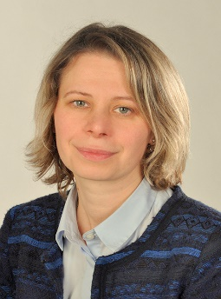
"In short, the solution consists of a combination of a roto sieve (0.5 mm slit opening), a pre-filter (200 microns) followed by ultrafiltration and then nanofiltration," says Dr. Ing Polina Pilipenko at Biovac. "Before the purified water enters the production line again, UV units are used as the last step for hygiene," she concludes.

Biovac has for several years conducted research and development to find an optimal solution for this factory. The first pilot test that laid the foundation for today's solution dates back to 2010.
Polina Pilipenko,
Dr. Ing. Biovac
Work on the plant has begun, and it will be completed by 2022-03-01.

If you would like more information about the delivery, contact the Chief Technical Officer at Biovac; Eskil Møllegaard at eskil@biovac.no or +47 934 09 109.

Biovac Environmental Technology AS is one of Scandinavia's leading companies in water and sewage solutions for municipalities, cottages and residential areas; including solutions for industrial wastewater such as the food industry, leachate from landfills, etc. The company has a turnover of over 200 million in Norway, Sweden and Denmark and has 60 employees who design, design and build.

Our vision is to secure the foundation of life. Clean water! Our task is to develop and facilitate technology and services that provide clean water.

