****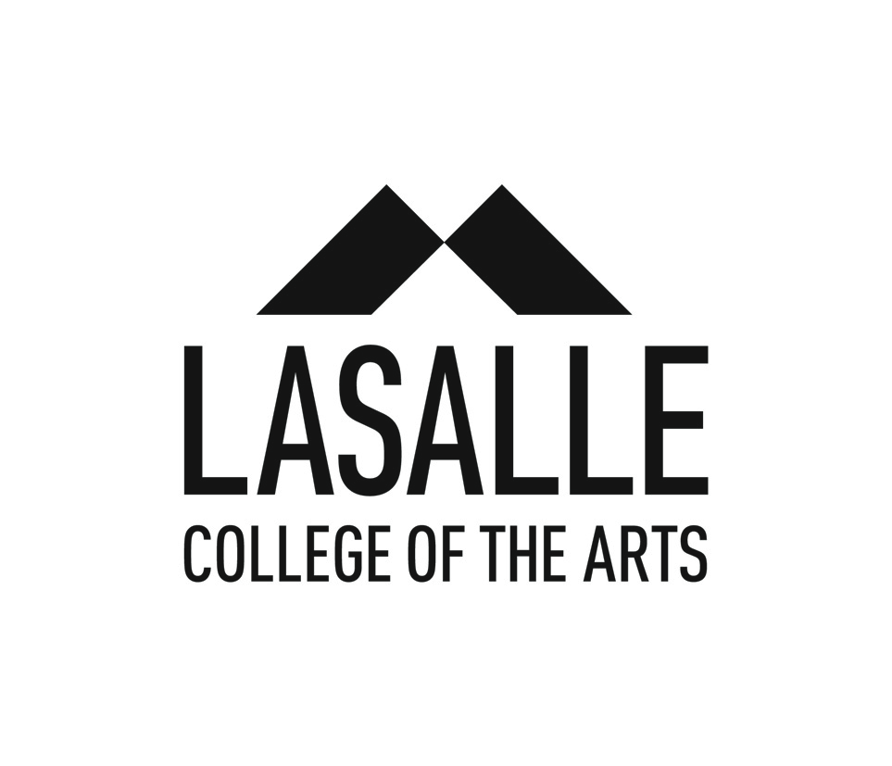

**MEDIA RELEASE**

**ARTWALK Little India 2019 promises to thrill and excite visitors of Singapore Art Week 2019**

*Singapore, 16 January 2019*

With the theme *Image and Sound of Fragrance*, popular multi-disciplinary arts festival ARTWALK Little India (ARTWALK) returns for a grand celebration of the cultural precinct’s rich heritage via the arts. Visitors can look forward to new highlights including an immersive exhibition at UltraSuperNew Gallery, five more murals to add to Little India’s colourful vibrancy, and an extended programming over 16 days, the festival’s longest period yet.

The exhibition at UltraSuperNew Gallery, a first for ARTWALK, features works by acclaimed artists Tan Ngiap Heng, Bani Haykal and more. Curated by Cultural Medallion winner and LASALLE’s Senior Fellow Milenko Prvacki, the artists will collectively transform smell into a visual soundscape for a truly multisensorial experience.

Also making first-time appearances are young artists SONG, who will unveil an ambitious wall mural that captures all the sights and smells of the neighbourhood, and Susanna Tan, who encapsulates her well-wishes for the Singapore Indian Fine Arts Society in a mural along Starlight Road.

Theatre fans can enjoy a re-telling of Kuo Pao Kun’s *The Coffin is Too Big for the Hole* by students from LASALLE’s Diploma in Performance programme. This rendition of one of Singapore’s most famous classic plays, as conveyed by a young Indian woman in modern day society, was staged in France’s Limoges Festival in 2018 where it received praise for its inventiveness and stagecraft.

Since its inception in 2015, ARTWALK has been a staple feature of Singapore Art Week, and is jointly organised by LASALLE College of the Arts (LASALLE) and Singapore Tourism Board (STB), with the support of Little India Shopkeepers and Heritage Association. From a visitorship of 74,000 in 2015’s inaugural edition of ARTWALK, the festival has grown by leaps and bounds, attracting over 260,000 visitors in 2018. Year-on-year engagement has seen many artists and partners continuing their collaboration with the festival.

Well-loved festival highlights returning in 2019 include master storyteller Kamini Ramachandran, who is back to breathe life into back-alley whispers from Rowell Road*,* while artists ZERO and Shah Rizzal add their unique signature to the walls of the district once more. Main sponsor Tekka Place and co-sponsor Nippon Paint have also renewed their commitment to support the neighbourhood, while Monster Day Tours, SIFAS, Mural Lingo and the Indian Heritage Centre present a host of specially created programmes. Adding to the multi-sensory experience are various exciting fringe activities – visitors can make their own bath salts in a spice workshop, or try their hand at creating music with a two-headed mridangam drum.

ARTWALK is managed by a team of eight BA(Hons) Arts Management students from LASALLE. Student Jack Kenneth Tan said, “Facilitating cross-cultural bonding and interaction has always been a goal of ARTWALK. Traditions and rituals that seem ordinary to the community can sometimes be hard to understand from an outsider’s perspective. The arts are a way to lower these barriers, propel conversation, and allow visitors and residents alike to walk away with insightful discoveries.”

“ARTWALK Little India brings the area’s rich heritage and culture to life, enabling locals and overseas visitors to experience Little India at a deeper level, while ensuring it stays relevant to the younger generation. We are happy to once again partner LASALLE on this project to make Little India a more vibrant and attractive precinct,” said Ms Serene Tan, Director, Arts and Cultural Precincts, STB.

ARTWALK Little India 2019 runs from 18 January – 2 February 2019, with programmes and activities happening on Fridays to Saturdays, 6:00pm – 9:30pm. Details can be found on [http://artwalklittleindia.sg](http://artwalklittleindia.sg/), where a digital version of the festival guide is also available for download. Members of the public can pick up a copy of the festival guide at the Indian Heritage Centre or Sate Kelinci Pak (event main ground).

**Guided Tours by Monster Day Tours:** Sign up at https://artwalklittleindia2019.peatix.com/

**Self-guided tours:** Available through the Locomole app on mobile devices, on both the App Store and Google Play store.

**About LASALLE College of the Arts**

LASALLE College of the Arts in Singapore is a leading tertiary institution in cutting edge contemporary arts and design education and practice. The college offers over 30 undergraduate and post-graduate programmes in art, design, film, animation, fashion, dance, music, theatre, arts management, artist education, art therapy, Asian art histories, and creative writing.

Its faculty is led by a community of award-winning artists, designers, educators and researchers, and their practice-led research sets LASALLE apart as an international centre of excellence. Critically acclaimed alumni form the core of the cultural and creative sectors in Singapore and increasingly internationally.

Founded in 1984 by de la Salle Brother Joseph McNally – a visionary artist and educator – LASALLE is a not-for-profit, private educational institution. LASALLE receives tuition grant support from the Singapore Ministry of Education. Its degree programmes are validated by Goldsmiths, University of London.

**About Singapore Art Week**

ARTWALK LITTLE INDIA is part of Singapore Art Week (19 – 27 January 2019). A joint initiative by the National Arts Council, the Singapore Tourism Board and the Singapore Economic Development Board, Singapore Art Week reinforces Singapore’s position as Asia’s leading arts destination. In its seventh edition in 2019, the nine-day celebration of the visual arts takes place in venues across Singapore, from galleries and museums to art precincts and non-profit spaces.

Reaching out to both Singapore residents and international visitors to promote art appreciation, Singapore Art Week offers a myriad of quality art experiences which span the visual arts, from traditional to modern to contemporary practices. Audiences can look forward to art fairs, gallery openings, exhibitions, lifestyle events, public art walks, and enriching discussions on art and culture. Singapore Art Week also aims to galvanise the arts sector to launch innovative art and lifestyle concepts and events in conjunction with art events during this period. www.artweek.sg

**For Media Enquiries, please contact:**

|  |  |
| --- | --- |
| Sabrina Zhang  Division of Communications  LASALLE College of the Arts  6496 5221  [sabrina.zhang@lasalle.edu.sg](mailto:cuifen.chen@lasalle.edu.sg) | Selena Sheikh  Director  PINPOINT PR  9746 8519  [selena@pinpointpr.sg](mailto:selena@pinpointpr.sg) |