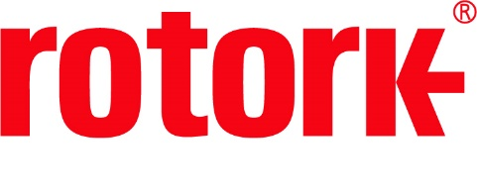
APPROVED PRESS RELEASE (3.1151) 2nd October 2020
Over 700 CK modular actuators installed at Chinese wastewater treatment plant
Rotork has installed over 700 CK modular electric actuators at the Shantou wastewater treatment in Guangdong, southern China facilities, where they enable sewage treatment to be carried out in accordance with new environmental regulations.
In order to comply with these new regulations, three new sewage treatment plants and 300 sewage intercepting wells will be built in Chaonan district, Shantou city. The installation of the CK actuators was a critical part of this enhancement. They have been installed on gate valves around the new sewage treatment plants, where they will be controlling the flow of raw sewage in and out of the sewage interceptors, where contaminants are separated from the wastewater, which can then continue the purification process until it is safe to return into the environment. 100,000 tonnes of wastewater will be processed every day.
The CK actuators were selected due to their performance and economical price reliability. Rotork Site Services were able to have the actuators commissioned within the tight timeframe specified for this project and will continue to provide maintenance services following the installation.
Rotork’s CK range of actuators is ideal for valves in the water industry and the modular nature of the actuators means that they can be configured to meet the needs of many different applications. With a multi-turn output torque of up to 10,800 Nm (8,000 lbf.ft), these actuators can provide continuous valve position indication, even on loss of power. They have a secure handwheel fully independent of the motor drive train and have an IP68 O-ring double sealed rating (8 m for 96 hours).

END
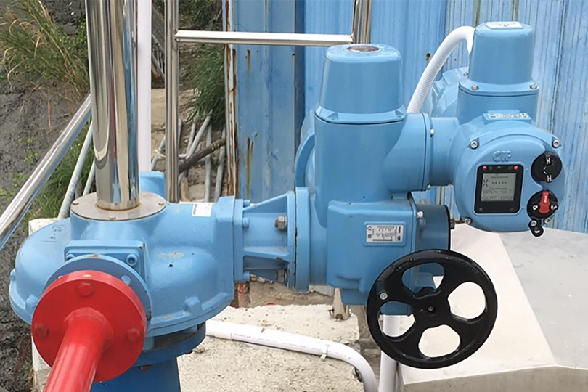
Caption: The CK modular actuators will control the flow of raw sewage in and out of the sewage interceptors.

For further information please contact Rotork PLC
Sarah Kellett Brassmill Lane
Group Marketing Communications Manager Bath
Telephone: +44 (0) 1225 733492 BA1 3JQ
Email: Sarah.Kellett@rotork.com UK

About Rotork
Rotork is a market-leading global provider of mission-critical flow control and instrumentation solutions for oil and gas, water and wastewater, power, chemical process and industrial applications. We help customers around the world to improve efficiency, reduce emissions, minimise their environmental impact and assure safety.

