Boats.co.uk – in the family for 50 years
Internationally successful dealership and brokerage boats.co.uk
celebrates 50 years as a family business

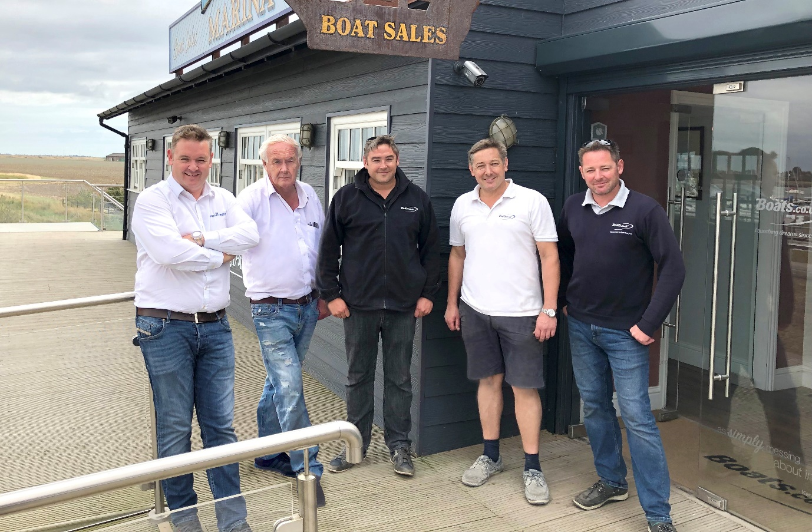
The Barke brothers with father David. Left to right: James, David (Senior), David (Junior), Guy, Nick
Boats.co.uk, one of the UK’s biggest and most diverse boat dealerships, celebrates its 50th anniversary this year.
Today, boats.co.uk handles sales of some of the biggest names in the business: Princess, Williams, Parker Boats and Arvor, to name a few. But you don’t get to the top of the pile without some hard graft, and behind the sleek exteriors of boats.co.uk’s offices in Essex, Dorset, Spain and Mallorca lies a family success story with its roots in the entrepreneurial spirit of one man: David Barke.
David started his career in 1969, selling trailers for speedboats. Based in South Woodham Ferrers, Essex, he soon found that he was being asked for boats to fill them. With fibreglass boats opening up boat ownership to a much wider audience, pursued by a thriving second-hand market, Barke began selling a variety of small, fast boats including Shetland, Fletcher, Norman, Cleopatra, Mitchell and Colvic.
Move the clock forward to 1978 and the business had grown significantly. Now trading as David Barke Marine Ltd, the company obtained the freehold of a boatyard at Maldon on the River Blackwater. Eight years later, in 1986, Barke moved again, purchasing Paglesham Boatyard on the River Roach.
Paglesham proved to be the crucible for the family business to take off. Over the course of the next 19 years, the small riverside yard saw sons James, Nick and Guy take increasingly active roles, with James Barke taking over the running of Paglesham Boatyard in 1997 amid speculation that his father would now retire. He didn’t, instead opting to join forces with James to launch a new brand, Essex Boatyards Ltd, in 1999. The same year the company was awarded the rights to sell Arvor boats, and a year later David Barke resigned his directorship in favour of his son, Nick.
Retirement was clearly beckoning and a sale was mooted, but family prevailed and in 2004 the company was awarded the dealership for Fairline yachts. A fourth son, David Barke (Junior), also joined the company, which had now grown beyond the confines of Paglesham boatyard, despite considerable expansion work. A year later Essex Boatyards Ltd purchased Essex Marina on Wallasea Island and moved their operations from Paglesham.
The move meant that the family now had a large marina and its associated facilities to manage, a challenge which was taken up by sons Guy and David, now also company directors. Meanwhile, Essex Boatyards Ltd had established an unusual business model in the marine world. Alongside their new boat sales, they sell used boats via three strategies:
- Buying into stock for cash
- ‘Stockerage’, where the boat is listed as stock, sold with a warranty and may be part-exchanged. A guide price is agreed, but negotiations are carried out at the discretion of the sales team
- Traditional brokerage
This emphasis on maintaining stock is expensive on storage, but allows buyers to see a range of boats in one location and offers sellers the chance of a faster sale for a good price.
Boosted by this winning strategy, the business was growing rapidly. In 2011 they were awarded the Essex dealership for Jeanneau sailing yachts, and in 2014 started a charter business in Mallorca, offering customers the chance to try out some of the new boats before purchase.
The same year, the Barke brothers acquired the boats.co.uk domain, and rebranded the company accordingly. Fairline took their boat sales back in-house in 2015, but Princess were quick to step in to sign boats.co.uk as their East Coast distributor. Since then, the company has gone from strength the strength, opening sales offices in Mallorca, Spain and Poole, and signing dealership agreements with Williams, Axopar and Parker Boats in addition to their existing ones with Princess and Arvor.
This year, despite first planning to retire 20 years ago, David Barke (Senior) is still actively involved in the business, working with his four sons six days a week to support a business which has grown beyond all recognition from its fledgling days in South Woodham Ferrers. The future looks bright for boats.co.uk – what will the next chapter hold?
For more information, visit www.boats.co.uk
####
Media contact:

David Pugh
Saltwater Stone
+44 (0) 1202 669 244
d.pugh@saltwater-stone.com
Boats.co.uk Timeline
- 1969: David Barke (Senior) starts selling trailers for speedboats in South Woodham Ferrers, Essex, soon expanding to sell small fibreglass motorboats.
- 1978: David Barke (Senior) founds David Barke Marine Ltd and moves to a freehold boatyard on the River Blackwater in Maldon, Essex.
- 1986: David Barke Marine acquires freehold for Paglesham Boatyard.
- 1991: James Barke joins David Barke Marine Ltd (Junior Sales).
- 1992: Nick Barke joins David Barke Marine Ltd (Junior Engineer).
- 1997: James Barke takes over running of Paglesham Boatyard.
- 1998: Guy Barke joins business.
- 1999: Essex Boatyards incorporated, David Barke (Senior) and James Barke, Directors.
- 1999: Awarded Arvor dealership.
- 2000: David Barke (Senior) resigns as Director, James Barke and Nick Barke now Directors.
- 2004: Awarded Fairline dealership.
- 2004: David Barke (Junior) joins company.
- 2005: Essex Marina purchased, main operation moves from Paglesham.
- 2006: Guy Barke becomes Director, Marina Operations.
- 2006: David Barke (Junior) becomes Director, Marina.
- 2011: Awarded Jeanneau sailboat dealership.
- 2014: Charter business launched in Cala d’Or, Mallorca.
- 2014: Acquire boats.co.uk for £200,000, start to trade under new brand.
- 2015: Awarded Princess dealership.
- 2015: Poole office opens: Princess, Williams, Arvor and Jeanneau.
- 2016: Cala d’Or, Mallorca office opens: Princess, brokerage and yard facilities.
- 2016: Costa Blanca (Dénia) office opens: Princess and brokerage.
- 2016: Awarded Williams dealership.
- 2016: Awarded Axopar dealership (Costa Blanca region).
- 2017: Awarded Parker dealership.
- 2017: Paglesham Boatyard sold.
- 2019: 50-year celebration!

