Greensea IQ’s EverClean Shortlisted for GREEN4SEA Clean Shipping Award
Pioneer in intelligent ocean solutions, Greensea IQ, is pleased to have its revolutionary EverClean service nominated, and shortlisted, for the GREEN4SEA Clean Shipping Award.
This accolade recognizes organizations that have made substantial contributions to advancing cleaner shipping practices, aligning with the industry's commitment to a cleaner and more sustainable future.
EverClean represents a groundbreaking technological advancement that is transforming the landscape of maritime operations. Designed to address the environmental impact of shipping and its age-old problem of biofouling, EverClean offers an integrated suite of technologies and practices that enhance efficiency and reduce the ecological footprint of vessels. Leveraging 17 years of extensive development and expertise in control, autonomy, and navigation, it is revolutionizing conventional hull maintenance methods.
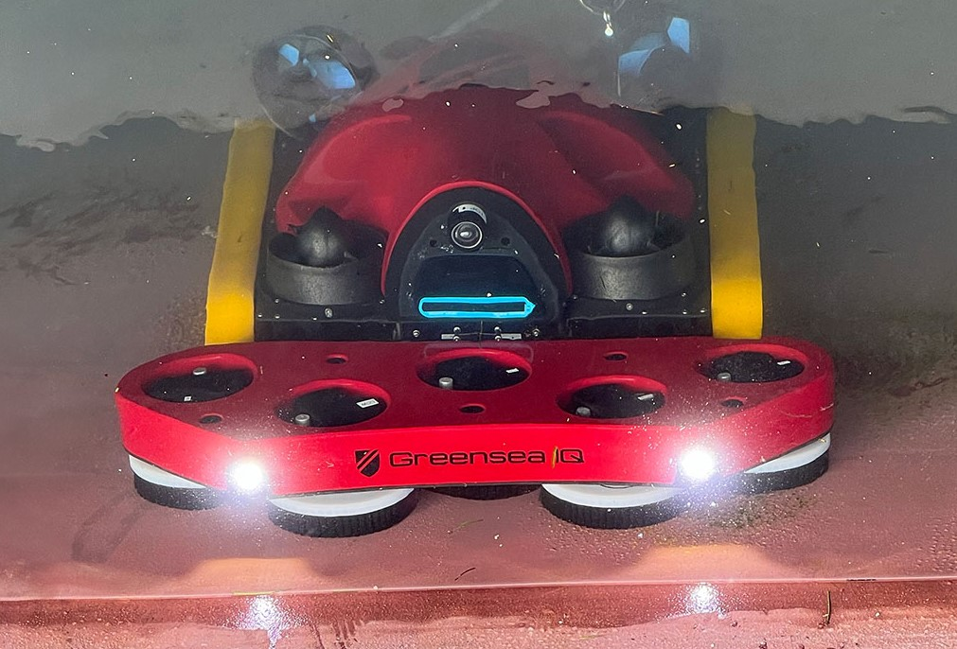
Utilizing proprietary robot technology with Over the Horizon (OTH) operational capability, and enhanced by Greensea’s extensively refined and modified software system, OPENSEA, EverClean showcases an exceptional leap forward in supervised reliable autonomy.

Packed with features such as depth aided navigation, smarter obstacle avoidance, improved maneuvering, and enhanced user interaction capabilities, EverClean’s hull service robots provide unparalleled precise hull relative navigation – a crucial evolution in providing faster and efficient cleans. The service not only contributes to carbon reduction, with an impressive 6.4% average fuel consumption decrease, aligning with the industry's pursuit of hydrodynamically efficient operations, but it also introduces groundbreaking data-driven intelligence through EverClean IQ.
EverClean IQ produces data-driven reports, offering commercial vessel owners’ valuable insights into their hull’s health, aiding in informed decisions on preventative maintenance, repairs, and pre-dry-dock planning, thereby saving both time and money.
“We are honored to be shortlisted for the GREEN4SEA Clean Shipping Award. The EverClean service is a truly transformative solution which is significant in directing the industry towards cleaner shipping practices.
“The nomination underscores our mission and ongoing efforts to drive positive change in the maritime industry and its practices. It is great to have the product and its capabilities recognized for its outstanding contributions.” says Rob Howard, CGO at Greensea IQ.
The GREEN4SEA Clean Shipping Award nomination reflects Greensea IQ's dedication to fostering a cleaner and more sustainable future for the maritime sector. The company's impactful initiatives have not only elevated industry standards but have also showcased its commitment to environmental responsibility.
The voting process for the GREEN4SEA Clean Shipping Award has officially commenced, allowing the public to contribute to the selection of the winner. A remarkable 50% of the votes will come from the public, emphasizing the importance of community involvement in acknowledging and supporting advancements in cleaner shipping technologies.
To cast your vote and support Greensea IQ, please visit the official voting page here: 2024 Clean Shipping Award
The winner of the GREEN4SEA Clean Shipping Award will be revealed at a dedicated virtual event scheduled for Thursday, 9th May.
For more information about Greensea IQ, please contact:
Dawn D’Angelillo
Greensea IQ
ddangelillo@greenseaiq.com
or
Megan Liggett
Saltwater Stone
m.liggett@saltwater-stone.com

About Greensea IQ
Greensea IQ develops intelligent ocean solutions that drive technical advancement for defense, transportation, energy, and science applications.
The world on and beneath the waves has long been a source of fascination and mystery. As technology advances, our ability to explore and understand the oceans has grown exponentially. Greensea IQ is the merger of three companies at the forefront of this revolution – Greensea Systems, Bayonet Ocean Vehicles, and Armach Robotics. Each of these organizations has made significant strides in marine technology, revolutionizing the way we work in the ocean. Together, as Greensea IQ, emerges a more powerful and innovative company, committed to making the work that is done on and under the ocean more efficient, safer, and for the protection of earth and humankind.
Greensea IQ is the developer of OPENSEA, an open architecture robotics platform that provides control, navigation, and autonomy for the marine industry. One of the key strengths of OPENSEA’s technology is its adaptability. The software can be integrated into a wide range of underwater vehicles, from remotely operated vehicles (ROVs) to autonomous underwater vehicles (AUVs). This flexibility makes Greensea IQ’s solutions invaluable for various applications, including offshore energy, scientific research, and maritime defense.

