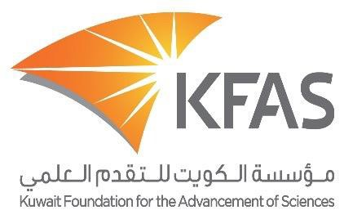

Al-Sumait Prize 2018
Invitation for Nominations

The Amir of the State of Kuwait, His Highness Sheikh Sabah Al-Ahmad Al-Jaber Al-Sabah, announced an initiative to the third African Arab Summit hosted by the State of Kuwait. The initiative described an annual award by the State of Kuwait for the advancement of economic, social, human resources, and infrastructure development in the African continent titled the "Dr. Abdulrahman Al-Sumait Prize", after a Kuwaiti physician who dedicated his lifetime towards helping the poor in Africa in the field of health and education.
The objective of the prize is the appreciation and recognition of the best studies, scientific projects, applied research, and innovative initiatives, which have made significant impact and lasting influence in advancing progress to economic and social development in Africa, in particular for the underprivileged. The awarded projects should help African nations to overcome poverty, hunger, lack of potable water, injustice or to improve health care systems, literacy and the allocation of economic resources. The Prize should also highlight successes within the following subjects: Food security, Health and Education.
The subject for the 2018 prize is Health:
- Combating diseases prevalent in Africa.
- Provision of medical staff for the national health care systems (physicians, paramedics and nursing), medicine, pharmaceutical, and medical equipment.
- National capacity building, in medical research, national medical education and medical staff.
- Upgrading and maintenance of national medical facilities.
- Developing national health policies and successful implementation of the outcomes.
The prize is to be awarded to individuals or institutions who through their research projects or initiatives have made significant advancement within the field of Health that produced seminal impact and tangible results on the public health care system, especially for the underprivileged. The prize has a value of $1,000,000 (one million US Dollars). The cash sum is awarded along with a gold medal, shield and certificate of recognition.
Conditions and requirements:
- The nominated candidates’ research work or projects and initiatives must be innovative and must have achieved high-impact in line with international standards for the prize.
- The submitted work must be of paramount importance in promoting significant economic, social, human resources and infrastructure development in the African continent within the announced field of the prize.
- Submitted research work of a nominated candidate should be composed of studies and applied research, published in referred journals and recognized at a global level within the announced field. The research outcomes need to have been applied after publication in African countries within the past ten years. Adequate supporting evidence needs to be provided.
- Nominations are to be accepted from institutions and scientific centers (universities, institutes and centers of scientific research) as well as from competent regional or international and UN organizations and awards and former winners in the field of the prize or former evaluation members. Nominations will only be accepted through institutions or other possible nominators mentioned above.
- All submissions must be submitted in English. If the work is carried out in other working UN languages, a comprehensive summary of the nominated work in English must be submitted.
- Fill in the prize nomination form and send it along with the scientific production works electronically in PDF format via CD, DVD, Flash Memory or via the Kuwait Foundation for the Advancement of Sciences (KFAS) Prizes Office email http://kfas.org.kw/alsumait . The nomination form can be obtained from the KFAS website http://oe.kfas.org.kw/alsumait. Applications are addressed to the Director General of the foundation.
- The nomination form and submitted works must be received before 30/06/2018

For more information and inquiries please, contact the Prizes Office
T: (+965) 22270465 F:(+965) 22270462 E: alsumaitprize@kfas.org.kw

