Epson launches new LightScene accent lighting laser projector for retail, F&B, and hospitality industry
New solution revolutionises spatial design and enhances customer experiences

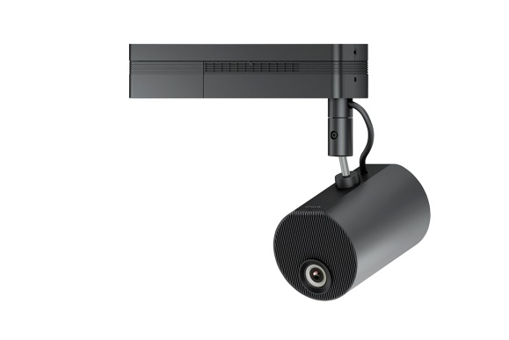
LightScene EV-105 projector

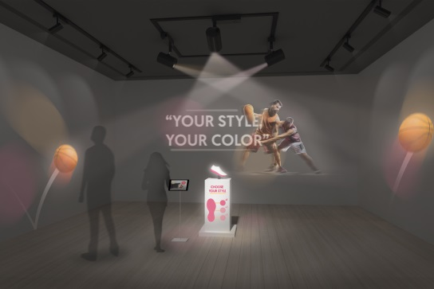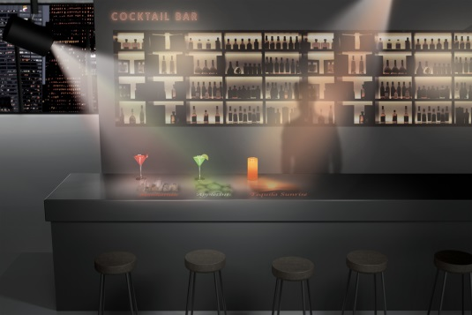
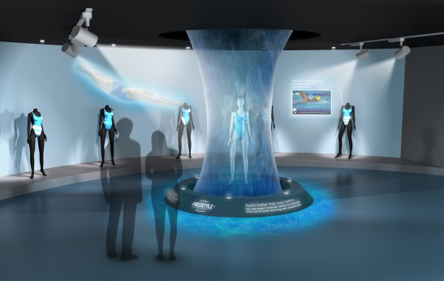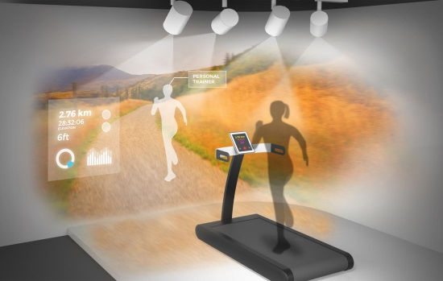

Kuala Lumpur, Malaysia, 5 July 2018, –

Epson, the world's leading projector manufacturer, has announced the launch of the LightScene projector, a new category of spotlight-shaped accent lighting laser projectors. The innovative projector is designed to simultaneously illuminate and project dynamic content on virtually any surface or material.

The new projectors offer a fresh solution for retailers, restaurants, bars or hotels facing an increasingly competitive environment, by providing an innovative experience for digital art, commercial signage, and spatial design applications. The LightScene EV-105 is ideal for curated visual environments such as retail showrooms, shop window displays, museum exhibits and art installations where minimal visual clutter is key.

“Display technology is changing the way consumers interact with brands and products, with the ability to delight and engage consumers in entirely new and visually compelling ways. The LightScene projector expands Epson’s presence in the signage and lighting sector with its space friendly design and flexible visual expressions. It can enable creative displays to deliver edutainment type content through imagery, motion and information. Retailers and businesses can easily create captivating and immersive environments for a memorable experience,” said Danny Lee, Director, Sales & Marketing, Epson Malaysia.

The LightScene projectors blend in discreetly and offer an array of configuration, mounting and programming options. The technology offers the best of both worlds – beautiful displays and unobtrusive visuals – while providing performance, versatility and reliability.

Additional features include:

- 3LCD laser technology – Epson laser technology provides up to 20,000 hours of virtually maintenance-free operation, plus a sealed optical engine for amazing image quality and outstanding performance.
- Robust content tools for ease of programming– The Epson Content Manager software includes templates, effects, colour and shape filters, and customizable options. Users can also create playlists, and schedule synchronized playback for up to 16 projectors at the same time.
- Management and control – Control the projector remotely with PC/ smart devices using Epson Web Control via the browser. User can also manage multiple projectors simultaneously using the Epson Management Software such as checking of status, and power on/off scheduling via the network.
- Scalable for an array of applications – Install multiple LightScene projectors and utilize Edge Blending technology for versatile, breath taking displays.
- Flexible positioning – Includes vertical and horizontal rotation with 360-degree mounting on floors, walls, or ceilings; 1.58x powered optical zoom and powered focus allows for installation in both large and small spaces
- Expansive connectivity – HDMI, wired and wireless LAN, and SD card slot for direct content storage when needed.
- Bright visual display system – Offers up to 2,000 lumens of colour brightness and 2,000 lumens of white brightness for vibrant, rich colours.

Making its first appearance in Malaysia at the ARCHIDEX 2018 – the region’s leading architecture business event, consumers can see the creative display potential of the LightScene range of projectors in the signage and lighting sector. The annual industry trade event will take place from 4 to 7 July 2018 at the Kuala Lumpur Convention Centre.

***
About Epson
Epson is a global technology leader dedicated to connecting people, things and information with its original efficient, compact and precision technologies. With a lineup that ranges from inkjet printers and digital printing systems to 3LCD projectors, smart glasses, sensing systems and industrial robots, the company is focused on driving innovations and exceeding customer expectations in inkjet, visual communications, wearables and robotics.
Led by the Japan-based Seiko Epson Corporation, the Epson Group comprises more than 80,000 employees in 86 companies around the world, and is proud of its contributions to the communities in which it operates and its ongoing efforts to reduce environmental impacts.

About Epson Singapore
Since 1982, Epson has developed a strong presence across major markets in Southeast Asia and South Asia. Led by the regional headquarters Epson Singapore, Epson’s business in Southeast Asia spans an extensive network of 11 countries with a comprehensive infrastructure of close to 500 service outlets, 7 Epson solution centres and 7 manufacturing facilities.

About Epson Malaysia
Epson Malaysia Sdn Bhd was established in Malaysia in 1991 as Epson Trading (M) Sdn Bhd, a sales company of the Seiko Epson Corporation, Japan. The company has exclusive rights to market, distribute and support a complete range of leading-edge Epson consumer and business digital imaging products in Malaysia and Brunei. Today, Epson Malaysia has 84 employees and an extensive network of 59 authorised service outlets nationwide. For more info, please visit www.epson.com.my or connect with us at www.facebook.com.my/EpsonMalaysia

Media Enquiries:
Epson Malaysia Sdn Bhd  Chua Li Tinn  Manager – Marketing Communications  Tel: (03) 5628 8288 Ext 274  Email: ltchua@emsb.epson.com.my | SWOT Communications Sdn Bhd  Vino Nair  Tel: 016 365 6268  Email: vino@swotcommunications.com

Largest unit share of the market for 500-lumen and higher projectors. (Source: Futuresource Consulting Limited, 2001-2016)
20,000 hours is the estimated projector life when used in Normal Mode. Actual hours may vary depending on mode and usage environment.

