Kongsberg Maritime to supply equipment to world’s largest floating offshore wind farm
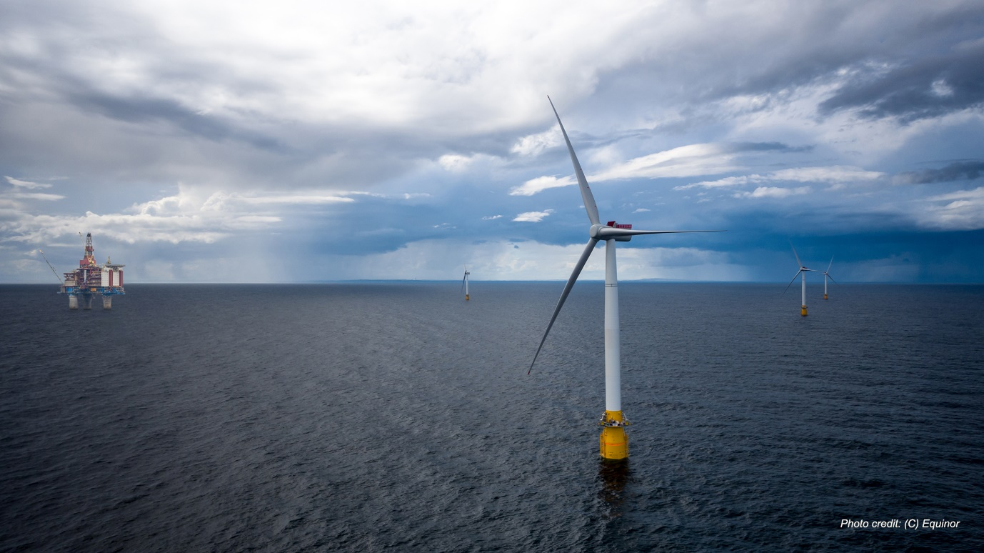KONGSBERG will supply positioning and monitoring equipment from their well proven offshore product portfolio
Trondheim, Norway, 21st January 2021 – Kongsberg Maritime is pleased to announce that it will be supplying key positioning and monitoring equipment to Equinor’s Hywind Tampen floating wind farm, as part of a contract with industrial solutions provider Wood PLC.
The 88MW installation is the first of its type to be installed to supply renewable energy directly to offshore oil and gas platforms, and Kongsberg Maritime will supply technologies from its existing offshore product portfolio to meet the specific challenges posed by operating in this challenging and sometimes hostile environment. By using proven equipment which is already successfully in use in other areas of the offshore maritime market, KONGSBERG is able to ensure safe, tried-and-tested performance whilst at the same time reducing both cost and development time.
Kongsberg Maritime’s world-class portfolio of solutions for positioning in the offshore environment is built on many years of experience and application know-how, and core to this product delivery is its DPS position reference system and Motion Reference Unit (MRU). The DPS exploits all available GNSS infrastructure to deliver continuously available, reliable position information, and is ideally suited to monitor the location of the turbines relative to the seabed. This will help to ensure secure, safe and optimal positioning for each unit within the wind farm.
The MRU will check roll, pitch, yaw and heave motion, informing the blade trimming system to ensure that the turbine is not overloaded in strong winds and thus likely to become unstable. Marine traffic situational awareness and visibility to other vessels will be facilitated by the AIS AQ610 base station. All the KONGSBERG equipment permits remote access and monitoring.
Vidar Bjørkedal, Vice President Sales & Customer Support, Kongsberg Seatex AS, said: “We are delighted to be involved with this innovative project. Kongsberg Maritime’s offshore positioning portfolio leads the market, and it is a testament to the versatility of these existing technologies that they are being shown to be optimal for use in a range of diverse applications, including windfarms.”
About Hywind Tampen
Hywind Tampen is an 88MW floating wind power project intended to provide electricity for the Snorre and Gullfaks offshore field operations in the Norwegian North Sea. It will be the world’s first floating wind farm to power offshore oil and gas platforms.
It will also be the world’s largest floating offshore wind farm and an essential step in industrialising solutions and reducing costs for future offshore wind power projects.
Ends

For further information, please contact:
Gunvor Hatling Midtbø, VP Communication
Kongsberg Maritime
Tel: +47 9921 4209
gunvor.hatling.midtbo@km.kongsberg.com
David Pugh
Saltwater Stone
Tel: +44 (0)1202 669244
d.pugh@saltwater-stone.com

About Kongsberg Maritime
Kongsberg Maritime is a global marine technology company providing innovative and reliable ‘Full Picture’ technology solutions for all marine industry sectors including merchant, offshore, cruise, subsea and naval. Headquartered in Kongsberg, Norway, Kongsberg Maritime has manufacturing, sales and service facilities in 34 countries.
Kongsberg Maritime solutions cover all aspects of marine automation, safety, manoeuvring, navigation, and dynamic positioning as well as energy management, deck handling and propulsion systems, and ship design services. Subsea solutions include single and multibeam echo sounders, sonars, AUV and USV, underwater navigation and communication systems.
Training courses at locations globally, LNG solutions, information management, position reference systems and technology for seismic and drilling operations are also part of the company’s diverse technology portfolio. Additionally, Kongsberg Maritime provides services within EIT (Electro, Instrument & Telecom) engineering and system integration, on an EPC (Engineering, Procurement & Construction) basis.
Kongsberg Maritime is part of Kongsberg Gruppen (KONGSBERG), an international, knowledge-based group that celebrated 200 years in business during 2014. KONGSBERG supplies high-technology systems and solutions to customers in the oil and gas industry, the merchant marine, and the defence and aerospace industries.
Web: Kongsberg Gruppen | Kongsberg Maritime
Social media: LinkedIn | Twitter | Facebook

