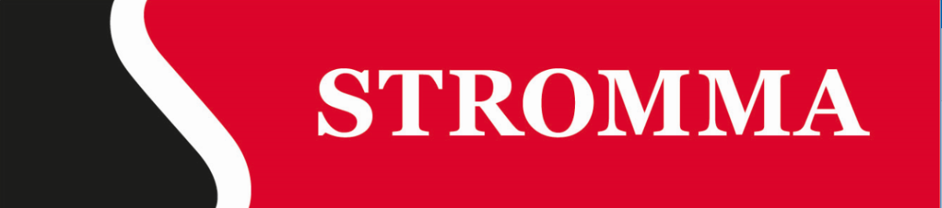
Press release 24 March 2020

Update on Stromma’s operations in response to Covid-19

In response to lower tourism demand caused by travel restrictions and other effects of Covid-19, Strömma Turism & Sjöfart AB (“Stromma”) has decided to close its operations in all active destinations and postponed season start in the remaining destinations which have not yet opened for the season. All offerings and operations in our 16 destinations are closed at moment.
The global measures taken to mitigate the spread of the COVID-19 virus have a major impact on traveling, both leisure and business. All travels, not only by air, are affected. Since many countries have closed their boarders, Stromma’s largest target group, international tourists, have disappeared from the market leading to a substantial decrease in demand for our tours and activities.
As a minimum, we expect our destinations to remain closed throughout April, which will mean an estimated loss of revenues in Q1 of 15-20 MSEK and in the start of Q2 of approx. 70 MSEK. Once restrictions of meeting and travelling are lifted, we will gradually re-open our tours and activities after seeing a proven demand on the market to keep production costs matching actual sales. We will have reduced offerings throughout the whole season due to this event. It is still too early to make any estimates of the full year impact on revenues and result.
Stromma is launching several activities to mitigate the loss of revenues and to adapt to lower demand during the course of the season. As a seasonal company we have per default a lot of variable costs which will be reduced along with reduced operations. COGS, which on average the last three years has been 32 % of revenues, will be reduced in proportion to revenues. Maintenance will be reduced since not all vessels will be in use even after reopening. The most effectful action is to abort all hiring of seasonal staff, which in a high season month consist of approx. 65 % of personnel costs. Since this crisis has rolled out during a period when we usually contract seasonal staff, we will simply not make any material new hires as planned and hence be able to avoid major layoffs within the operational staff. Other measures include some temporary layoffs, consultant stop, postponed non-critical projects, reduced marketing, and notice of permanent layoff in administrational staff.
Finally, Stromma will receive compensation of costs from our different governments. The most valuable of such available compensations include:
- Netherlands: 90 % compensation of salaries if 100 % of revenues are lost to 22,5% compensation if 25 % lost, for at least 3 months starting 1st of March with possibility to prolongate another 3 months. No maximum salary;
- Denmark: compensation of fixed costs from 9 March 2020 plus compensation for staff temporarily sent home with salary. Compensation is up to 23 TDKK per administrational employee and for staff paid by hour up to 26 TDKK;
- Germany: 100 % compensation of salary cost, no maximum salary, 100 % compensation of social security fees, only lost working hours are compensated;
- Sweden: salary compensation for temporary layoffs up to 23 TSEK per employee; and
- Norway, 100 % compensation for salaries up to 600 TNOK/year during 20 days.
For further information, please contact:
Björn Hamberg, CFO Strömma Turism & Sjöfart AB
+46 70 206 73 05
bjorn.hamberg@stromma.se
This information is information that Strömma Turism & Sjöfart AB is obliged to make public pursuant to the EU Market Abuse Regulation. The information was submitted for publication, through the agency of the contact person set out above, on March 24, 2020 at 19:10 CET.

Stromma is the leading provider of experiences within sightseeing in Northern Europe. Stromma offers experiences that aim to give every single guest memories for life. These experiences focus on sightseeing tours, entertainment and activities for tourists, local residents and companies. Stromma has a history dating back to 1809 with a strong tradition of historic and cultural values. Today Stromma operates in 15 destinations; Amsterdam, Utrecht, Copenhagen, Århus, Oslo, Bergen, Ålesund, Geiranger, Stavanger, Stockholm, Uppsala, Gothenburg, Malmö, Helsinki and Berlin. Stromma’s brands include the well-known names Göta Kanal Rederiaktiebolag, Paddan Sightseeing, Strömma Kanalbolaget, Canal Tours Copenhagen, Helsinki Sightseeing, Canal Tours Amsterdam, but also unique experiences like Birka (the Viking City), A’dam Lookout and Vaxholms Kastell. Read more on www.stromma.com.

