Kongsberg Digital develops cloud-based simulators for maritime industry, with funds from Innovation Norway
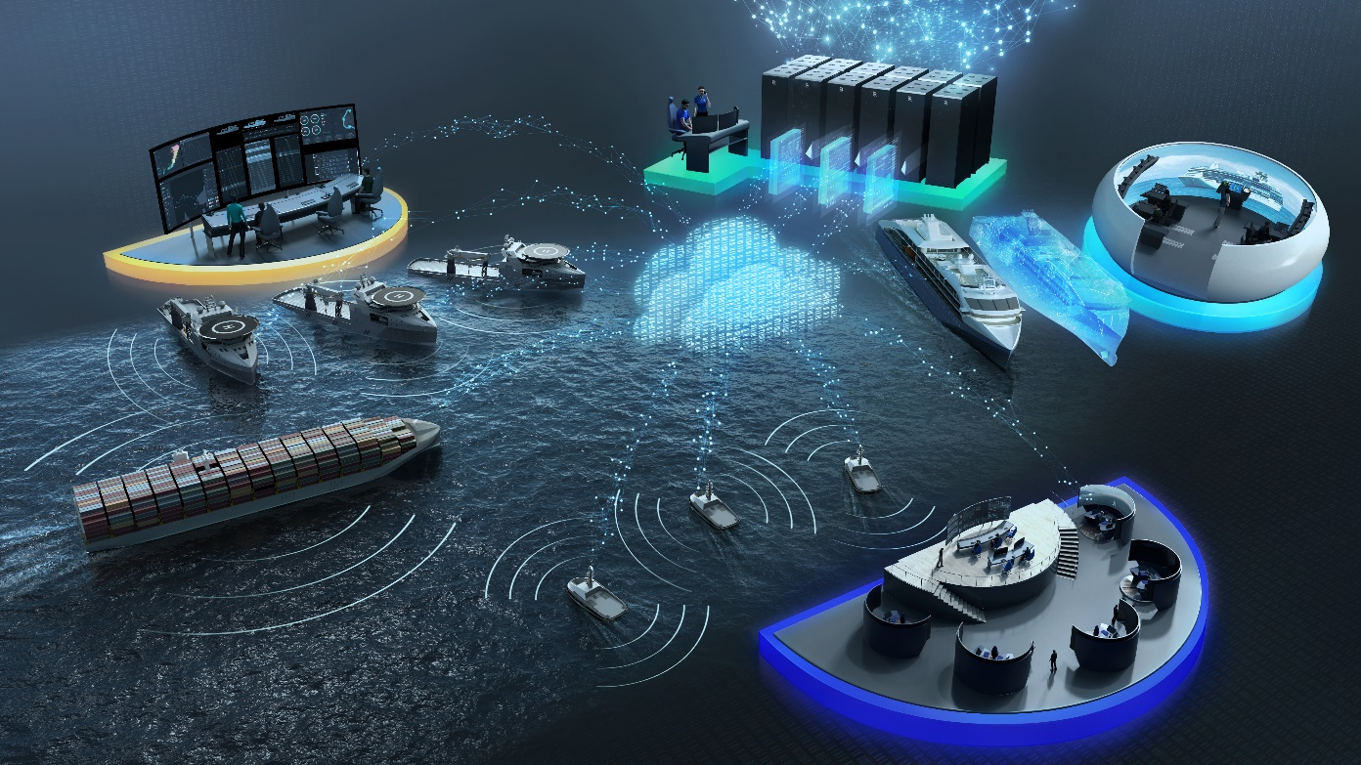
Kongsberg Digital develops cloud-based simulators to assist in improving the quality of
maritime navigation training
Asker, Norway, September 23rd, 2020 – Kongsberg Digital develops cloud-based simulation technology to support advanced operational studies, research and education in the maritime industry. The use of increasingly advanced equipment and an elevated focus on safety and sustainability has raised the bar for innovative new solutions to collect, simulate and share data to assist in optimization of vessel operations.
With its digital expertise, Kongsberg Digital is central to this industrial shift. Its advanced simulation technology has huge potential and is already in use by several international projects focused on developing digital twins and autonomous vessels. In addition, the company continues to develop its simulation technology in support of new competence requirements. It is this focus on improving the quality of maritime education and training which has led to a recent funding award from Innovation Norway of NOK 24 million, to be dedicated to developing cloud-based simulation solutions for teaching and practicing navigation.
“Digitalization and the use of big data will play an increasingly major part in improving safety, efficiency and, not least, in contributing to more sustainable maritime operations. Kongsberg Digital is intensifying its commitment to these goals, and is now establishing a new business domain – Digital Ocean – to deliver value-generating digital solutions in close cooperation with our industry partners,” comments Hege Skryseth, President, Kongsberg Digital. “This project to develop cloud-based training technology is one of many initiatives in which we will participate going forward. By combining our unique domain expertise in digital solutions with our broad experience in developing advanced simulation technology, Kongsberg Digital is in a strong position to raise the bar for quality training in the maritime industry.”
Haakon Haugli, CEO, Innovation Norway, added: “The solution developed by Kongsberg Digital has huge market potential and great scope for innovation. Norway is well placed to lead the way in digitalization, and the value and possibilities granted by this are clearly relevant considering the Covid-19 pandemic. Kongsberg Digital has previously succeeded with development and commercialization of cloud-based solutions, and there is good reason to believe that they will also achieve success with this project.”
By combining KONGSBERG’s world-leading simulation technology with Azure, Microsoft’s cloud-based infrastructure, Kongsberg Digital will develop a cloud-based simulation solution for navigation-related training according to the IMO’s International Convention on Standards of Training, Certification and Watchkeeping for Seafarers (STCW). The resulting simulator will – unlike traditional simulators which are demanding in terms of space and hardware – be a highly cost-effective teaching tool, which can be made available to more students, at any time and in any place.
As an example, countries who do not normally have the resources to invest in expensive simulators will now be able to grant students the ability to carry out online learning
(e-learning) according to STCW requirements, and to acquire key basic skills such as the use of RADAR, navigation and maneuvering. The cloud simulator will also assist in crisis management and other more advanced training, and will accommodate requirements for post-qualification education of navigators and help simplify the certificate renewal process.
The research community at the University of South-Eastern Norway (USN) is also taking part in this innovative project, and will contribute to developing the professional curriculum and in necessary research activities to optimize the instructional technology and educational aspects of the cloud-based training solution.
Ends

For further information, please contact:

Anne Voith
Marketing Manager, Maritime Simulation
Kongsberg Digital
Tel: +47 4567 8255
anne.voith@kdi.kongsberg.com

David Pugh
Saltwater Stone
Tel: +44 (0)1202 669244
d.pugh@saltwater-stone.com

About Kongsberg Digital
Kongsberg Digital is a provider of next-generation software and digital solutions to customers within maritime, oil and gas, and renewables and utilities. The company consists of more than 500 software experts with leading competence within the internet of things, smart data, artificial intelligence, maritime simulation, automation and autonomous operations.
Kongsberg Digital is subsidiary of KONGSBERG (OSE-ticker: KOG), an international, knowledge-based group delivering high-technology systems and solutions to clients within the oil and gas industry, subsea, merchant marine, defence and aerospace. KONGSBERG has 11,000 employees located in more than 40 countries.
Web: Kongsberg Gruppen | Kongsberg Digital
Social media: LinkedIn | Twitter | Facebook

