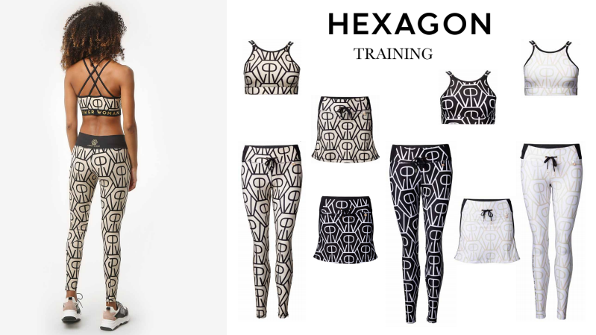
Hexagon Collection

We love our logo, so we decided to put it all over. More is more, less is a bore.

Our Hexagon logo is so stylish we had to make an all over print out of it. The clean shapes of the pattern stand out from the elegant and neutral background in a geometrical and contemporary way. This collection is made for the performer that wants to stand out, though with discretion and style.

Our logo symbolizes that every woman is a force of nature, a powerwoman. We come in different shapes but we are all diamonds in our own unique way. Some ruff, some polished, some small, some large. That does not matter. We are strong as .. and nothing can break us. Women are natures diamonds, the strongest material on earth.

All the pieces in the collection are made for extreme challenges and will stand marathons and hard core training, but suits as well as leisure wear, powerwalks and so on all day (and night) long. 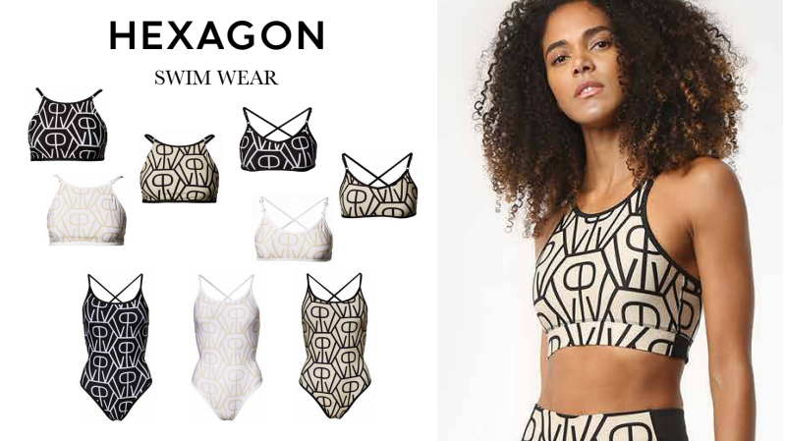
In the collection we have our high quality tights with gold details and Xtra all in material, fit and design. Wide waist with elastic and drawstring with gold endings meek with Powerwoman. Gold pendant on left waist for extra bling. Gold zipper and placket back on legs to give a nice cut and fit.

New addition to our collection is our high halter top. This one is made with a supportive elastic to keep everything in place. Double fabric for extra support. Gold rings on shoulder straps for extra glow.

The Training skirt is made for runners, as well as for leissure wear. Wide comfortable waist elastics and drawstring will keep it in place and a ”built in” boxer short will make it safe to run, twist and turn just as you want!

Our Swimwear is made to stand long and hard swim sessions, but with this design you can both enjoy training and look great at the beach. In the collection we have a swimsuit and a swim bikini. Both with lining and adjustable shoulder straps.

Anna Wretling – Founder of Power Woman

__________________________________________________________________________________
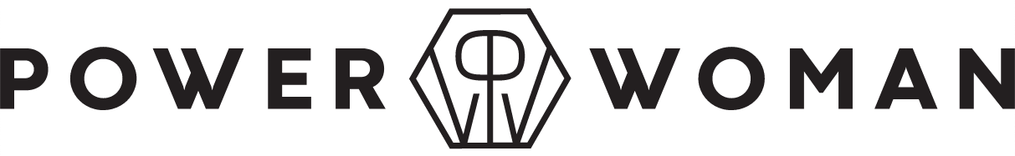About Power Woman
Power Woman is a Swedish high-end sportswear brand. Power Woman design sports apparel that are perfect for the female body and extensively tested by the world's top female athletes. The apparel combine fashion, fit and sports in one. Behind the brand stand entrepreneur and triathlete Anna Wretling who´s passion is to empower women through the brand and through the sports community Team Powerwoman Athletic club.
Contact: info@powerwoman.com
Instagram: @powerwoman_official
Site: www.powerwoman.com

