Digital Yacht introduce NavLink MAC
Electronic charting and navigation software for MacBook PCs with detailed UK Charting
Launch at the Southampton Boatshow Stand G147
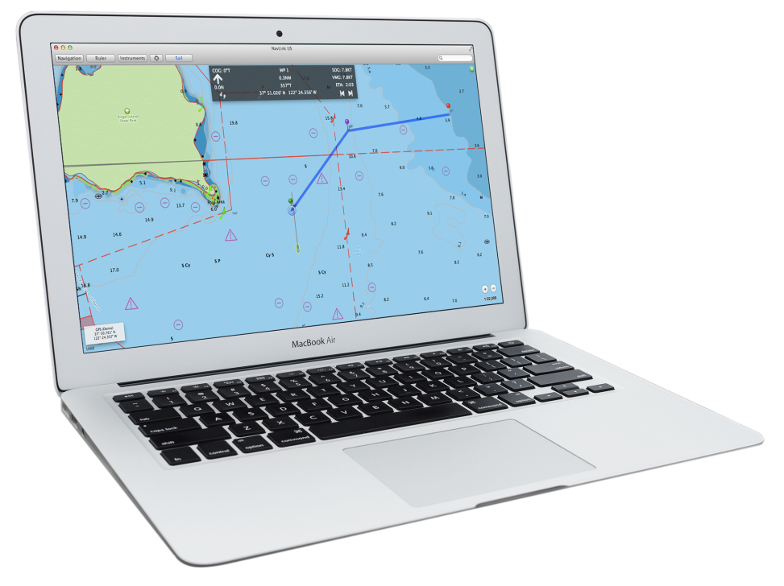

For release: SBS Preview Editions

A new, £29.95 MAC application called NavLink from Digital Yacht will turn your MacBook into a full featured, electronic charting system with detailed UK charting and real time GPS and AIS support for simple navigation

NavLink MAC is an Apple MAC based electronic charting and navigation package which turns a MacBook into a full function chart plotter. The application comes complete with highly detailed UK Hydrographic Office vector charts for the whole of the UK & Eire and allows real time positioning, tracking and routing. Simply create a route with a click of the mouse to quickly and easily get bearing, distance and ETA information to your destination. AIS targets can also be overlaid onto the electronic charting. Charts can be zoomed and panned using intuitive finger gestures on the MAC track pad.

The MAC will require a GPS connection for location and optional connection to AIS if an AIS overlay of targets is required. Digital Yacht’s range of GPS sensors or their low cost USB-NMEA adaptor can be utilised to connect the MAC to the boat’s GPS/AIS system. Alternatively, for a wire free solution, NavLink supports a connection via wifi to any of Digital Yacht’s NMEA to wireless devices such as iAIS and the WLN10.

The seamless, UKHO charts feature incredible detail as they are the official digitised versions of the UK Admiralty charts and show buoys, navaids, depth contours, wrecks, spot depths, restrictions etc. It also supports “drill down” data so an object such as a buoy can be queried for its characteristics. Weather buoys are also supported for local weather conditions (an internet connection is required for this live data) and a tidal atlas is included. NavLink MAC users can also share routes with the NavLink iPad app.

NavLink has been designed from the ground up to take advantage of the MACs simplicity of operation and clarity of the high resolution displays on Apple’s latest products. Priced at £29.95, it’s available for download from the MAC app store. Visit Digital Yacht on Stand G147 at the Southampton Boatshow for a demo.

-Ends-
Digital Yacht – Note’s For Editors
Digital Yacht is a UK based manufacturer of specialist marine electronics with offices in the UK, US and China and a global network of resellers in over 100 countries. We produce a range of innovative products including AIS receivers and transponders, WiFi servers for on board NMEA data, long range WiFi internet devices and a range of sensors including GPS and electronic compasses. Digital Yacht won the prestigious METS DAME Electronic Product Award for iAIS as well as the NMEA Technology Award for BOATraNet in 2011. The GPS150 was nominated for a DAME award at this year’s 2013 exhibition in November. Our blog at www.digitalyacht.net has a range of interesting White Papers on many aspects of marine technology.

For further information, please contact:

Nick Heyes Direct Line 0207 100 9116

Digital Yacht UK : The Technology Centre, Green Lane, Failand. BS8 3TR TEL 01179 554474
WWW.DIGITALYACHT.CO.UK

